New Era Institute of Vocational

And Continuing Education

Subject: SEDSC029 Commercial Software Development (Major Project)

Project Title: Boutique commerce website

Student Name: Yap Yi Liang

Student ID: 2160109 - SEDSC

Due Date: 19 July 2023

Project Supervisor: Mr. Ching Kin Keong

SEDSC029 Commercial Software Development (Major Project)

Project Title: Boutique commerce website

Table of Contents

1. **Acknowledgement** 3
2. **Preface** 4
3. **Documentation** 5

**Gantt Chart** 5

**Use Case Diagram** 6

**Use cases Description.** 7

**ERD Diagram** 22

**Activity Diagram** 23

1. **User Manual** 31

**Admin** 31

**Normal User** 41

1. **System Coding** 54

**Admin** 54

**Normal User** 136

**Data Base Coding** 320

1. **Project Specification From (PSF)** 327
2. **Project Proposal From** 329
3. **Weekly Report** 331

# **Acknowledgement**

During my two years of studying, I have learned various knowledge, which has brought about a huge change in my values. The teachers have taught me various skills and know what skills are needed for future work.

The earnest teaching of the teachers let me know where I want to go in the future. I would like to sincerely thank every teacher who has taught me, I will keep my curiosity moving forward, and never give up any learning opportunity.

# **Preface**

This book shows my Final Year Project, as you can see it's an e-commerce site, selling various products. This website is made using JavaScript, HTML, PHP, CSS, and Mysql programming languages, which I have learned during my two years of study.

# **Documentation**

### **Gantt Chart**

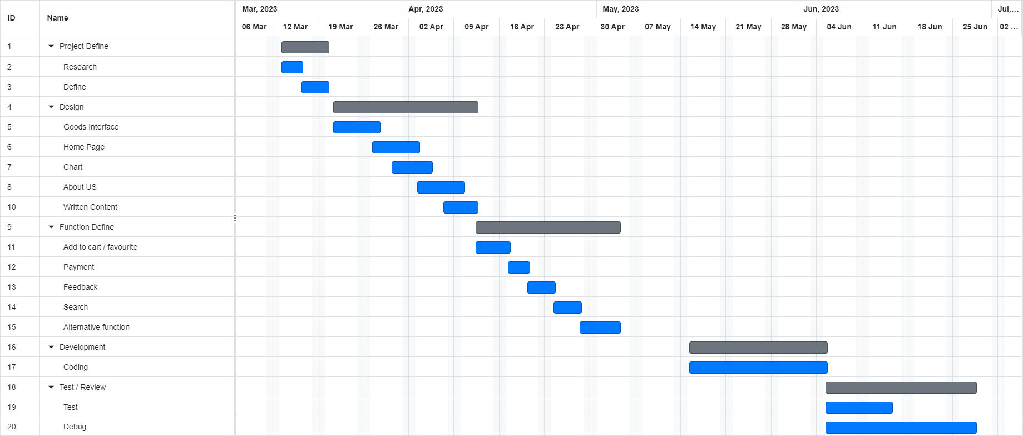

### **Use Case Diagram**

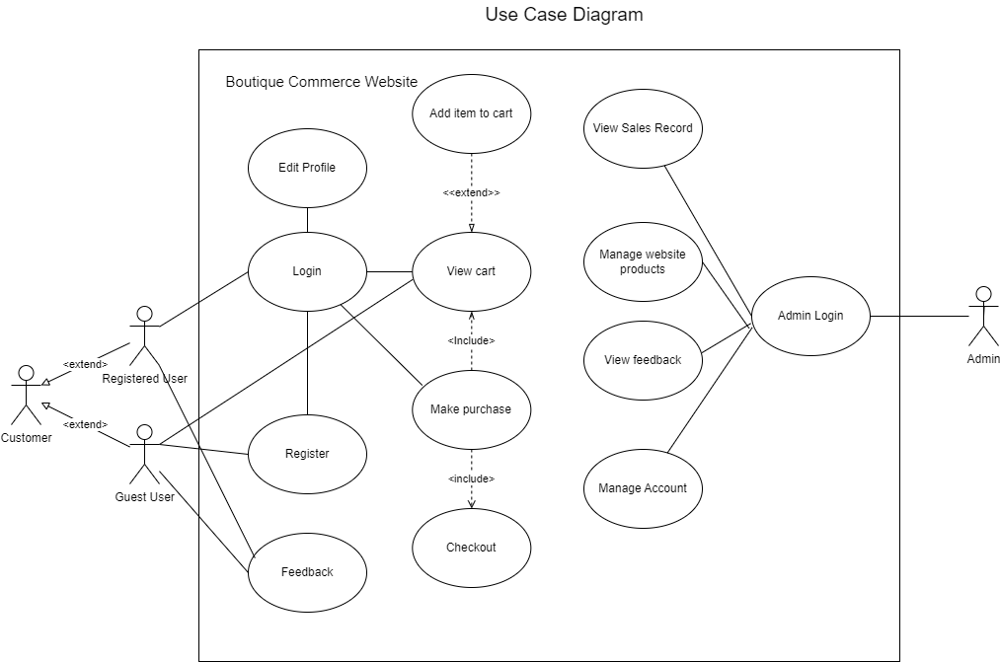

### **Use cases Description**

|  |  |
| --- | --- |
| UC 1 | **Use case No** |
| Login | **Use case name** |
| ● Customer | **Participating Actor** |
| Users can log in to this website with their own username and password. | **Brief Description** |
| The user has already applied for an account. | **Pre-Condition** |
| 1. Click on the login page 2. User can see text field for user and password 3. Fill in the username and password of your own account, and click Login 4. The system will enter the homepage after verifying that the username and password are correct | **Main Flow** |
| **A1: The user does not choose to log in to the system**   1. If the user does not log in, he can directly browse the webpage, but cannot use the cart and payment functions. | **Alternative Flow** |
| **E1: Invalid username and password**   1. If the user enters a wrong or nonexistent username or password, the system will display "Incorrect password or username". 2. Users who forget their password or username can click Forgot Password to reset their password or username. | **Exceptional Flow** |
| 1. Customer logged into the system successfully and can access to the shopping page. | **Post-Condition** |

|  |  |
| --- | --- |
| UC 2 | **Use case No** |
| Register | **Use case name** |
| ● Customer | **Participating Actor** |
| Users who do not have an account can apply for an account and fill in their personal information to facilitate future services. | **Brief Description** |
| The user does not have an account with the site. | **Pre-Condition** |
| 1. Users can click Register Account on the login page. 2. Fill in username, password and personal information 3. Click Register. 4. Store the user's data in the database. 5. Go to the login page after the registration is completed. | **Main Flow** |
| **A1: Customer cancels registering a new account**   1. Customers can browse the web as usual. | **Alternative Flow** |
| **E1: Username exists, or does not meet the conditions**   1. I If the username already exists, the system will prompt "username already exists, please enter another username" 2. If the password and username do not comply with the regulations, the system will prompt the user "username and password do not comply with the regulations", please fill in again. | **Exceptional Flow** |
| 1. If user successfully apply for an account, user will be directed to the home page. | **Post-Condition** |

|  |  |
| --- | --- |
| UC 3 | **Use case No** |
| Add item to cart | **Use case name** |
| ● Customer | **Participating Actor** |
| Users can put the items they want to buy into the shopping cart. | **Brief Description** |
| The user has logged into the account. | **Pre-Condition** |
| 1. The user must log in to the account first. 2. Select the desired item and click the add to cart button. 3. Items will be displayed in the cart | **Main Flow** |
| **A1: Product won’t add to cart.**   1. Product will not be added in cart. | **Alternative Flow** |
| **E1: Product exists.**   1. If product already added in cart, quantity of the product in cart will increase. | **Exceptional Flow** |
| 1. Customer purchased add-on item | **Post-Condition** |

|  |  |
| --- | --- |
| **Use case No** | UC 4 |
| **Use case name** | View Cart |
| **Participating actor** | * Customer |
| **Brief description** | User can see what items are in the cart, quantity and size can be adjusted.. |
| **Pre-condition** | 1. The user has logged into the account. |
| **Main flow** | 1. The user clicks on the shopping cart. 2. System retrieves cart information from the database. 3. Adjust the amount and size. |
| **Alternative flow** | **A1: User cancels the viewing.**   1. No product will be displayed. |
| **Exceptional flow** | **E1: System fails to connect to the database.**   1. Use case terminates. |
| **Post-condition** | 1. Products is chosen |

|  |  |
| --- | --- |
| **Use case No** | UC 5 |
| **Use case name** | Make purchase |
| **Participating actor** | * Customer |
| **Brief description** | The user identifies the item and decides to make a payment. |
| **Pre-condition** | 1. Products exist in the cart. 2. User login account. |
| **Main flow** | 1. User clicks on cart 2. Confirm the products 3. Click payment button |
| **Alternative flow** | **A1: User cancels purchase.**   1. Back to the cart page. |
| **Exceptional flow** | **E1: System fails to connect to the database.**   1. Use case terminates. |
| **Post-condition** | 1. Go to checkout page. |

|  |  |
| --- | --- |
| UC 6 | **Use case No** |
| Checkout | **Use case name** |
| ● Customer | **Participating Actor** |
| It is used to determine whether the user really wants to pay, and to provide information on the items to be purchased and various payment channels. | **Brief Description** |
| 1. User login account 2. There must be items in the cart. | **Pre-Condition** |
| 1. User login account 2. *Click on the cart* 3. *Click make payment* 4. *Choose payment method* 5. *Click pay* | **Main Flow** |
| **A1: User cancels checkout**   1. Back to cart page. 2. Can continue to browse the web. | **Alternative Flow** |
| **E1:  *The selected payment method cannot be paid***   1. The system will display "This payment method cannot be paid", and the user can choose other payment methods. | **Exceptional Flow** |
| 1. Payment successfully and the item is shipped to the user's address. | **Post-Condition** |

|  |  |
| --- | --- |
| UC 7 | **Use case No** |
| Manage website product | **Use case name** |
| ● Admin | **Participating Actor** |
| Manage products on the site | **Brief Description** |
| 1. Login the system as admin account | **Pre-Condition** |
| 1. Add or remove products | **Main Flow** |
| **NA** | **Alternative Flow** |
| **E1: System fails to connect to the database.**   1. Use case terminates. | **Exceptional Flow** |
| 1. To show customers the price of the item, the name and photo will change. | **Post-Condition** |

|  |  |
| --- | --- |
| UC 8 | **Use case No** |
| Feedback | **Use case name** |
| * Customer | **Participating Actor** |
| Users provide us with feedback to improve the quality of the website. | **Brief Description** |
| 1. User must login. | **Pre-Condition** |
| 1. Login. 2. Enter feedback. 3. Click ok. | **Main Flow** |
| **NA** | **Alternative Flow** |
| **E1: System fails to connect to the database.**   1. Use case terminates. | **Exceptional Flow** |
| 1. Feedback will save into database. | **Post-Condition** |

|  |  |
| --- | --- |
| UC 9 | **Use case No** |
| Sales Record | **Use case name** |
| * Admin | **Participating Actor** |
| View sales record | **Brief Description** |
| 1. Admin must login | **Pre-Condition** |
| 1. Login. 2. Search records by condition or view all records | **Main Flow** |
| **NA** | **Alternative Flow** |
| **E1: System fails to connect to the database.**   1. Use case terminates. | **Exceptional Flow** |
| 1. View Sales | **Post-Condition** |

|  |  |
| --- | --- |
| UC 10 | **Use case No** |
| Admin Login | **Use case name** |
| * Admin | **Participating Actor** |
| Admin Login | **Brief Description** |
| 1. Have an account | **Pre-Condition** |
| 1. Login | **Main Flow** |
| **NA** | **Alternative Flow** |
| **E1: System fails to connect to the database.**   1. Use case terminates. | **Exceptional Flow** |
| 1. Login into admin page. | **Post-Condition** |

|  |  |
| --- | --- |
| UC 11 | **Use case No** |
| Manage Account | **Use case name** |
| * Admin | **Participating Actor** |
| Delete user account | **Brief Description** |
| 1. Login admin account | **Pre-Condition** |
| 1. Login 2. Select the user to delete | **Main Flow** |
| **NA** | **Alternative Flow** |
| **E1: System fails to connect to the database.**   1. Use case terminates. | **Exceptional Flow** |
| 1. Admin can delete user account | **Post-Condition** |

|  |  |
| --- | --- |
| UC 12 | **Use case No** |
| Edit Profile | **Use case name** |
| * Customer | **Participating Actor** |
| Allow users to edit their personal information | **Brief Description** |
| 1. User has an account | **Pre-Condition** |
| 1. Login 2. Direct to profile page and click edit button 3. Change the information 4. Click submit | **Main Flow** |
| **NA** | **Alternative Flow** |
| **E1: System fails to connect to the database.**   1. Use case terminates. | **Exceptional Flow** |
| 1. Users can change their information and update the database. | **Post-Condition** |

### **ERD Diagram**

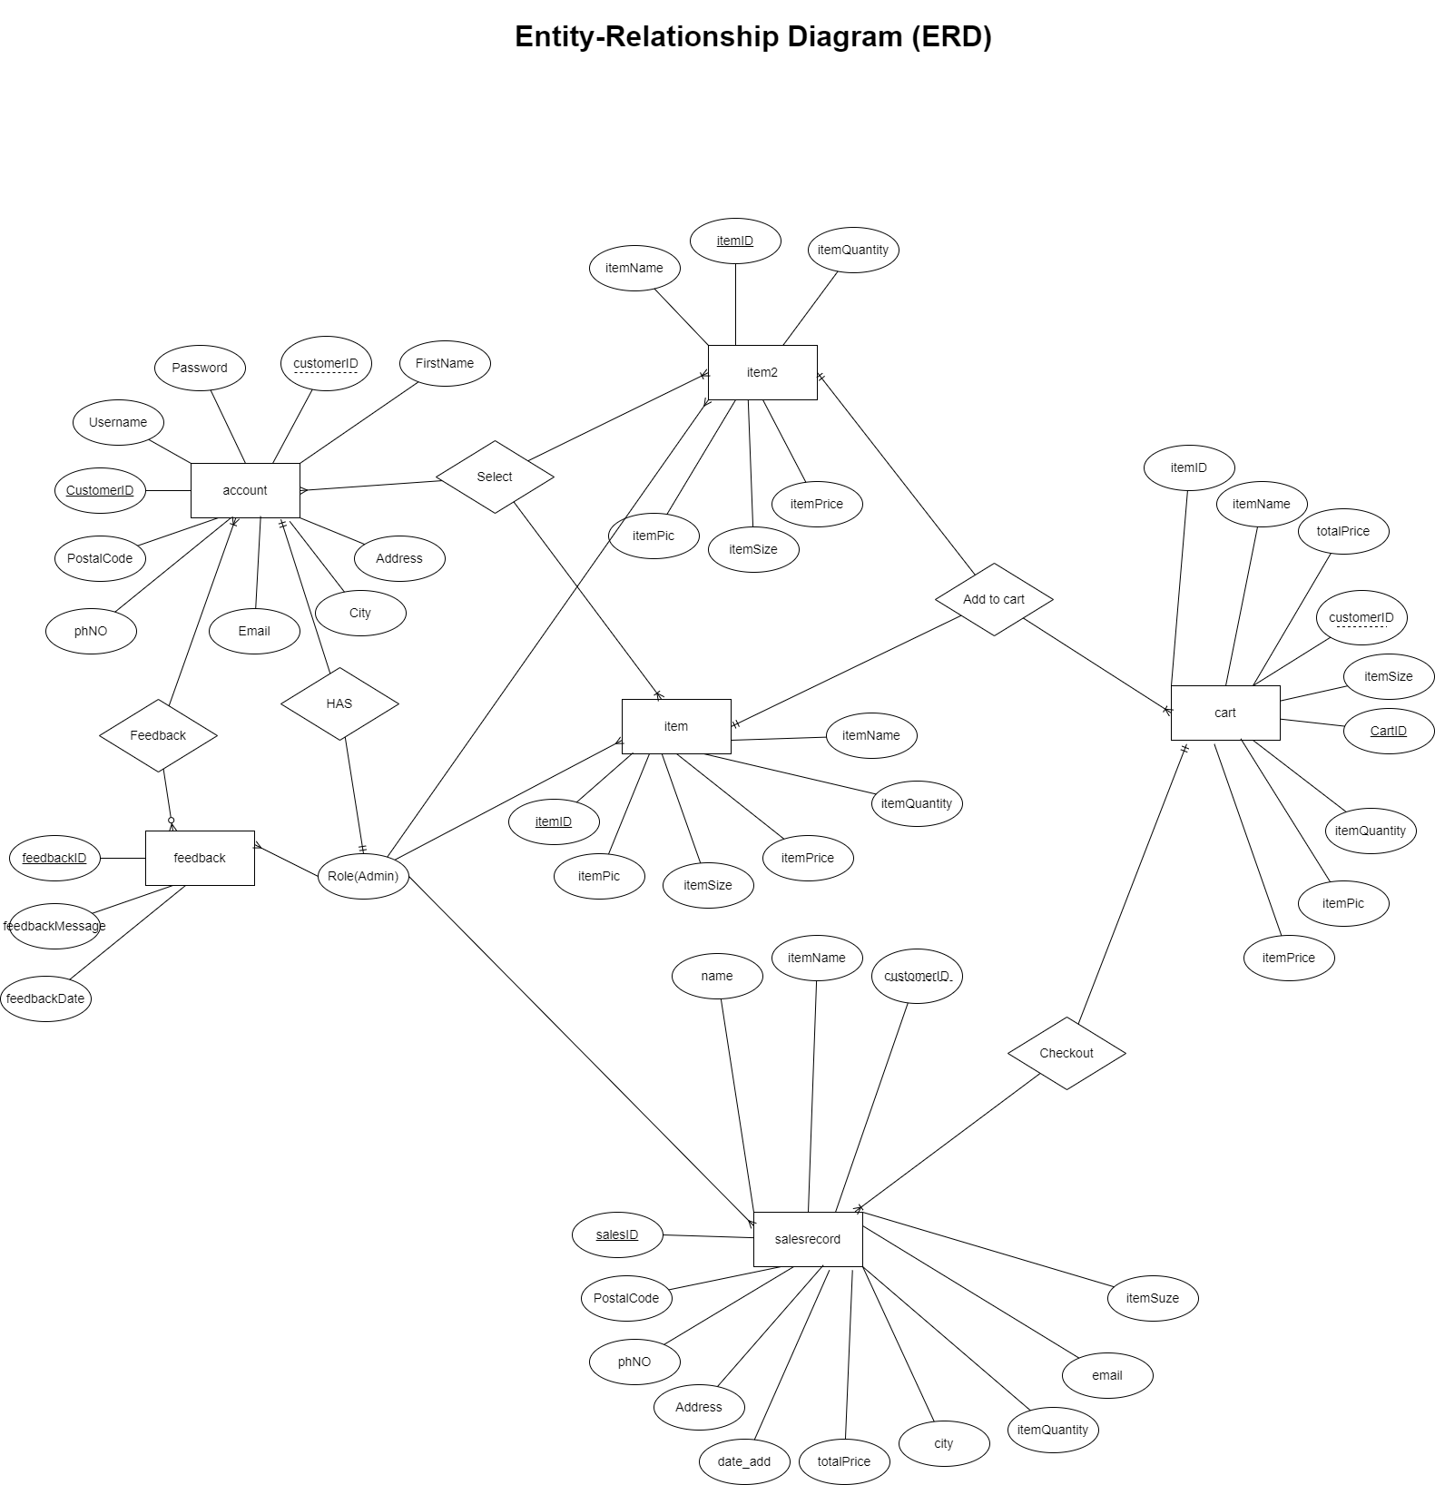

### **Activity Diagram**

#### **User Activity Diagram**

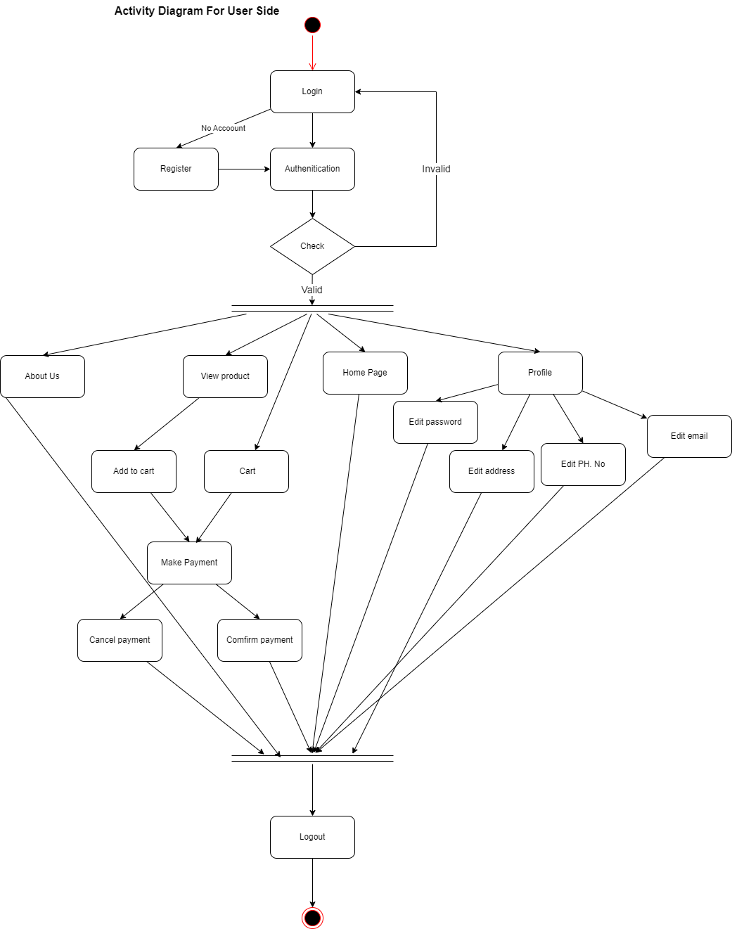

#### **Register Activity Diagram**

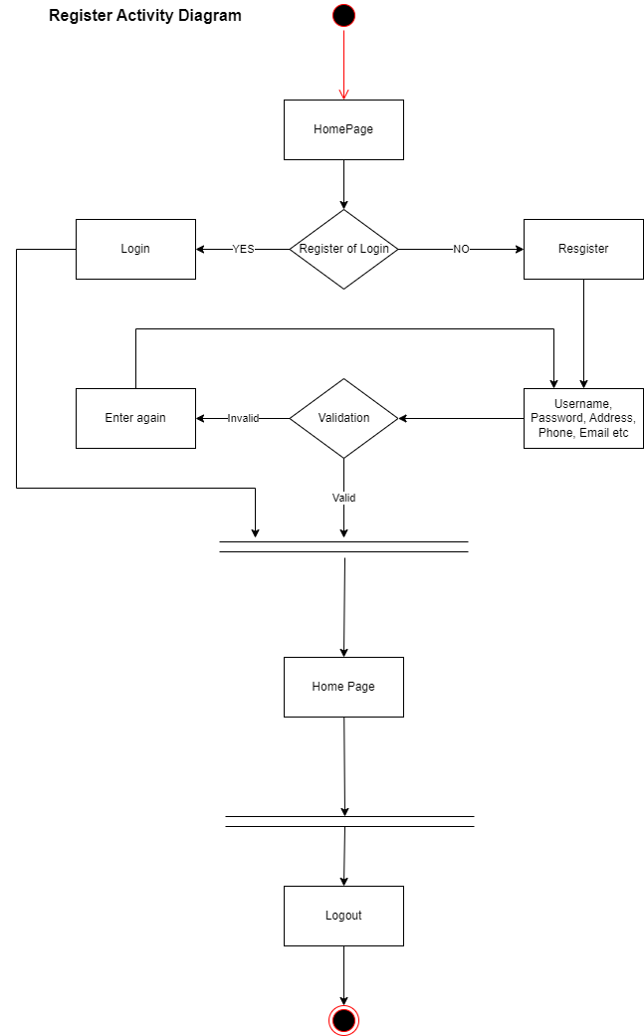

#### **Cart Activity Diagram**

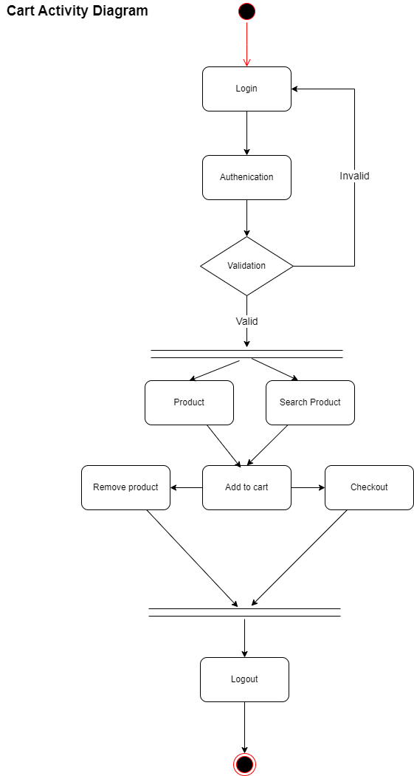

#### **Admin Activity Diagram**

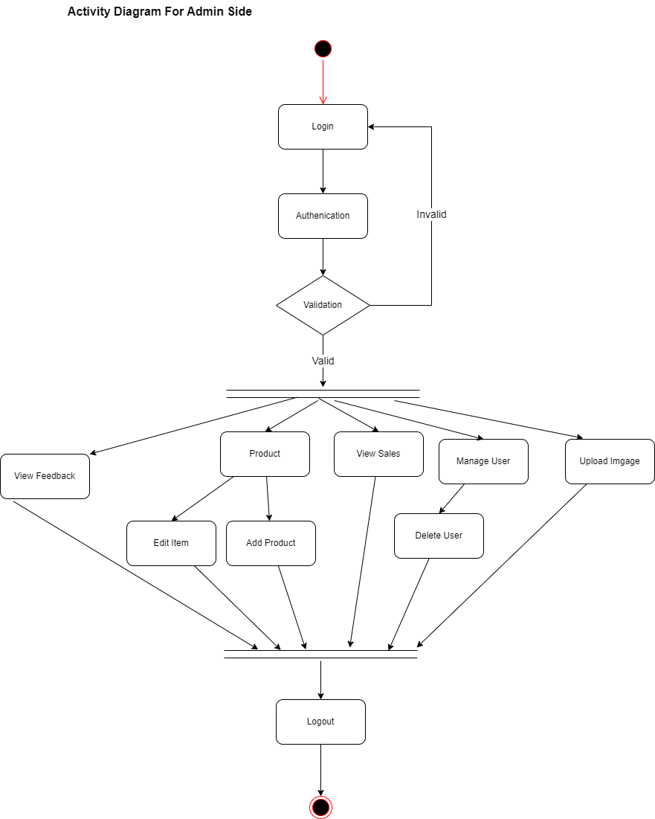

#### **Edit Product Activity Diagram**

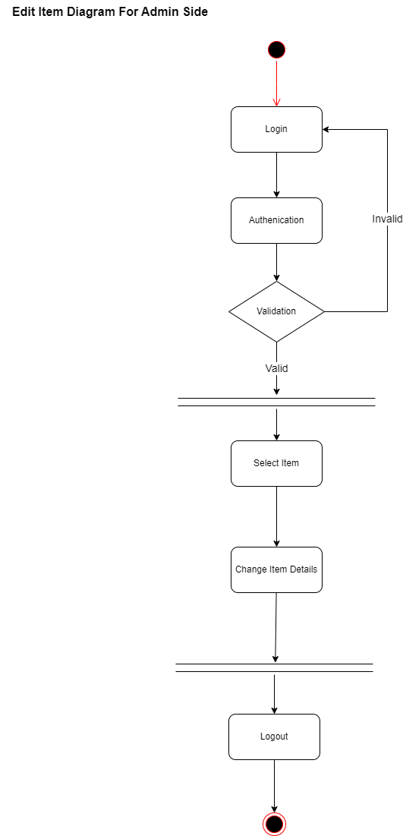

#### **Add Item Activity Diagram**

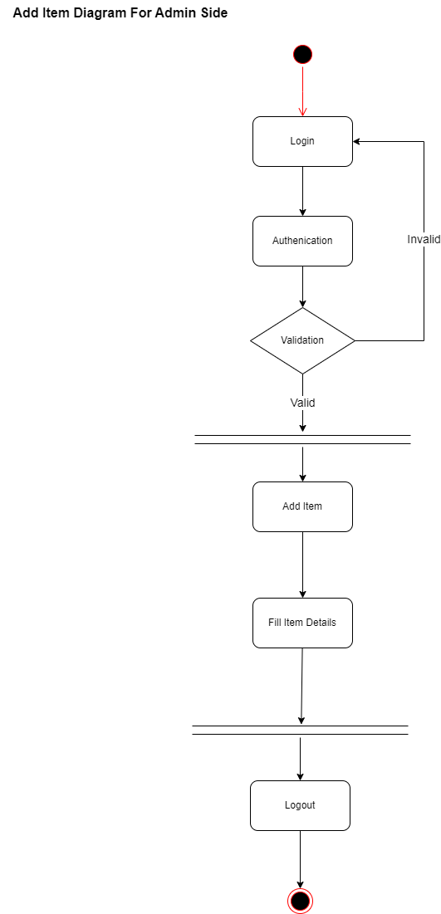

#### **Delete Account Activity Diagram**

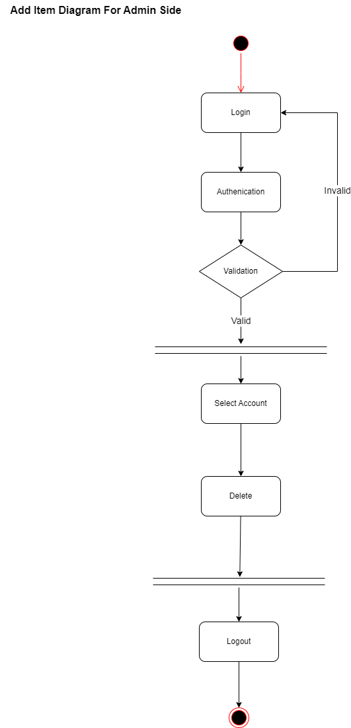

#### **Upload Image Activity Diagram**

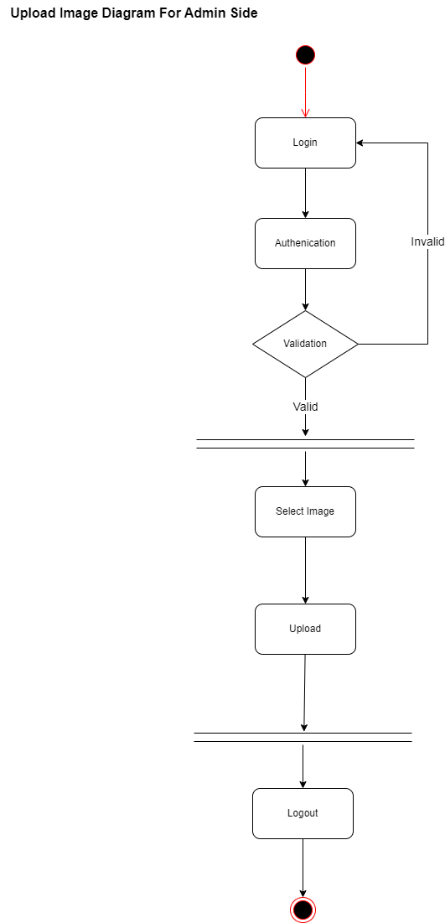

# **User Manual**

### **Admin**

**Admin Login**

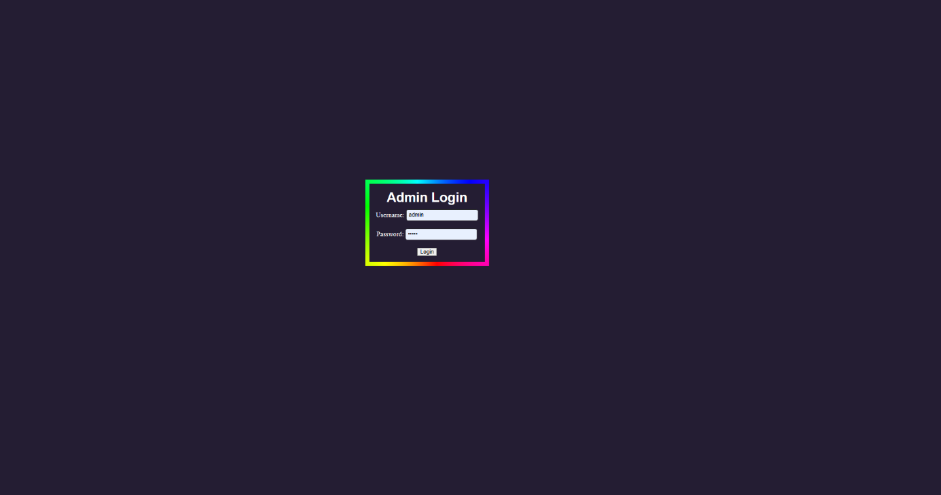 Admins enter username and password to log in to the admin page.

**Sales Record**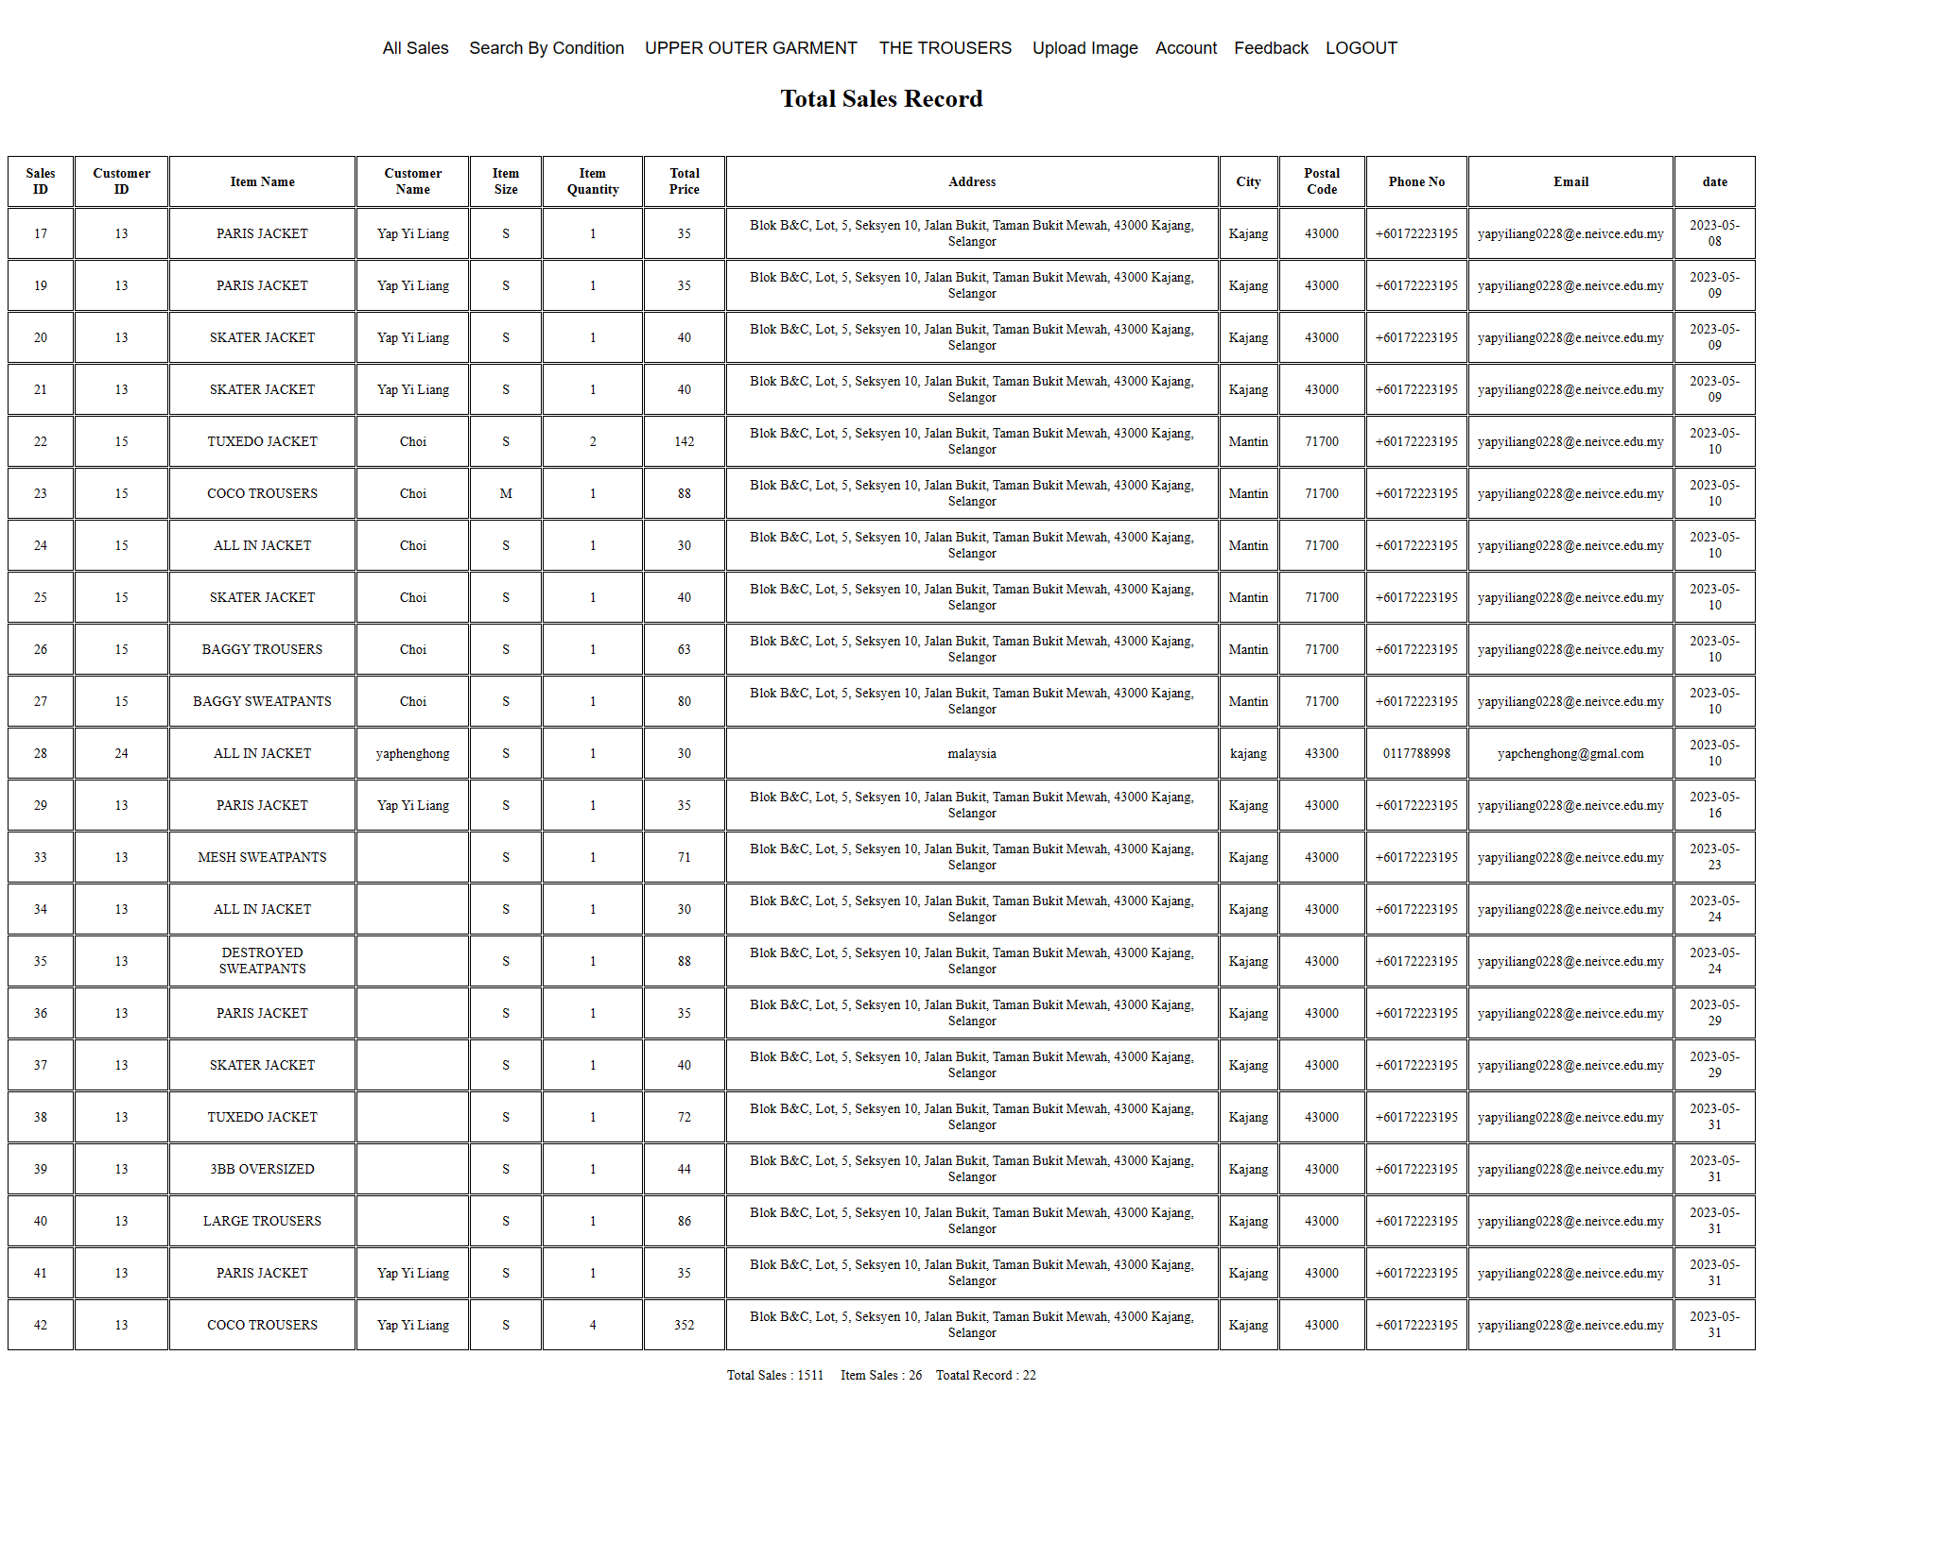 Allows users to view all sales records.

**Search sales by condition**

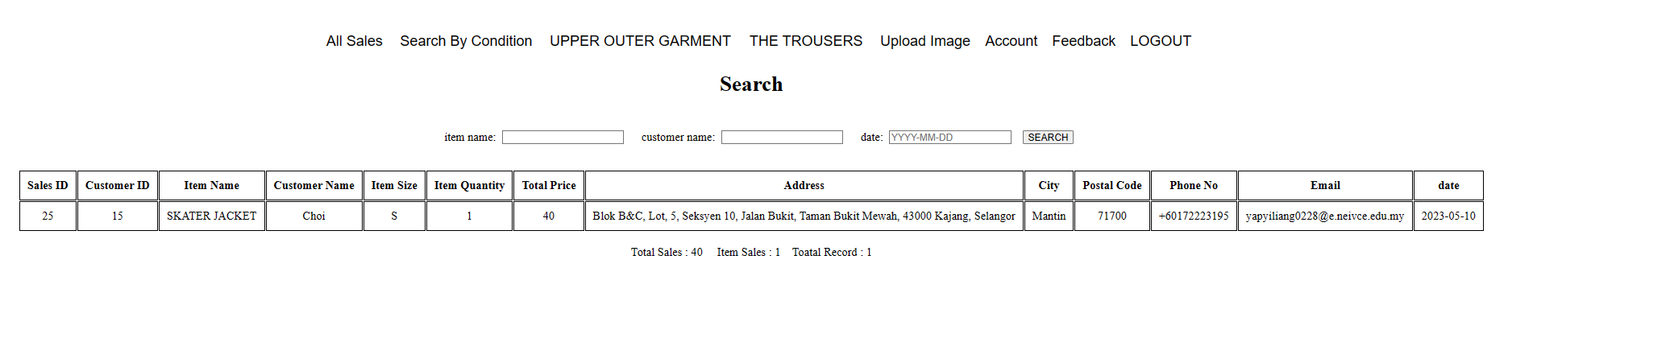 Let admin search sales records by specific criteria.

**Edit item (Upper Outer Garment)**

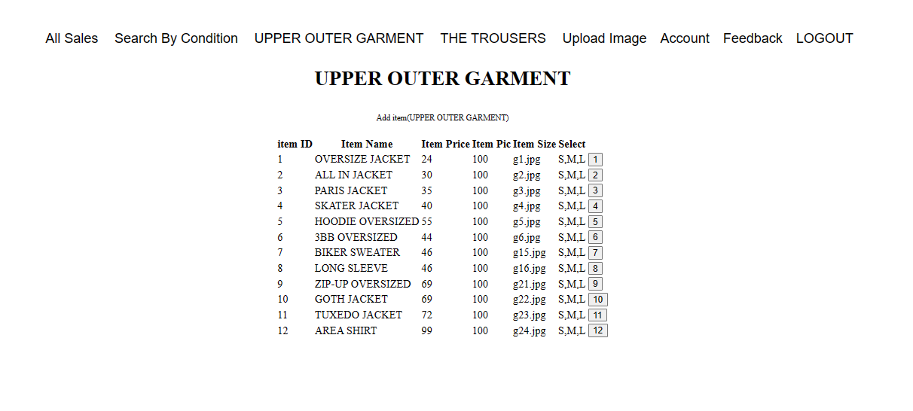 Select item to change item's profile. Click add item to add item.

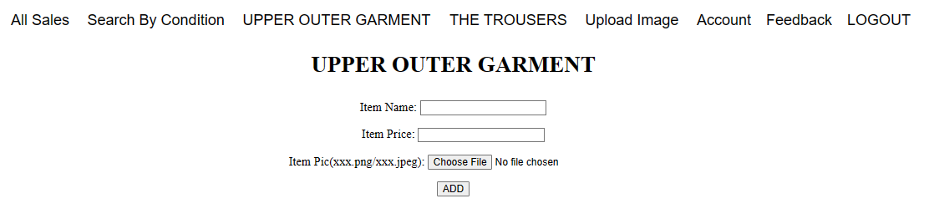

Fill in all the information to add item.

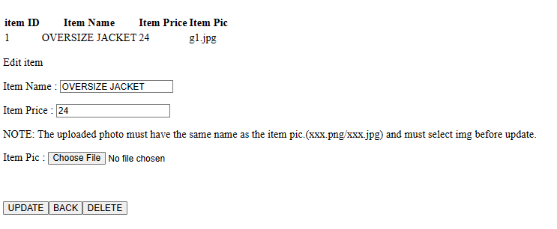

Fill in all the information and click update to update the item's information. Click back to return to the previous page. Clicking delete will delete the item.

**Edit item (THE TROUSERS)**

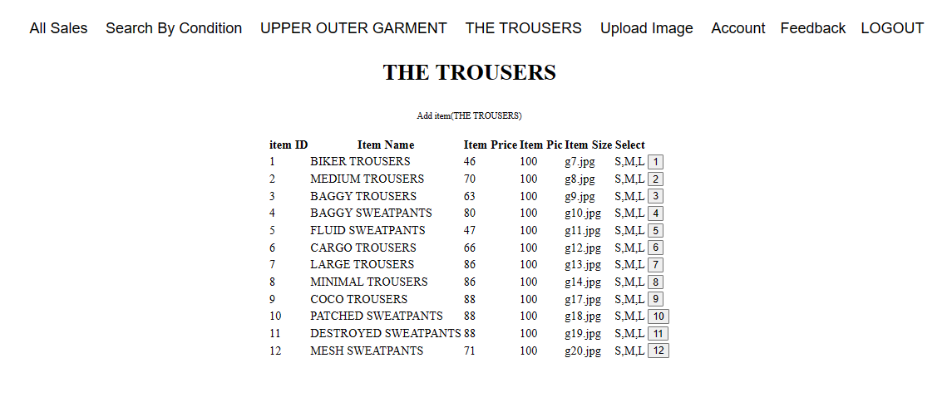

Select item to change item's profile. Click add item to add item.

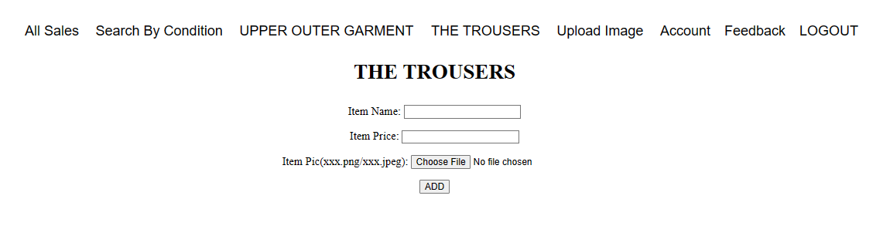

Fill in all the information to add item.

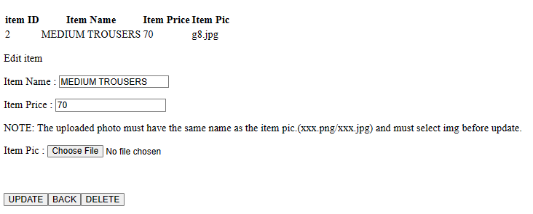

Fill in all the information and click update to update the item's information. Click back to return to the previous page. Clicking delete will delete the item.

**Upload image**

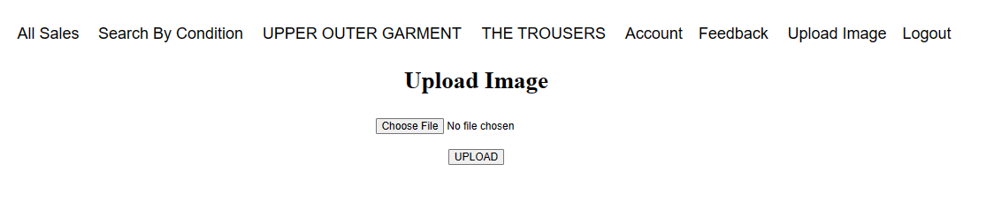 After selecting a photo, upload it to the database.

**Edit Account**

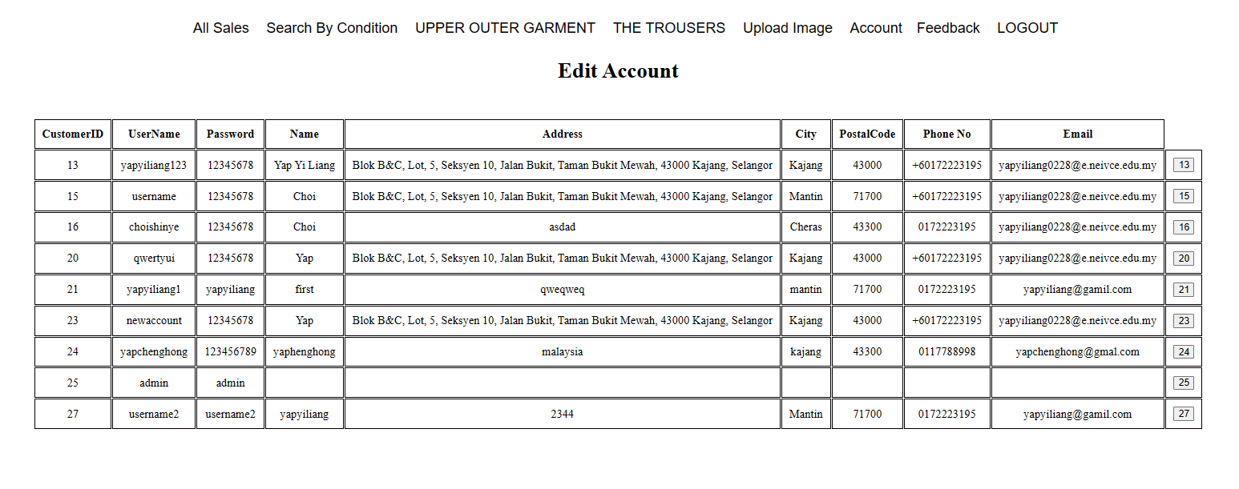

Click on an account to delete it.

**Feedback**

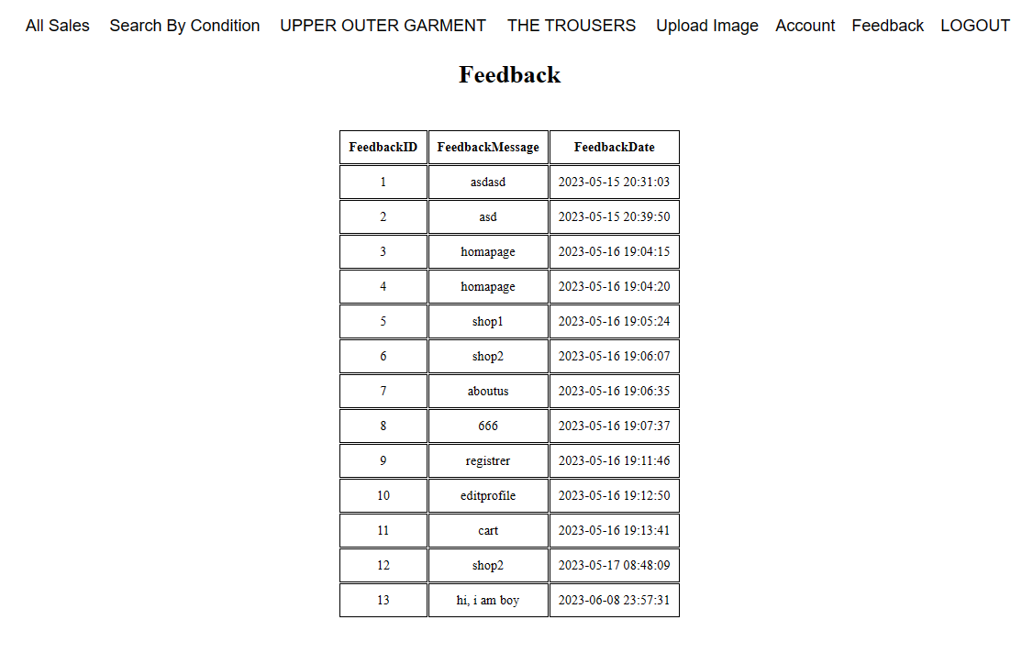 Feedback can be viewed here.

### **User**

#### **Home Page**

This is the first page of the website and you can see various introductions. All websites will have navigation bar and footer.

**SHOP (Upper Outer Garment)**

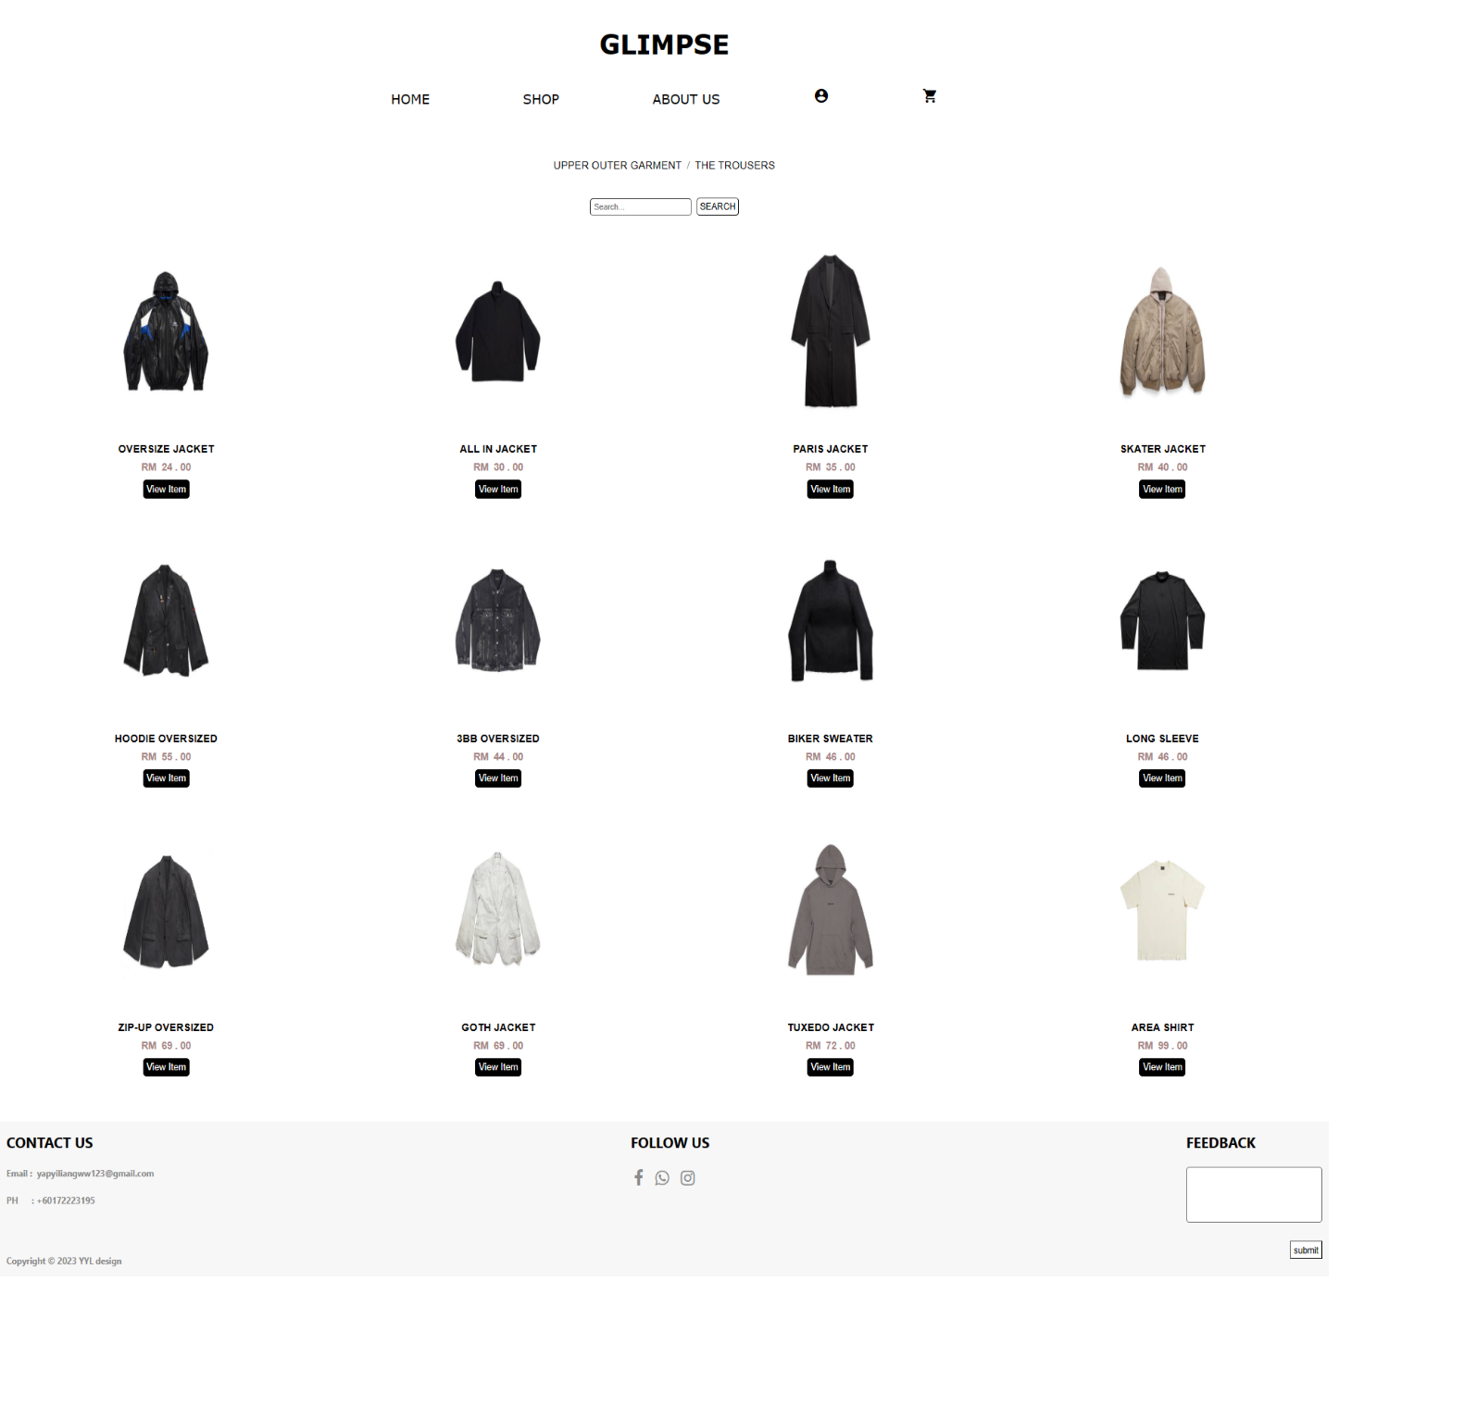

This is a website that displays items (Upper Outer Garment), and users can enter the item name to find it. When a user sees an item they like, they can click View Item to view it.

**Shop (The Trousers)**

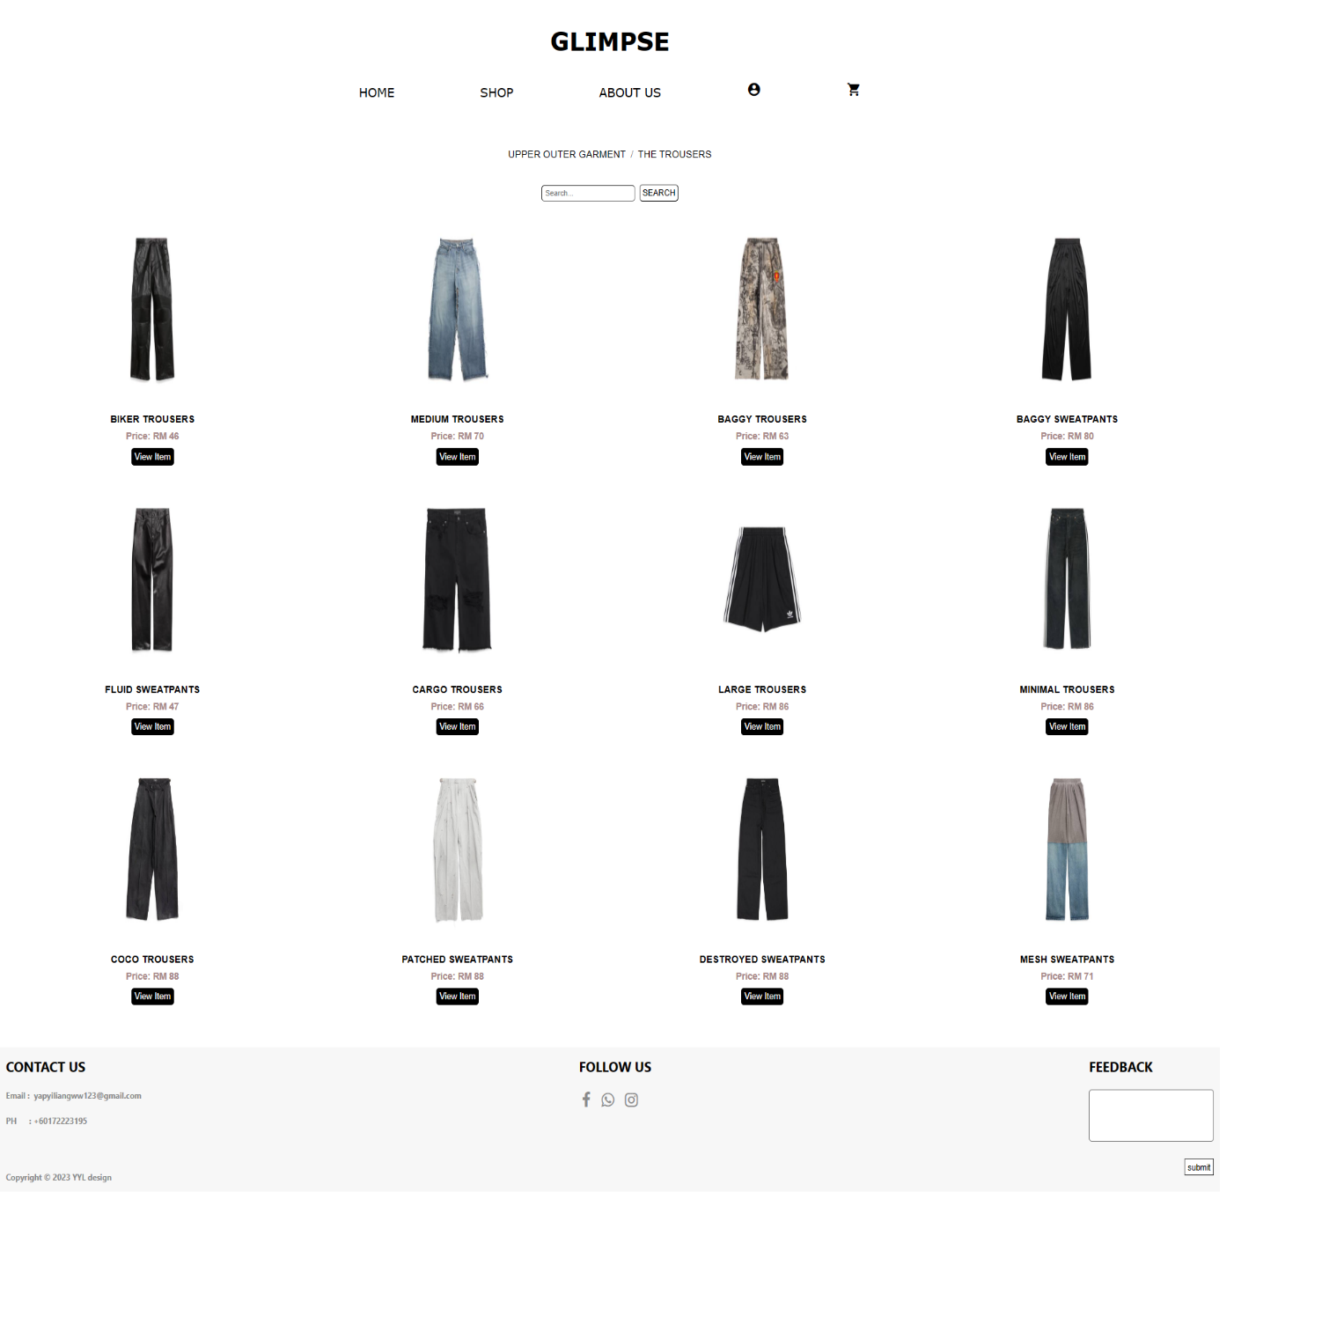

This is a website that displays items (The Trousers), and users can enter the item name to find it. When a user sees an item they like, they can click View Item to view it.

**Display Item**

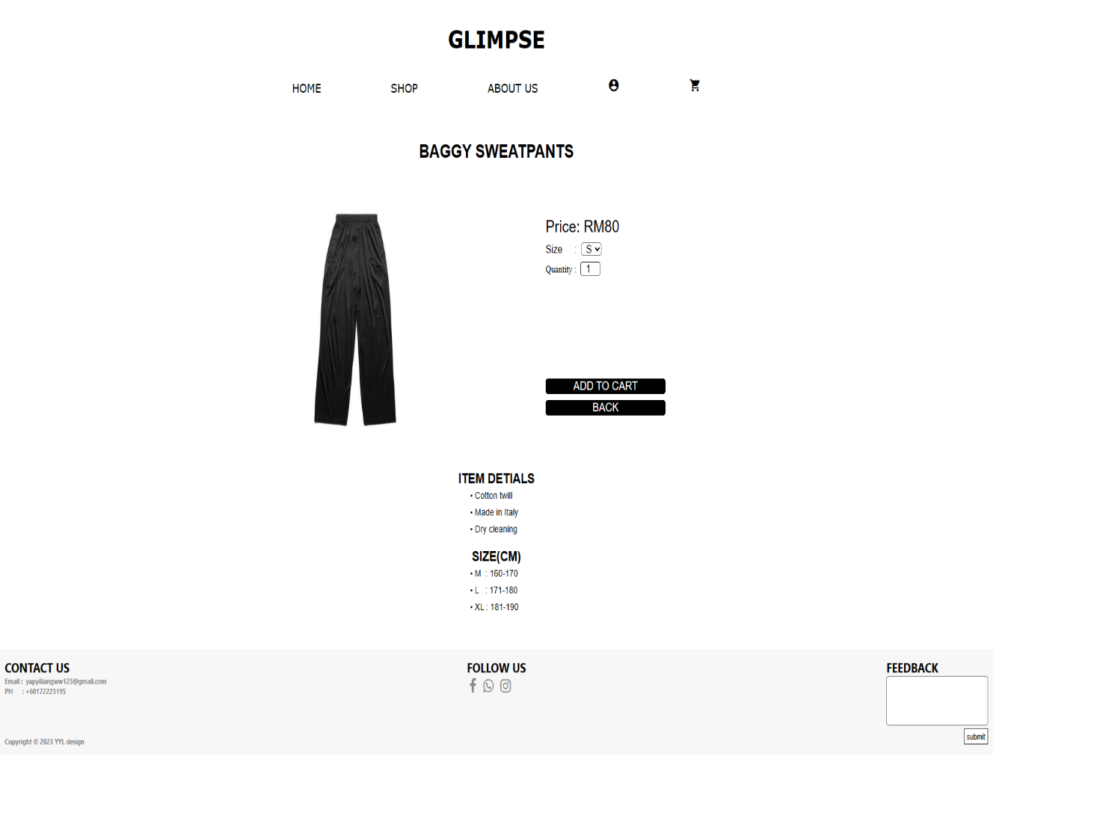 When the user selects an item, he will be able to select the quantity and size of the item, and then click add to cart to add it to the cart or click back to return to the shop page.

**About Us**

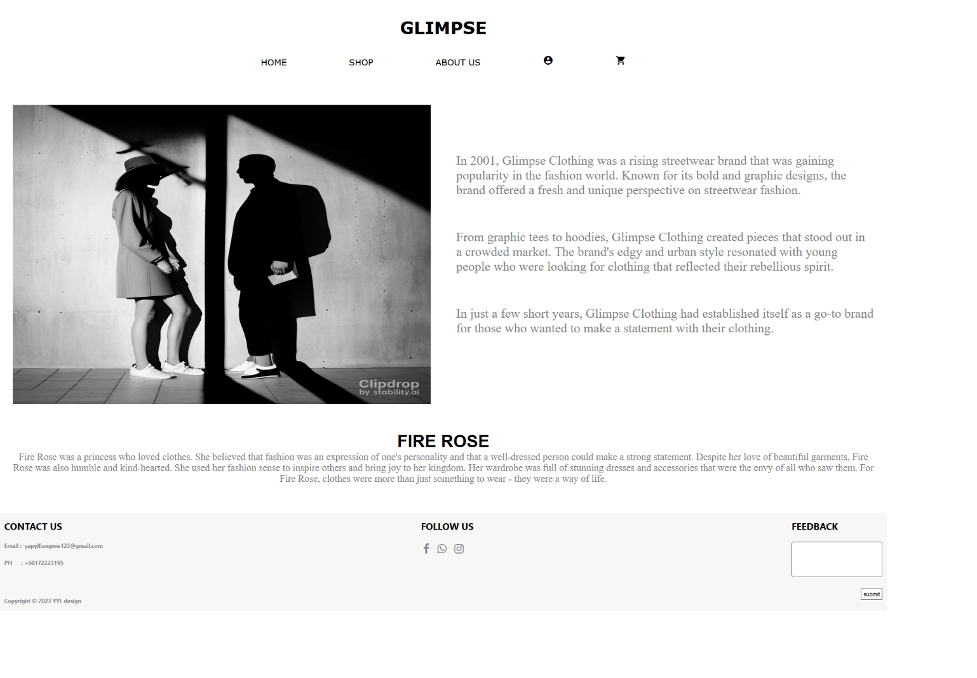 This is a page for the purpose of introducing our company's history and goals.

**Cart**

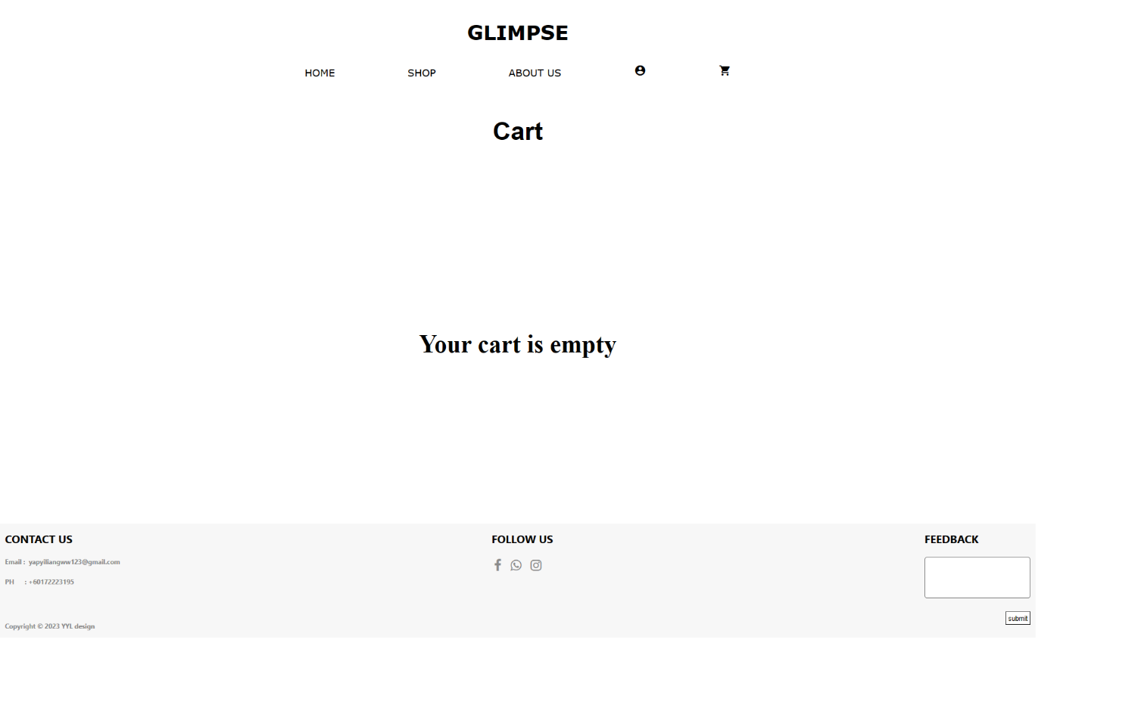 Cart is used to collect items that users want to buy. If the user has not logged in, the cart page will display "Your cart is empty". 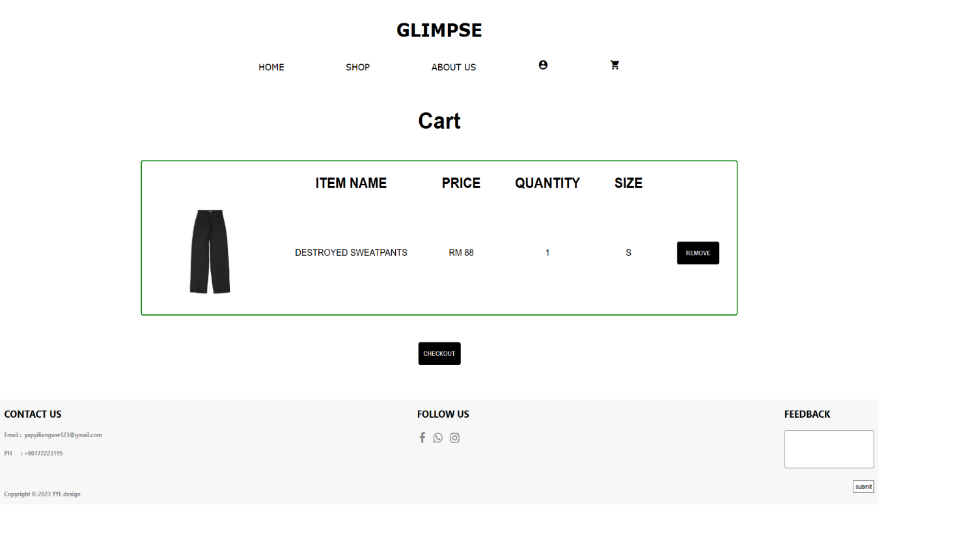 Instead, the user will be able to see the selected item in the cart after logging in. Click checkout to make payment.

**Login (User)**

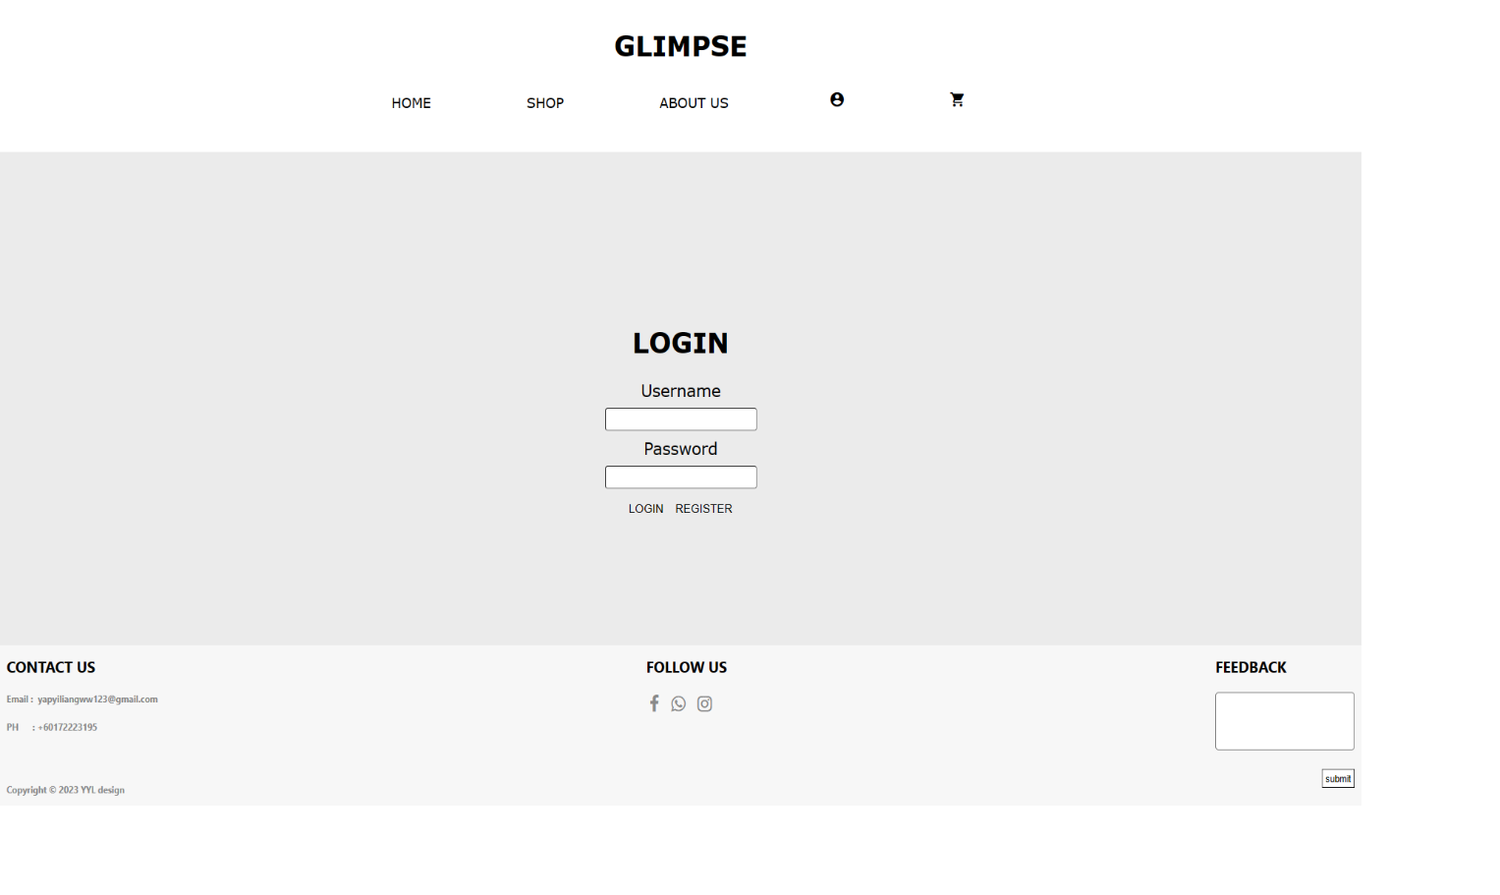 This is the page for users to log in. If the user does not have an account, they can click register to apply for an account.

**Register**

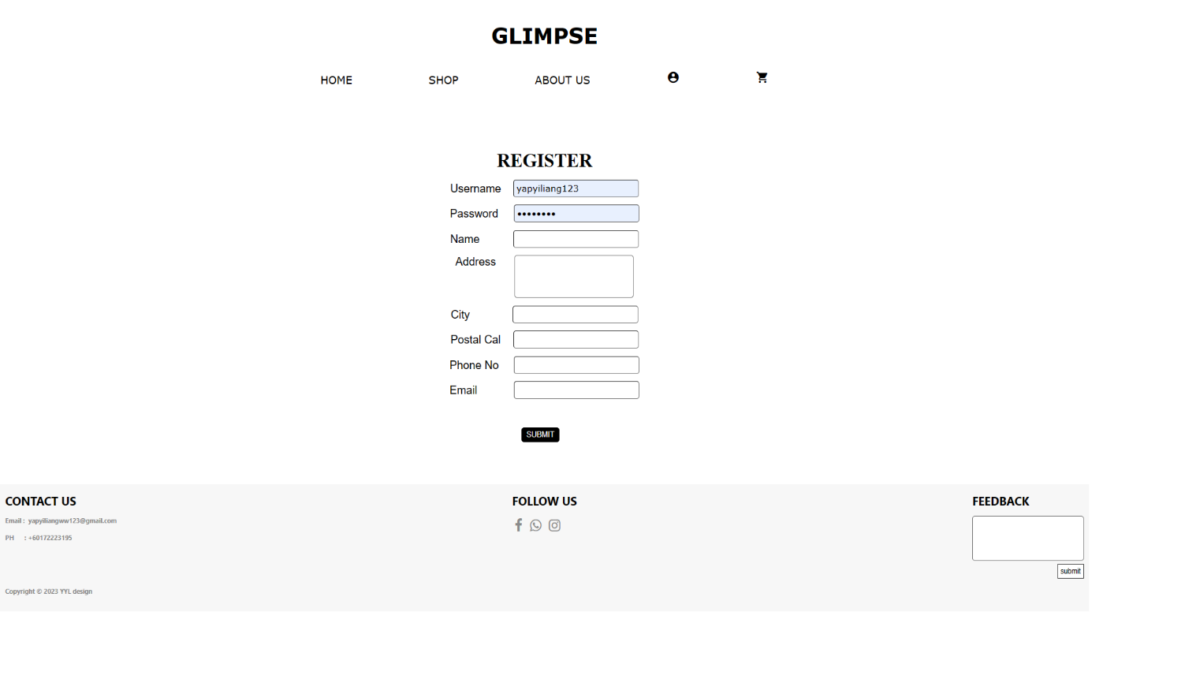 Users can apply for an account after filling in all the information.

**Edit Profile**

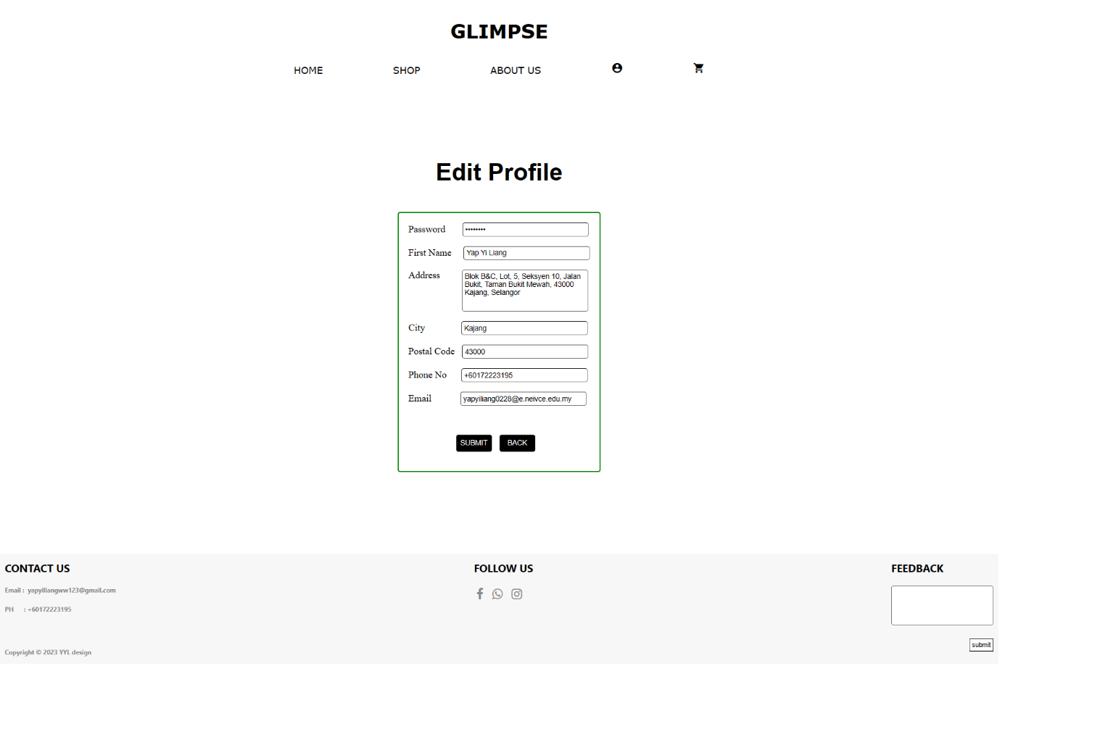 Users can change their personal information. After the modification is complete, click submit to update personal information or click back to return to the account page.

**Checkout**

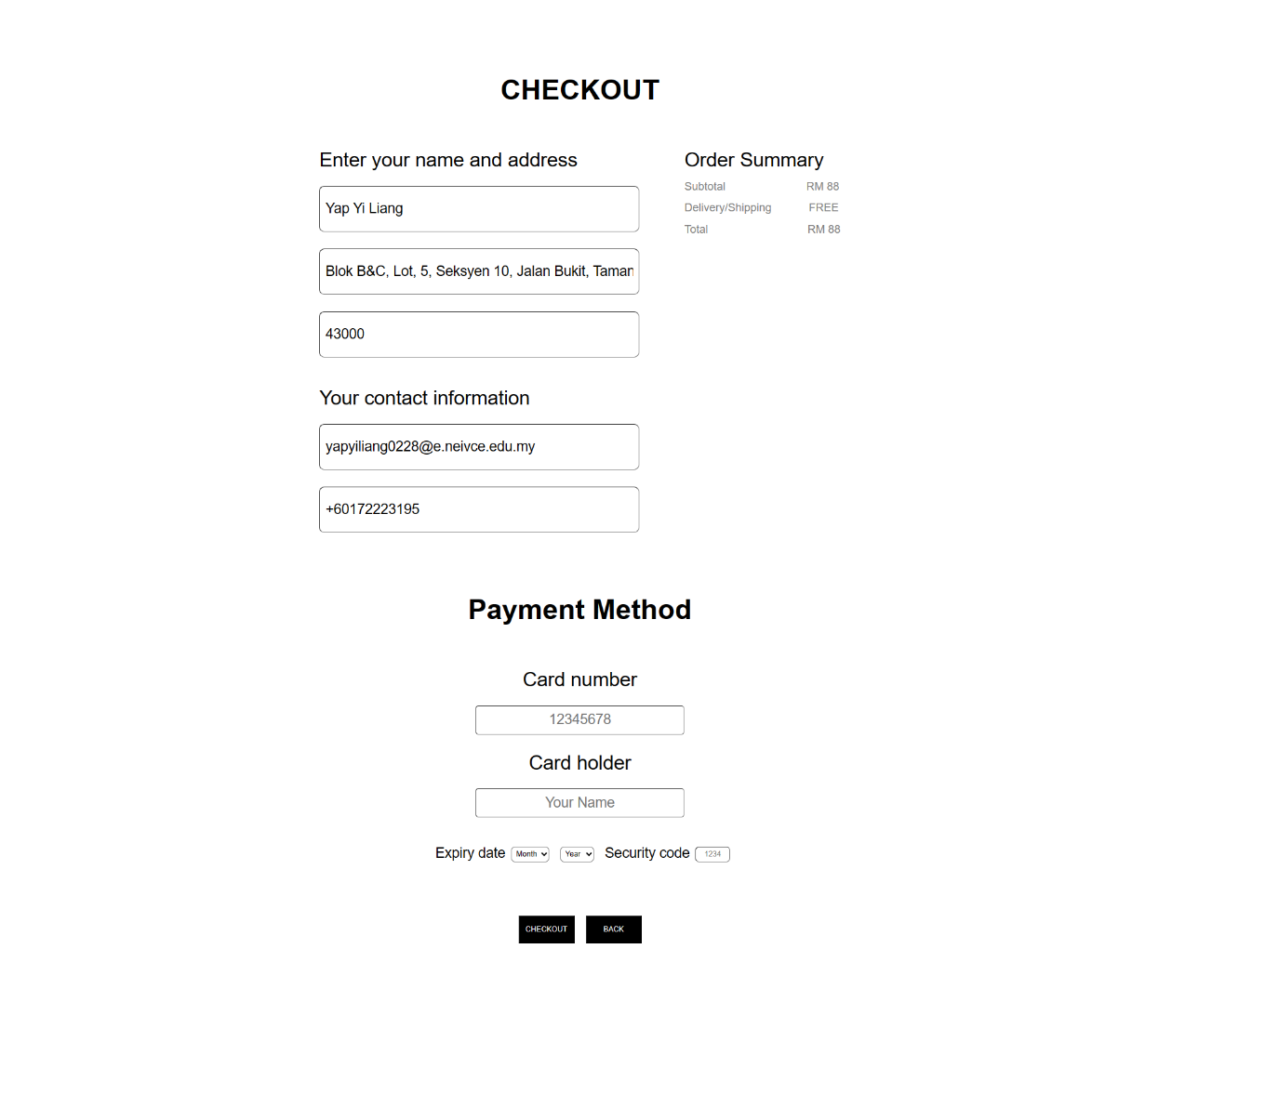 After filling in all the information, click checkout to complete the payment. Or click back to return to the cart page.

**Footer**

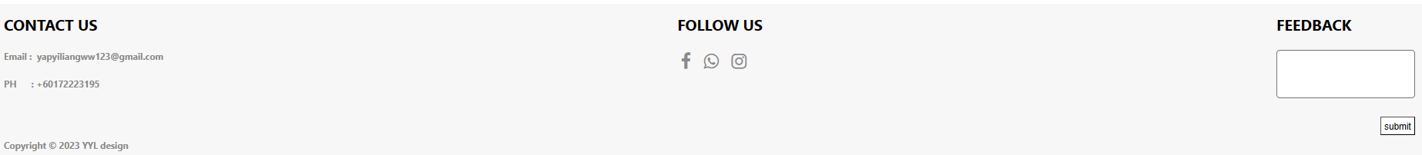

Footer has various contact methods and fills in feedback.

**Header**



The function of Header is navigation.

# **System Coding**

### 

### **Admin**

**fypAdmin.php**

<!DOCTYPE html>

<html>

<head>

<title>Admin Login</title>

<style type="text/css">

body {

display: flex;

justify-content: center;

align-items: center;

height: 100vh;

background-color: #241d33;

}

.form{

--angle: 0deg;

padding: 15px;

border: 1vmin solid;

border-image: conic-gradient(from var(--angle), red, yellow, lime, aqua, blue, magenta, red) 1;

animation: 10s rotate linear infinite;

width: 250px;

height: auto;

border-radius: 5px;

color: white;

}

@keyframes rotate {

to {

--angle: 360deg;

}

}

@property --angle {

syntax: '<angle>';

initial-value: 0deg;

inherits: false;

}

.username{

border-radius: 5px;

padding: 5px;

}

</style>

</head>

<body>

<?php

session_start();

include 'fypDatabase.php';

if (isset($_POST['login'])) {

if (empty($_POST['username']) || empty($_POST['password'])) {

echo '<script>alert("Fill in the Blank")</script>';

} else {

$username = $_POST['username'];

$password = $_POST['password'];

$sql = "SELECT * FROM account WHERE UserName ='$username' AND Password ='$password'";

$result = mysqli_query($mysqli, $sql);

if(mysqli_num_rows($result) == 1){

$row = mysqli_fetch_assoc($result);

$_SESSION['admin'] = $username;

header('location: fypAdminSalesRecord.php');

exit;

} else {

echo "<script>alert('Invalid username or password')</script>";

}

}

}

?>

<center>

<div class="form">

<h1 style="margin: 0px;margin-bottom: 10px;font-family: Arial;color: white;">Admin Login</h1>

<form method="post">

<label for="username">Username:</label>

<input type="text" id="username" name="username" required class="username"><br>

<br>

<label for="password">Password:</label>

<input type="password" id="password" name="password" required class="username"><br>

<br>

<input type="submit" name="login" value="Login">

</form>

</div>

</center>

</body>

</html>

**fypAdminSalesRecord.php**

<!DOCTYPE html>

<html>

<head>

<meta charset="utf-8">

<meta name="viewport" content="width=device-width, initial-scale=1">

<title>Sales Record</title>

<style type="text/css">

th{

padding: 10px;

border: 1px solid black;

}

td{

text-align: center;

padding: 10px;

border: 1px solid black;

}

.t{

font-size: 30px;

font-weight: bold;

}

a{

text-decoration: none;

color: black;

font-size: 20px;

font-family: 'GT America Extended Bold', sans-serif;

margin-left: 20px;

}

a:hover{

color: gray;

}

</style>

</head>

<body>

<center>

<br>

<br>

<a href="fypAdminSalesRecord.php">All Sales</a>

<a href="fypAdminSearch.php">Search By Condition</a>

<a href="fypEditItem.php">UPPER OUTER GARMENT

</a><a class='ww' href="fypEditItem2.php">THE TROUSERS</a>

<a href="fypUpload.php">Upload Image</a><a class='ww' href="fypEditAccount.php">Account</a><a class='ww' href="fypFeedback.php">Feedback</a><a class='ww' href="fypAdminLogout.php">LOGOUT</a>

<p class="t">Total Sales Record</p>

<?php

include 'fypDatabase.php';

session_start();

if (!isset($_SESSION['admin']) || $_SESSION['admin'] !== "admin" || empty($_SESSION['admin'])) {

header('Location: fypAdminLogin.php');

exit;

}

$sql = "SELECT * FROM salesrecord";

$result = $mysqli->query($sql);

$itemSales = 0;

$totalPrice = 0;

$totalRecord = 0;

if ($result->num_rows > 0) {

echo "<br>";

echo "<table>";

echo "<th>Sales ID</th><th>Customer ID</th><th>Item Name</th><th>Customer Name</th><th>Item Size</th><th>Item Quantity</th><th>Total Price</th><th>Address</th><th>City</th><th>Postal Code</th><th>Phone No</th><th>Email</th><th>date</th>";

// loop through each row of results and display it in a table row

while ($row = $result->fetch_assoc()) {

echo "<tr>";

echo '<td>'.$row["salesID"].'</td>';

echo '<td>'.$row["customerID"].'</td>';

echo '<td>'.$row["itemName"].'</td>';

echo '<td>'.$row["name"].'</td>';

echo '<td>'.$row["itemSuze"].'</td>';

echo '<td>'.$row["itemQuantity"].'</td>';

echo '<td>'.$row["totalPrice"].'</td>';

echo '<td>'.$row["Address"].'</td>';

echo '<td>'.$row["City"].'</td>';

echo '<td>'.$row["PostalCode"].'</td>';

echo '<td>'.$row["phNO"].'</td>';

echo '<td>'.$row["Email"].'</td>';

echo '<td>'.$row["date_added"].'</td>';

echo "</tr>";

$totalPrice += $row["totalPrice"];

$itemSales += $row["itemQuantity"];

$totalRecord += 1;

}

echo "</table>";

}

echo "<br>";

echo "Total Sales : $totalPrice &nbsp;&nbsp;&nbsp;&nbsp;";

echo "Item Sales : $itemSales&nbsp;&nbsp;&nbsp;&nbsp;";

echo "Toatal Record : $totalRecord";

?>

</body>

</html>

**fypAdminSearch.php**

<!DOCTYPE html>

<html>

<head>

<meta charset="utf-8">

<meta name="viewport" content="width=device-width, initial-scale=1">

<title>Sales Record</title>

<style type="text/css">

.p{

font-size: 30px;

font-weight: bold;

}

a{

text-decoration: none;

color: black;

font-size: 20px;

font-family: 'GT America Extended Bold', sans-serif;

margin-left: 20px;

}

a:hover{

color: gray;

}

.c{

margin-left: 20px;

text-transform: lowercase;

}

th{

padding: 10px;

border: 1px solid black;

}

td{

text-align: center;

padding: 10px;

border: 1px solid black;

}

</style>

</head>

<body>

<center>

<br>

<br>

<a href="fypAdminSalesRecord.php">All Sales</a>

<a href="fypAdminSearch.php">Search By Condition</a>

<a href="fypEditItem.php">UPPER OUTER GARMENT

</a><a class='ww' href="fypEditItem2.php">THE TROUSERS</a>

<a href="fypUpload.php">Upload Image</a><a class='ww' href="fypEditAccount.php">Account</a><a class='ww' href="fypFeedback.php">Feedback</a><a class='ww' href="fypAdminLogout.php">LOGOUT</a>

<p class="p">Search</p>

<div class="s">

<form method="post">

<p class="c" style="display: inline-block;">Item Name: &nbsp;<input type="text" name="itemName"></p>

<p class="c" style="display: inline-block;">Customer Name: &nbsp;<input type="text" name="customerName"></p>

<p class="c" style="display: inline-block;">Date: &nbsp;<input type="text" name="date" placeholder="YYYY-MM-DD"></p>&nbsp;&nbsp;&nbsp;

<input type="submit" name="submit" value="SEARCH">

</form>

</div>

<?php

include 'fypDatabase.php';

session_start();

if (!isset($_SESSION['admin']) || $_SESSION['admin'] !== "admin" || empty($_SESSION['admin'])) {

header('Location: fypAdminLogin.php');

exit;

}

if (isset($_POST['submit'])) {

$itemName = $_POST['itemName'];

$customerName = $_POST['customerName'];

$date = $_POST['date'];

$itemSales = 0;

$totalPrice = 0;

$totalRecord = 0;

if ($itemName != "" && $customerName=="" && $date=="") {

$sql = "SELECT * FROM salesrecord WHERE itemName = '$itemName'";

$result = $mysqli->query($sql);

if ($result->num_rows > 0) {

echo "<br>";

echo "<table>";

echo "<th>Sales ID</th><th>Customer ID</th><th>Item Name</th><th>Customer Name</th><th>Item Size</th><th>Item Quantity</th><th>Total Price</th><th>Address</th><th>City</th><th>Postal Code</th><th>Phone No</th><th>Email</th><th>date</th>";

// loop through each row of results and display it in a table row

while ($row = $result->fetch_assoc()) {

echo "<tr>";

echo '<td>'.$row["salesID"].'</td>';

echo '<td>'.$row["customerID"].'</td>';

echo '<td>'.$row["itemName"].'</td>';

echo '<td>'.$row["name"].'</td>';

echo '<td>'.$row["itemSuze"].'</td>';

echo '<td>'.$row["itemQuantity"].'</td>';

echo '<td>'.$row["totalPrice"].'</td>';

echo '<td>'.$row["Address"].'</td>';

echo '<td>'.$row["City"].'</td>';

echo '<td>'.$row["PostalCode"].'</td>';

echo '<td>'.$row["phNO"].'</td>';

echo '<td>'.$row["Email"].'</td>';

echo '<td>'.$row["date_added"].'</td>';

echo "</tr>";

$totalPrice += $row["totalPrice"];

$itemSales += $row["itemQuantity"];

$totalRecord ++;

}

echo "</table>";

}

echo "<br>";

echo "Total Sales : $totalPrice &nbsp;&nbsp;&nbsp;&nbsp;";

echo "Item Sales : $itemSales &nbsp;&nbsp;&nbsp;&nbsp;";

echo "Toatal Record : $totalRecord";

}

if ($customerName != "" && $itemName=="" && $date=="") {

$sql = "SELECT * FROM salesrecord WHERE name = '$customerName'";

$result = $mysqli->query($sql);

if ($result->num_rows > 0) {

echo "<br>";

echo "<table>";

echo "<th>Sales ID</th><th>Customer ID</th><th>Item Name</th><th>Customer Name</th><th>Item Size</th><th>Item Quantity</th><th>Total Price</th><th>Address</th><th>City</th><th>Postal Code</th><th>Phone No</th><th>Email</th><th>date</th>";

// loop through each row of results and display it in a table row

while ($row = $result->fetch_assoc()) {

echo "<tr>";

echo '<td>'.$row["salesID"].'</td>';

echo '<td>'.$row["customerID"].'</td>';

echo '<td>'.$row["itemName"].'</td>';

echo '<td>'.$row["name"].'</td>';

echo '<td>'.$row["itemSuze"].'</td>';

echo '<td>'.$row["itemQuantity"].'</td>';

echo '<td>'.$row["totalPrice"].'</td>';

echo '<td>'.$row["Address"].'</td>';

echo '<td>'.$row["City"].'</td>';

echo '<td>'.$row["PostalCode"].'</td>';

echo '<td>'.$row["phNO"].'</td>';

echo '<td>'.$row["Email"].'</td>';

echo '<td>'.$row["date_added"].'</td>';

echo "</tr>";

$totalPrice += $row["totalPrice"];

$itemSales += $row["itemQuantity"];

$totalRecord ++;

}

echo "</table>";

}

echo "<br>";

echo "Total Sales : $totalPrice &nbsp;&nbsp;&nbsp;&nbsp;";

echo "Item Sales : $itemSales&nbsp;&nbsp;&nbsp;&nbsp;";

echo "Toatal Record : $totalRecord";

}

if ($customerName == "" && $itemName=="" && $date!="") {

$sql = "SELECT * FROM salesrecord WHERE date_added = '$date'";

$result = $mysqli->query($sql);

if ($result->num_rows > 0) {

echo "<br>";

echo "<table>";

echo "<th>Sales ID</th><th>Customer ID</th><th>Item Name</th><th>Customer Name</th><th>Item Size</th><th>Item Quantity</th><th>Total Price</th><th>Address</th><th>City</th><th>Postal Code</th><th>Phone No</th><th>Email</th><th>date</th>";

// loop through each row of results and display it in a table row

while ($row = $result->fetch_assoc()) {

echo "<tr>";

echo '<td>'.$row["salesID"].'</td>';

echo '<td>'.$row["customerID"].'</td>';

echo '<td>'.$row["itemName"].'</td>';

echo '<td>'.$row["name"].'</td>';

echo '<td>'.$row["itemSuze"].'</td>';

echo '<td>'.$row["itemQuantity"].'</td>';

echo '<td>'.$row["totalPrice"].'</td>';

echo '<td>'.$row["Address"].'</td>';

echo '<td>'.$row["City"].'</td>';

echo '<td>'.$row["PostalCode"].'</td>';

echo '<td>'.$row["phNO"].'</td>';

echo '<td>'.$row["Email"].'</td>';

echo '<td>'.$row["date_added"].'</td>';

echo "</tr>";

$totalPrice += $row["totalPrice"];

$itemSales += $row["itemQuantity"];

$totalRecord ++;

}

echo "</table>";

}

echo "<br>";

echo "Total Sales : $totalPrice &nbsp;&nbsp;&nbsp;&nbsp;";

echo "Item Sales : $itemSales&nbsp;&nbsp;&nbsp;&nbsp;";

echo "Toatal Record : $totalRecord";

}

if ($itemName != "" && $customerName!="" && $date=="") {

$sql = "SELECT * FROM salesrecord WHERE itemName = '$itemName' AND name = '$customerName'";

$result = $mysqli->query($sql);

if ($result->num_rows > 0) {

echo "<br>";

echo "<table>";

echo "<th>Sales ID</th><th>Customer ID</th><th>Item Name</th><th>Customer Name</th><th>Item Size</th><th>Item Quantity</th><th>Total Price</th><th>Address</th><th>City</th><th>Postal Code</th><th>Phone No</th><th>Email</th><th>date</th>";

// loop through each row of results and display it in a table row

while ($row = $result->fetch_assoc()) {

echo "<tr>";

echo '<td>'.$row["salesID"].'</td>';

echo '<td>'.$row["customerID"].'</td>';

echo '<td>'.$row["itemName"].'</td>';

echo '<td>'.$row["name"].'</td>';

echo '<td>'.$row["itemSuze"].'</td>';

echo '<td>'.$row["itemQuantity"].'</td>';

echo '<td>'.$row["totalPrice"].'</td>';

echo '<td>'.$row["Address"].'</td>';

echo '<td>'.$row["City"].'</td>';

echo '<td>'.$row["PostalCode"].'</td>';

echo '<td>'.$row["phNO"].'</td>';

echo '<td>'.$row["Email"].'</td>';

echo '<td>'.$row["date_added"].'</td>';

echo "</tr>";

$totalPrice += $row["totalPrice"];

$itemSales += $row["itemQuantity"];

$totalRecord ++;

}

echo "</table>";

}

echo "<br>";

echo "Total Sales : $totalPrice &nbsp;&nbsp;&nbsp;&nbsp;";

echo "Item Sales : $itemSales&nbsp;&nbsp;&nbsp;&nbsp;";

echo "Toatal Record : $totalRecord";

}

if ($itemName != "" && $customerName=="" && $date!="") {

$sql = "SELECT * FROM salesrecord WHERE itemName = '$itemName' AND date_added = '$date'";

$result = $mysqli->query($sql);

if ($result->num_rows > 0) {

echo "<br>";

echo "<table>";

echo "<th>Sales ID</th><th>Customer ID</th><th>Item Name</th><th>Customer Name</th><th>Item Size</th><th>Item Quantity</th><th>Total Price</th><th>Address</th><th>City</th><th>Postal Code</th><th>Phone No</th><th>Email</th><th>date</th>";

// loop through each row of results and display it in a table row

while ($row = $result->fetch_assoc()) {

echo "<tr>";

echo '<td>'.$row["salesID"].'</td>';

echo '<td>'.$row["customerID"].'</td>';

echo '<td>'.$row["itemName"].'</td>';

echo '<td>'.$row["name"].'</td>';

echo '<td>'.$row["itemSuze"].'</td>';

echo '<td>'.$row["itemQuantity"].'</td>';

echo '<td>'.$row["totalPrice"].'</td>';

echo '<td>'.$row["Address"].'</td>';

echo '<td>'.$row["City"].'</td>';

echo '<td>'.$row["PostalCode"].'</td>';

echo '<td>'.$row["phNO"].'</td>';

echo '<td>'.$row["Email"].'</td>';

echo '<td>'.$row["date_added"].'</td>';

echo "</tr>";

$totalPrice += $row["totalPrice"];

$itemSales += $row["itemQuantity"];

$totalRecord ++;

}

echo "</table>";

}

echo "<br>";

echo "Total Sales : $totalPrice &nbsp;&nbsp;&nbsp;&nbsp;";

echo "Item Sales : $itemSales&nbsp;&nbsp;&nbsp;&nbsp;";

echo "Toatal Record : $totalRecord";

}

if ($itemName == "" && $customerName!="" && $date!="") {

$sql = "SELECT * FROM salesrecord WHERE name = '$customerName' AND date_added = '$date'";

$result = $mysqli->query($sql);

if ($result->num_rows > 0) {

echo "<br>";

echo "<table>";

echo "<th>Sales ID</th><th>Customer ID</th><th>Item Name</th><th>Customer Name</th><th>Item Size</th><th>Item Quantity</th><th>Total Price</th><th>Address</th><th>City</th><th>Postal Code</th><th>Phone No</th><th>Email</th><th>date</th>";

// loop through each row of results and display it in a table row

while ($row = $result->fetch_assoc()) {

echo "<tr>";

echo '<td>'.$row["salesID"].'</td>';

echo '<td>'.$row["customerID"].'</td>';

echo '<td>'.$row["itemName"].'</td>';

echo '<td>'.$row["name"].'</td>';

echo '<td>'.$row["itemSuze"].'</td>';

echo '<td>'.$row["itemQuantity"].'</td>';

echo '<td>'.$row["totalPrice"].'</td>';

echo '<td>'.$row["Address"].'</td>';

echo '<td>'.$row["City"].'</td>';

echo '<td>'.$row["PostalCode"].'</td>';

echo '<td>'.$row["phNO"].'</td>';

echo '<td>'.$row["Email"].'</td>';

echo '<td>'.$row["date_added"].'</td>';

echo "</tr>";

$totalPrice += $row["totalPrice"];

$itemSales += $row["itemQuantity"];

$totalRecord ++;

}

echo "</table>";

}

echo "<br>";

echo "Total Sales : $totalPrice &nbsp;&nbsp;&nbsp;&nbsp;";

echo "Item Sales : $itemSales&nbsp;&nbsp;&nbsp;&nbsp;";

echo "Toatal Record : $totalRecord";

}

if ($itemName != "" && $customerName!="" && $date!="") {

$sql = "SELECT * FROM salesrecord WHERE itemName = '$itemName' AND date_added = '$date' AND name = '$customerName'";

$result = $mysqli->query($sql);

if ($result->num_rows > 0) {

echo "<br>";

echo "<table>";

echo "<th>Sales ID</th><th>Customer ID</th><th>Item Name</th><th>Customer Name</th><th>Item Size</th><th>Item Quantity</th><th>Total Price</th><th>Address</th><th>City</th><th>Postal Code</th><th>Phone No</th><th>Email</th><th>date</th>";

// loop through each row of results and display it in a table row

while ($row = $result->fetch_assoc()) {

echo "<tr>";

echo '<td>'.$row["salesID"].'</td>';

echo '<td>'.$row["customerID"].'</td>';

echo '<td>'.$row["itemName"].'</td>';

echo '<td>'.$row["name"].'</td>';

echo '<td>'.$row["itemSuze"].'</td>';

echo '<td>'.$row["itemQuantity"].'</td>';

echo '<td>'.$row["totalPrice"].'</td>';

echo '<td>'.$row["Address"].'</td>';

echo '<td>'.$row["City"].'</td>';

echo '<td>'.$row["PostalCode"].'</td>';

echo '<td>'.$row["phNO"].'</td>';

echo '<td>'.$row["Email"].'</td>';

echo '<td>'.$row["date_added"].'</td>';

echo "</tr>";

$totalPrice += $row["totalPrice"];

$itemSales += $row["itemQuantity"];

$totalRecord ++;

}

echo "</table>";

}

echo "<br>";

echo "Total Sales : $totalPrice &nbsp;&nbsp;&nbsp;&nbsp;";

echo "Item Sales : $itemSales&nbsp;&nbsp;&nbsp;&nbsp;";

echo "Toatal Record : $totalRecord";

}

}

?>

</center>

</body>

</html>

**fypEditItem.php**

<!DOCTYPE html>

<html>

<head>

<meta charset="utf-8">

<meta name="viewport" content="width=device-width, initial-scale=1">

<title>UPPER OUTER GARMENT

</title>

<style type="text/css">

.ww{

text-decoration: none;

color: black;

font-size: 20px;

font-family: 'GT America Extended Bold', sans-serif;

margin-left: 20px;

}

.ww:hover{

color: gray;

}

.p{

font-size: 30px;

font-weight: bold;

}

.adduog{

text-decoration: none;

font-size: 12px;

color: black;

}

.adduog:hover{

color: gray;

}

</style>

</head>

<body>

<center>

<br>

<br>

<a class='ww' href="fypAdminSalesRecord.php">All Sales</a>

<a class='ww' href="fypAdminSearch.php">Search By Condition</a>

<a class='ww' href="fypEditItem.php">UPPER OUTER GARMENT</a>

<a class='ww' href="fypEditItem2.php">THE TROUSERS</a>

<a class='ww' href="fypUpload.php">Upload Image</a><a class='ww' href="fypEditAccount.php">Account</a><a class='ww' href="fypFeedback.php">Feedback</a><a class='ww' href="fypAdminLogout.php">LOGOUT</a>

<p class="p">UPPER OUTER GARMENT

</p>

<a class="adduog" href="fypAddUog.php">Add item(UPPER OUTER GARMENT)</a>

<div class="s">

<?php

include 'fypDatabase.php';

session_start();

if (!isset($_SESSION['admin']) || $_SESSION['admin'] !== "admin" || empty($_SESSION['admin'])) {

header('Location: fypAdminLogin.php');

exit;

}

$sql = "SELECT * FROM item ";

$result = $mysqli->query($sql);

if ($result->num_rows > 0) {

echo "<br>";

echo "<form method='post' action='fypEdit.php'>";

echo "<table>";

echo "<th>item ID</th><th>Item Name</th><th>Item Price</th><th>Item Pic</th><th>Item Size</th><th>Select</th>";

while ($row = $result->fetch_assoc()) {

echo "<tr>";

echo '<input type="hidden" name="itemID_'.$row["itemID"].'" value="'.$row["itemID"].'">';

echo '<td>'.$row["itemID"].'</td>';

echo '<td>'.$row["itemName"].'</td>';

echo '<td>'.$row["itemPrice"].'</td>';

echo '<td>'.$row["itemPic"].'</td>';

echo '<td>'.$row["itemSize"].'</td>';

echo '<td><input type="submit" name="itemID_SELECT" value="'.$row["itemID"].'"></td>';

echo "</tr>";

}

echo "</table>";

echo "</form>";

}

?>

</div>

</center>

</body>

</html>

**fypAddUog.php**

<!DOCTYPE html>

<html>

<head>

<meta charset="utf-8">

<meta name="viewport" content="width=device-width, initial-scale=1">

<title>ADD UPPER OUTER GARMENT

</title>

<style type="text/css">

.ww{

text-decoration: none;

color: black;

font-size: 20px;

font-family: 'GT America Extended Bold', sans-serif;

margin-left: 20px;

}

.ww:hover{

color: gray;

}

.p{

font-size: 30px;

font-weight: bold;

}

.adduog{

text-decoration: none;

font-size: 12px;

color: black;

}

.adduog:hover{

color: gray;

}

</style>

</head>

<body>

<center>

<br>

<br>

<a class='ww' href="fypAdminSalesRecord.php">All Sales</a>

<a class='ww' href="fypAdminSearch.php">Search By Condition</a>

<a class='ww' href="fypEditItem.php">UPPER OUTER GARMENT

</a>

<a class='ww' href="fypEditItem2.php">THE TROUSERS</a>

<a class='ww' href="fypUpload.php">Upload Image</a>

<a class='ww' href="fypEditAccount.php">Account</a><a class='ww' href="fypFeedback.php">Feedback</a><a class='ww' href="fypAdminLogout.php">LOGOUT</a>

<p class="p">UPPER OUTER GARMENT</p>

<form method="post" enctype="multipart/form-data">

<p>Item Name: <input type="text" name="itemName"></p>

<p>Item Price: <input type="text" name="itemPrice"></p>

<p>Item Pic(xxx.png/xxx.jpeg): <input type='file' name='itemPic'></p>

<p class='size'>Size &nbsp;&nbsp;&nbsp;&nbsp;:&nbsp; <select name='itemSize' class='select'><option value='S'>S</option><option value='M'>M</option><option value='L'>L</option><option value='S,M'>S,M</option><option value='S,M,L'>S,M,L</option><option value='M,L'>M,L</option><option value='S,L'>S,L</option></select></p>

<input type="submit" name="submit" value="ADD">

</form>

<?php

include 'fypDatabase.php';

session_start();

if (!isset($_SESSION['admin']) || $_SESSION['admin'] !== "admin" || empty($_SESSION['admin'])) {

header('Location: fypAdminLogin.php');

exit;

}

if (isset($_POST['submit'])) {

$itemName = $_POST['itemName'];

$itemPrice = $_POST['itemPrice'];

$ipc_name = $_FILES['itemPic']['name'];

$ipc = "$ipc_name";

$itemSize = $_POST['itemSize'];

$sql = "INSERT INTO item (itemName, itemPrice,itemQuantity, itemPic,itemSize) VALUES ('$itemName','$itemPrice',100,'$ipc','$itemSize')

";

if (mysqli_query($mysqli, $sql)) {

echo "New record created successfully";

} else {

echo "Error: " . $sql . "<br>" . mysqli_error($mysqli);

}

// Close database connection

mysqli_close($mysqli);

header('Location: fypAddUog.php');

}

?>

</center>

</body>

</html>

**fypEdit.php**

<!DOCTYPE html>

<html>

<head>

<meta charset="utf-8">

<meta name="viewport" content="width=device-width, initial-scale=1">

<title>Edit UPPER OUTER GARMENT

</title>

<style type="text/css">

a{

text-decoration: none;

color: black;

font-size: 20px;

font-family: 'GT America Extended Bold', sans-serif;

margin-left: 20px;

}

a:hover{

color: gray;

}

</style>

</head>

<body>

<?php

include 'fypDatabase.php';

// Check if the form has been submitted and an item has been selected

if (isset($_POST['itemID_SELECT'])) {

$selected_item_id = $_POST['itemID_SELECT'];

// Query the database for the selected item

$sql = "SELECT * FROM item WHERE itemID = '$selected_item_id'";

$result = $mysqli->query($sql);

// If the query returned a result, display the item details

if ($result->num_rows > 0) {

$row = $result->fetch_assoc();

echo "<br>";

echo "<table>";

echo "<th>item ID</th><th>Item Name</th><th>Item Price</th><th>Item Pic</th>";

echo "<tr>";

echo '<td>'.$row["itemID"].'</td>';

echo '<td>'.$row["itemName"].'</td>';

echo '<td>'.$row["itemPrice"].'</td>';

echo '<td>'.$row["itemPic"].'</td>';

echo "</tr>";

echo "</table>";

// Display the edit form for the selected item

echo "<p>Edit item</p>";

echo '<form method="post" enctype="multipart/form-data">';

echo "<input type='hidden' name='id' value=".$row['itemID'].">";

echo "<p>Item Name : <input type='input' name='itemName' value='".$row['itemName']."'></p>";

echo "<p>Item Price : <input type='input' name='itemPrice' value=".$row['itemPrice']."></p>";

echo "<p>NOTE: The uploaded photo must have the same name as the item pic.(xxx.png/xxx.jpg) and must select img before update.</p>";

echo "<p>Item Pic : <input type='file' name='itemPic' value=".$row['itemPic']."></p>";

echo "<p class='size'>Size&nbsp;&nbsp;&nbsp;&nbsp;:&nbsp; <select name='itemSize' class='select'>

<option value='S'>S</option>

<option value='M'>M</option>

<option value='L'>L</option>

<option value='S,M'>S,M</option>

<option value='S,M,L'>S,M,L</option>

<option value='M,L'>M,L</option>

<option value='S,L'>S,L</option>

</select></p>";

echo "<br>";

echo "<br>";

echo '<input type="submit" value="UPDATE" name="ok">';

echo "<input type='submit' value='BACK' name='back'>";

echo "<input type='submit' value='DELETE' name='delete'>";

echo "</form>";

} else {

echo "No item with that ID was found.";

}

}

// Handle the form submission to update the item

if (isset($_POST['ok'])) {

$id = $_POST['id'];

$in = $_POST['itemName'];

$ip = $_POST['itemPrice'];

$ipc_name = $_FILES['itemPic']['name'];

$itemSize = $_POST['itemSize'];

$ipc = "$ipc_name";

$sql = "UPDATE item SET itemName = '$in', itemPrice = '$ip', itemPic = '$ipc', itemSize = '$itemSize' WHERE itemID = '$id'";

$result = $mysqli->query($sql);

echo "<script>alert('UPDATE SUCCESSFULLY')</script>";

header('Location: fypEditItem.php');

}

// Handle the form submission to go back to the item selection page

if (isset($_POST['back'])) {

header('Location: fypEditItem.php');

}

if (isset($_POST['delete'])) {

$id = $_POST['id'];

$sql = "DELETE FROM item WHERE itemID = '$id'";

$result = $mysqli->query($sql);

echo "<script>alert('DELETE SUCCESSFULLY')</script>";

header('Location: fypEditItem.php');

}

?>

</body>

</html>

**fypEditItem2.php**

<!DOCTYPE html>

<html>

<head>

<meta charset="utf-8">

<meta name="viewport" content="width=device-width, initial-scale=1">

<title>UPPER OUTER GARMENT

</title>

<style type="text/css">

.ww{

text-decoration: none;

color: black;

font-size: 20px;

font-family: 'GT America Extended Bold', sans-serif;

margin-left: 20px;

}

.ww:hover{

color: gray;

}

.p{

font-size: 30px;

font-weight: bold;

}

.adduog{

text-decoration: none;

font-size: 12px;

color: black;

}

.adduog:hover{

color: gray;

}

</style>

</head>

<body>

<center>

<br>

<br>

<a class='ww' href="fypAdminSalesRecord.php">All Sales</a>

<a class='ww' href="fypAdminSearch.php">Search By Condition</a>

<a class='ww' href="fypEditItem.php">UPPER OUTER GARMENT</a>

<a class='ww' href="fypEditItem2.php">THE TROUSERS</a>

<a class='ww' href="fypUpload.php">Upload Image</a>

<a class='ww' href="fypEditAccount.php">Account</a><a class='ww' href="fypFeedback.php">Feedback</a><a class='ww' href="fypAdminLogout.php">LOGOUT</a>

<p class="p">THE TROUSERS

</p>

<a class="adduog" href="fypAddTT.php">Add item(THE TROUSERS)</a>

<div class="s">

<?php

include 'fypDatabase.php';

session_start();

if (!isset($_SESSION['admin']) || $_SESSION['admin'] !== "admin" || empty($_SESSION['admin'])) {

header('Location: fypAdminLogin.php');

exit;

}

$sql = "SELECT * FROM item2 ";

$result = $mysqli->query($sql);

if ($result->num_rows > 0) {

echo "<br>";

echo "<form method='post' action='fypEdit2.php'>";

echo "<table>";

echo "<th>item ID</th><th>Item Name</th><th>Item Price</th><th>Item Pic</th><th>Item Size</th><th>Select</th>";

while ($row = $result->fetch_assoc()) {

echo "<tr>";

echo '<input type="hidden" name="itemID_'.$row["itemID"].'" value="'.$row["itemID"].'">';

echo '<td>'.$row["itemID"].'</td>';

echo '<td>'.$row["itemName"].'</td>';

echo '<td>'.$row["itemPrice"].'</td>';

echo '<td>'.$row["itemPic"].'</td>';

echo '<td>'.$row["itemSize"].'</td>';

echo '<td><input type="submit" name="itemID_SELECT" value="'.$row["itemID"].'"></td>';

echo "</tr>";

}

echo "</table>";

echo "</form>";

}

?>

</div>

</center>

</body>

</html>

**fypAddTT.php**

<!DOCTYPE html>

<html>

<head>

<meta charset="utf-8">

<meta name="viewport" content="width=device-width, initial-scale=1">

<title>ADD UPPER OUTER GARMENT

</title>

<style type="text/css">

.ww{

text-decoration: none;

color: black;

font-size: 20px;

font-family: 'GT America Extended Bold', sans-serif;

margin-left: 20px;

}

.ww:hover{

color: gray;

}

.p{

font-size: 30px;

font-weight: bold;

}

.adduog{

text-decoration: none;

font-size: 12px;

color: black;

}

.adduog:hover{

color: gray;

}

</style>

</head>

<body>

<center>

<br>

<br>

<a class='ww' href="fypAdminSalesRecord.php">All Sales</a>

<a class='ww' href="fypAdminSearch.php">Search By Condition</a>

<a class='ww' href="fypEditItem.php">UPPER OUTER GARMENT

</a>

<a class='ww' href="fypEditItem2.php">THE TROUSERS</a>

<a class='ww' href="fypUpload.php">Upload Image</a>

<a class='ww' href="fypEditAccount.php">Account</a><a class='ww' href="fypFeedback.php">Feedback</a><a class='ww' href="fypAdminLogout.php">LOGOUT</a>

<p class="p">THE TROUSERS</p>

<form method="post" enctype="multipart/form-data">

<p>Item Name: <input type="text" name="itemName"></p>

<p>Item Price: <input type="text" name="itemPrice"></p>

<p>Item Pic(xxx.png/xxx.jpeg): <input type='file' name='itemPic'></p>

<p class='size'>Size &nbsp;&nbsp;&nbsp;&nbsp;:&nbsp; <select name='itemSize' class='select'><option value='S'>S</option><option value='M'>M</option><option value='L'>L</option><option value='S,M'>S,M</option><option value='S,M,L'>S,M,L</option><option value='M,L'>M,L</option><option value='S,L'>S,L</option></select></p>

<input type="submit" name="submit" value="ADD">

</form>

<?php

include 'fypDatabase.php';

session_start();

if (!isset($_SESSION['admin']) || $_SESSION['admin'] !== "admin" || empty($_SESSION['admin'])) {

header('Location: fypAdminLogin.php');

exit;

}

if (isset($_POST['submit'])) {

$itemName = $_POST['itemName'];

$itemPrice = $_POST['itemPrice'];

$ipc_name = $_FILES['itemPic']['name'];

$ipc = "$ipc_name";

$itemSize = $_POST['itemSize'];

$sql = "INSERT INTO item2 (itemName, itemPrice,itemQuantity, itemPic,itemSize) VALUES ('$itemName','$itemPrice',100,'$ipc','$itemSize')

";

if (mysqli_query($mysqli, $sql)) {

echo "New record created successfully";

} else {

echo "Error: " . $sql . "<br>" . mysqli_error($mysqli);

}

// Close database connection

mysqli_close($mysqli);

header('Location: fypAddTT.php');

}

?>

</center>

</body>

</html>

**fypEdit2.php**

<!DOCTYPE html>

<html>

<head>

<meta charset="utf-8">

<meta name="viewport" content="width=device-width, initial-scale=1">

<title>Edit UPPER OUTER GARMENT

</title>

<style type="text/css">

a{

text-decoration: none;

color: black;

font-size: 20px;

font-family: 'GT America Extended Bold', sans-serif;

margin-left: 20px;

}

a:hover{

color: gray;

}

</style>

</head>

<body>

<?php

include 'fypDatabase.php';

session_start();

if (!isset($_SESSION['admin']) || $_SESSION['admin'] !== "admin" || empty($_SESSION['admin'])) {

header('Location: fypAdminLogin.php');

exit;

}

if (isset($_POST['itemID_SELECT'])) {

$selected_item_id = $_POST['itemID_SELECT'];

$sql = "SELECT * FROM item2 WHERE itemID = '$selected_item_id'";

$result = $mysqli->query($sql);

if ($result->num_rows > 0) {

$row = $result->fetch_assoc();

echo "<br>";

echo "<table>";

echo "<th>item ID</th><th>Item Name</th><th>Item Price</th><th>Item Pic</th>";

echo "<tr>";

echo '<td>'.$row["itemID"].'</td>';

echo '<td>'.$row["itemName"].'</td>';

echo '<td>'.$row["itemPrice"].'</td>';

echo '<td>'.$row["itemPic"].'</td>';

echo "</tr>";

echo "</table>";

// Display the edit form for the selected item

echo "<p>Edit item</p>";

echo '<form method="post" enctype="multipart/form-data">';

echo "<input type='hidden' name='id' value=".$row['itemID'].">";

echo "<p>Item Name : <input type='input' name='itemName' value='".$row['itemName']."'></p>";

echo "<p>Item Price : <input type='input' name='itemPrice' value=".$row['itemPrice']."></p>";

echo "<p>NOTE: The uploaded photo must have the same name as the item pic.(xxx.png/xxx.jpg) and must select img before update.</p>";

echo "<p>Item Pic : <input type='file' name='itemPic' value=".$row['itemPic']."></p>";

echo "<p class='size'>Size&nbsp;&nbsp;&nbsp;&nbsp;:&nbsp; <select name='itemSize' class='select'>

<option value='S'>S</option>

<option value='M'>M</option>

<option value='L'>L</option>

<option value='S,M'>S,M</option>

<option value='S,M,L'>S,M,L</option>

<option value='M,L'>M,L</option>

<option value='S,L'>S,L</option>

</select></p>";

echo "<br>";

echo "<br>";

echo '<input type="submit" value="UPDATE" name="ok">';

echo "<input type='submit' value='BACK' name='back'>";

echo "<input type='submit' value='DELETE' name='delete'>";

echo "</form>";

} else {

echo "No item with that ID was found.";

}

}

// Handle the form submission to update the item

if (isset($_POST['ok'])) {

$id = $_POST['id'];

$in = $_POST['itemName'];

$ip = $_POST['itemPrice'];

$ipc_name = $_FILES['itemPic']['name'];

$ipc = "$ipc_name";

$itemSize = $_POST['itemSize'];

$sql = "UPDATE item2 SET itemName = '$in', itemPrice = '$ip', itemPic = '$ipc', itemSize = '$itemSize' WHERE itemID = '$id'";

$result = $mysqli->query($sql);

echo "<script>alert('UPDATE SUCCESSFULLY')</script>";

header('Location: fypEditItem2.php');

}

// Handle the form submission to go back to the item selection page

if (isset($_POST['back'])) {

header('Location: fypEditItem2.php');

}

if (isset($_POST['delete'])) {

$id = $_POST['id'];

$sql = "DELETE FROM item2 WHERE itemID = '$id'";

$result = $mysqli->query($sql);

echo "<script>alert('DELETE SUCCESSFULLY')</script>";

header('Location: fypEditItem2.php');

}

?>

</body>

</html>

**fypUpload.php**

<!DOCTYPE html>

<html>

<head>

<meta charset="utf-8">

<meta name="viewport" content="width=device-width, initial-scale=1">

<title>Upload Picture</title>

<style type="text/css">

a{

text-decoration: none;

color: black;

font-size: 20px;

font-family: 'GT America Extended Bold', sans-serif;

margin-left: 20px;

}

a:hover{

color: gray;

}

.p{

font-size: 30px;

font-weight: bold;

}

</style>

</head>

<body>

<center>

<br>

<br>

<a href="fypAdminSalesRecord.php">All Sales</a>

<a href="fypAdminSearch.php">Search By Condition</a>

<a href="fypEditItem.php">UPPER OUTER GARMENT

</a><a class='ww' href="fypEditItem2.php">THE TROUSERS</a>

<a class='ww' href="fypEditAccount.php">Account</a><a class='ww' href="fypFeedback.php">Feedback</a>

<a href="fypUpload.php">Upload Image</a><a class='ww' href="fypEditAccount.php">Logout</a>

<form method="post" enctype="multipart/form-data">

<p class="p">Upload Image</p>

<input type="file" name="fileToUpload" id="fileToUpload">

<br>

<br>

<input type="submit" name="submit" value="UPLOAD">

</form>

</center>

</body>

</html>

<?php

include'fypDatabase.php';

session_start();

if (!isset($_SESSION['admin']) || $_SESSION['admin'] !== "admin" || empty($_SESSION['admin'])) {

header('Location: fypAdminLogin.php');

exit;

}

if (isset($_POST['submit'])) {

$target_dir = "images/";

$target_file = $target_dir . basename($_FILES["fileToUpload"]["name"]);

$uploadOk = 1;

$imageFileType = strtolower(pathinfo($target_file,PATHINFO_EXTENSION));

if(isset($_POST["submit"])) {

$check = getimagesize($_FILES["fileToUpload"]["tmp_name"]);

if($check !== false) {

echo "File is an image - " . $check["mime"] . ".";

$uploadOk = 1;

} else {

echo "File is not an image.";

$uploadOk = 0;

}

}

if (file_exists($target_file)) {

echo "Sorry, file already exists.";

$uploadOk = 0;

}

if ($_FILES["fileToUpload"]["size"] > 100000000) {

echo "Sorry, your file is too large.";

$uploadOk = 0;

}

if($imageFileType != "jpg" && $imageFileType != "png" && $imageFileType != "jpeg"

&& $imageFileType != "gif" ) {

echo "Sorry, only JPG, JPEG, PNG & GIF files are allowed.";

$uploadOk = 0;

}

if ($uploadOk == 0) {

echo "Sorry, your file was not uploaded.";

} else {

if (move_uploaded_file($_FILES["fileToUpload"]["tmp_name"], $target_file)) {

echo "The file ". basename( $_FILES["fileToUpload"]["name"]). " has been uploaded.";

} else {

echo "Sorry, there was an error uploading your file.";

}

}

header("Location: fypUpload.php");

}

?>

**fypEditAccount.php**

<!DOCTYPE html>

<html>

<head>

<meta charset="utf-8">

<meta name="viewport" content="width=device-width, initial-scale=1">

<title>Edit Account

</title>

<style type="text/css">

th{

padding: 10px;

border: 1px solid black;

}

td{

text-align: center;

padding: 10px;

border: 1px solid black;

}

.t{

font-size: 30px;

font-weight: bold;

}

a{

text-decoration: none;

color: black;

font-size: 20px;

font-family: 'GT America Extended Bold', sans-serif;

margin-left: 20px;

}

a:hover{

color: gray;

}

.p{

font-size: 30px;

font-weight: bold;

}

</style>

</head>

<body>

<center>

<br>

<br>

<a class='ww' href="fypAdminSalesRecord.php">All Sales</a>

<a class='ww' href="fypAdminSearch.php">Search By Condition</a>

<a class='ww' href="fypEditItem.php">UPPER OUTER GARMENT</a>

<a class='ww' href="fypEditItem2.php">THE TROUSERS</a>

<a class='ww' href="fypUpload.php">Upload Image</a>

<a class='ww' href="fypEditAccount.php">Account</a><a class='ww' href="fypFeedback.php">Feedback</a>

<a class='ww' href="fypAdminLogout.php">LOGOUT</a>

<p class="p">Edit Account

</p>

<div class="s">

<?php

include 'fypDatabase.php';

session_start();

if (!isset($_SESSION['admin']) || $_SESSION['admin'] !== "admin" || empty($_SESSION['admin'])) {

header('Location: fypAdminLogin.php');

exit;

}

if (isset($_POST['delete'])) {

$delete = $_POST['delete'];

$sql = "DELETE FROM account WHERE customerID='$delete'";

$result = $mysqli->query($sql);

}

$sql = "SELECT * FROM account";

$result = $mysqli->query($sql);

if ($result->num_rows > 0) {

echo "<br>";

echo "<table>";

echo "<form method='post'>";

echo "<th>CustomerID</th><th>UserName</th><th>Password</th><th>Name</th><th>Address</th><th>City</th><th>PostalCode</th><th>Phone No</th><th>Email</th><th>Delete</th>";

// loop through each row of results and display it in a table row

while ($row = $result->fetch_assoc()) {

echo "<tr>";

echo '<td>'.$row["customerID"].'</td>';

echo '<td>'.$row["UserName"].'</td>';

echo '<td>'.$row["Password"].'</td>';

echo '<td>'.$row["FirstName"].'</td>';

echo '<td>'.$row["Address"].'</td>';

echo '<td>'.$row["City"].'</td>';

echo '<td>'.$row["PostalCode"].'</td>';

echo '<td>'.$row["phNO"].'</td>';

echo '<td>'.$row["Email"].'</td>';

echo '<td><input type="submit" name="delete" value="'.$row["customerID"].'"></td>';

echo "</tr>";

}

echo "</table>";

echo "</form>";

}

echo "<br>";

?>

</div>

</center>

</body>

</html>

**fypFeedback.php**

<!DOCTYPE html>

<html>

<head>

<meta charset="utf-8">

<meta name="viewport" content="width=device-width, initial-scale=1">

<title>Feedback</title>

<style type="text/css">

th{

padding: 10px;

border: 1px solid black;

}

td{

text-align: center;

padding: 10px;

border: 1px solid black;

}

.t{

font-size: 30px;

font-weight: bold;

}

a{

text-decoration: none;

color: black;

font-size: 20px;

font-family: 'GT America Extended Bold', sans-serif;

margin-left: 20px;

}

a:hover{

color: gray;

}

</style>

</head>

<body>

<center>

<br>

<br>

<a href="fypAdminSalesRecord.php">All Sales</a>

<a href="fypAdminSearch.php">Search By Condition</a>

<a href="fypEditItem.php">UPPER OUTER GARMENT

</a><a class='ww' href="fypEditItem2.php">THE TROUSERS</a>

<a href="fypUpload.php">Upload Image</a><a class='ww' href="fypEditAccount.php">Account</a><a class='ww' href="fypFeedback.php">Feedback</a><a class='ww' href="fypAdminLogout.php">LOGOUT</a>

<p class="t">Feedback</p>

<?php

include 'fypDatabase.php';

session_start();

if (!isset($_SESSION['admin']) || $_SESSION['admin'] !== "admin" || empty($_SESSION['admin'])) {

header('Location: fypAdminLogin.php');

exit;

}

$sql = "SELECT * FROM feedback";

$result = $mysqli->query($sql);

$itemSales = 0;

$totalPrice = 0;

$totalRecord = 0;

if ($result->num_rows > 0) {

echo "<br>";

echo "<table>";

echo "<th>FeedbackID</th><th>FeedbackMessage</th><th>FeedbackDate</th>";

// loop through each row of results and display it in a table row

while ($row = $result->fetch_assoc()) {

echo "<tr>";

echo '<td>'.$row["feedbackID"].'</td>';

echo '<td>'.$row["feedbackMessage"].'</td>';

echo '<td>'.$row["feedbackDate"].'</td>';

echo "</tr>";

}

echo "</table>";

}

echo "<br>";

?>

</body>

</html>

**fypAdminLogout.php**

<?php

session_start();

session_unset();

session_destroy();

header('Location: fypAdminLogin.php');

exit;

?>

### **User**

**fypHomePage.php**

<!DOCTYPE html>

<html>

<head>

<meta charset="utf-8">

<meta name="viewport" content="width=device-width, initial-scale=1">

<title>Home Page - GLIMPSE</title>

<link href="https://fonts.googleapis.com/icon?family=Material+Icons" rel="stylesheet">

<meta name="viewport" content="width=device-width, initial-scale=1">

<link rel="stylesheet" href="https://cdnjs.cloudflare.com/ajax/libs/font-awesome/4.7.0/css/font-awesome.min.css">

<link rel="stylesheet" type="text/css" href="fypHeaderCss.css">

<link rel="stylesheet" type="text/css" href="style.css">

<style type="text/css">

.content{

position: relative;

}

.bags{

position: absolute;

top: 79%;

left: 50%;

color: white;

font-size: 32px;

font-weight: bold;

font-family: Arial, sans-serif;

background-color: transparent;

border: none;

}

.women{

position: absolute;

top: 90%;

left: 50%;

color: white;

font-size: 29px;

font-weight: bold;

font-family: Arial, sans-serif;

background-color: transparent;

border: none;

}

.women:hover{

cursor: pointer;

}

.bags:hover{

cursor: pointer;

}

* {box-sizing: border-box}

.mySlides {display: none}

img {vertical-align: middle;}

/* Slideshow container */

.slideshow-container {

width: auto;

position: relative;

margin: auto;

}

/* Next & previous buttons */

.prev, .next {

cursor: pointer;

position: absolute;

top: 50%;

width: auto;

padding: 16px;

margin-top: -22px;

color: white;

font-weight: bold;

font-size: 18px;

transition: 0.6s ease;

border-radius: 0 3px 3px 0;

user-select: none;

}

/* Position the "next button" to the right */

.next {

right: 0;

border-radius: 3px 0 0 3px;

}

/* On hover, add a black background color with a little bit see-through */

.prev:hover, .next:hover {

background-color: rgba(0,0,0,0.8);

}

/* Caption text */

.text {

color: #f2f2f2;

font-size: 15px;

padding: 8px 12px;

position: absolute;

bottom: 8px;

width: 100%;

text-align: center;

}

/* The dots/bullets/indicators */

.dot {

cursor: pointer;

height: 15px;

width: 15px;

margin: 0 2px;

background-color: #bbb;

border-radius: 50%;

display: inline-block;

transition: background-color 0.6s ease;

}

.active, .dot:hover {

background-color: #717171;

}

/* Fading animation */

.fade {

animation-name: fade;

animation-duration: 1.5s;

}

@keyframes fade {

from {opacity: .4}

to {opacity: 1}

}

/* On smaller screens, decrease text size */

@media only screen and (max-width: 300px) {

.prev, .next,.text {font-size: 11px}

}

.shop{

position: absolute;

margin: 0 auto;

background-color: transparent;

border: none;

top: 50%;

left: 47%;

font-size: 35px;

font-weight: bold;

font-family: Arial, sans-serif;

}

.shop:hover{

color: white;

}

.IMG{

position: relative;

}

.handbag{

height: 90%; width: 100%;

}

.handbag:hover{

opacity: 0.7;

cursor: pointer;

}

.bags:hover ~.handbag{

opacity: 0.7;

}

.free{

font-weight: bold;

font-size: 50px;

font-family: Franklin Gothic Medium;

}

.dress{

font-family: Franklin Gothic Medium;

font-size: 20px;

width: 50%;

}

</style>

</head>

<body>

<div id="header"></div>

<script src="https://code.jquery.com/jquery-3.6.0.min.js"></script>

<script>

$(function(){

$("#header").load("fypHeader.html");

});

</script>

<div class="content">

<div class="content1">

<img class="handbag" onclick="aboutUs()" src="images/handbag.jpg" onmouseover="document.querySelector('.handbag').style.opacity = '0.7'" onmouseout="document.querySelector('.handbag').style.opacity = '1'">

<p onclick="aboutUs()" class="bags" onmouseover="document.querySelector('.handbag').style.opacity = '0.7'" onmouseout="document.querySelector('.handbag').style.opacity = '1'">We provide people with noble clothing to highlight their taste</p>

<p onclick="aboutUs()" class="women"onmouseover="document.querySelector('.handbag').style.opacity = '0.7'" onmouseout="document.querySelector('.handbag').style.opacity = '1'">Clothes are people's skin</p>

</div>

</div>

<br>

<br>

<div>

<center>

<div class="free">

Freedom To Dress

</div>

<br>

<div class="dress">

Today, people have a wide range of clothing options ranging from traditional dresses to modern fashion styles. Fashion is an expression of personal identity and style, and clothing plays a vital role in self-expression.

</div>

<br>

<br>

<div class="dress">

Clothing can be both functional and stylish, reflecting the wearer's lifestyle, beliefs and values. With endless options and styles, one can explore and experiment with fashion for a unique and personal look.

</div>

</center>

</div>

<br>

<br>

<div class="slideshow-container">

<div class="mySlides fade">

<img class="IMG" src="images/fypCloth1.jpg" style="width:100%; height:700px">

<button onclick="shopPage()" class="shop">SHOP NOW</button>

</div>

<div class="mySlides fade">

<img class="IMG" src="images/fypCloth.jpg" style="width:100%; height:700px">

<button onclick="shopPage()" class="shop">SHOP NOW</button>

</div>

<div class="mySlides fade">

<img class="IMG" src="images/fypCloth2.jpg" style="width:100%; height:700px">

<button onclick="shopPage()" class="shop">SHOP NOW</button>

</div>

<a class="prev" onclick="plusSlides(-1)">❮</a>

<a class="next" onclick="plusSlides(1)">❯</a>

</div>

<br>

<div style="text-align:center">

<span class="dot" onclick="currentSlide(1)"></span>

<span class="dot" onclick="currentSlide(2)"></span>

<span class="dot" onclick="currentSlide(3)"></span>

</div>

<script>

function shopPage() {

window.location.href = "/fypShop.php";

}

function aboutUs() {

window.location.href = "/fypAboutUs.php";

}

function opa(){

}

let slideIndex = 1;

showSlides(slideIndex);

function plusSlides(n) {

showSlides(slideIndex += n);

}

function currentSlide(n) {

showSlides(slideIndex = n);

}

function showSlides(n) {

let i;

let slides = document.getElementsByClassName("mySlides");

let dots = document.getElementsByClassName("dot");

if (n > slides.length) {slideIndex = 1}

if (n < 1) {slideIndex = slides.length}

for (i = 0; i < slides.length; i++) {

slides[i].style.display = "none";

}

for (i = 0; i < dots.length; i++) {

dots[i].className = dots[i].className.replace(" active", "");

}

slides[slideIndex-1].style.display = "block";

dots[slideIndex-1].className += " active";

}

</script>

<br>

<br>

<div class="bottom">

<div class="cs">

<p class="bold">CONTACT US</p>

<br>

<p style="color:#8a8a8a;font-size: 13px;font-weight: bold;">Email : &nbsp;yapyiliangww123@gmail.com</p>

<br>

<p style="color:#8a8a8a;font-size: 13px;font-weight: bold;">PH&nbsp;&nbsp;&nbsp;&nbsp;&nbsp;&nbsp;: +60172223195

<br>

<br>

<br>

<br>

<br>

<p style="color:#8a8a8a;font-size: 13px;font-weight: bold;">Copyright © 2023 YYL design</p>

</div>

<div class="follow">

<p class="bold">FOLLOW US</p>

<br>

<a href="https://www.facebook.com/yiliang.yap.7" class="fa fa-facebook"></a>&nbsp;

<a href="https://wa.me/0172223195"><i class="fa">&#xf232;</i></a>&nbsp;

<a href="https://instagram.com/yuliang1002?igshid=ZDdkNTZiNTM=" class="fa fa-instagram"></a>

</div>

<div class="follow">

<p class="bold">FEEDBACK</p>

<br>

<form method="post">

<textarea id="fback" name="fback" class="fback"rows="5" cols="50" ></textarea>

<br>

<br>

<input name="submit" type="submit" value="submit" class="button">

</form>

</div>

</div>

<?php

include 'fypDatabase.php'; // Include the file containing your database connection details

if (isset($_POST['submit'])) {

$feedback = $_POST['fback'];

// Create the SQL query

$sql = "INSERT INTO feedback (feedbackMessage) VALUES ('$feedback')";

// Execute the SQL query

if ($mysqli->query($sql) === TRUE) {

echo "Feedback inserted successfully.";

} else {

echo "Error inserting feedback: " . $mysqli->error;

}

// Close the database connection

$mysqli->close();

}

?>

<!-- <script>

$(function(){

$("#footer").load("fypFooter.php");

});

</script> -->

</body>

</html>

**fypShop.php**

<?php

include 'fypDatabase.php';

// $sql = "INSERT INTO item (itemID, itemName, itemPrice, itemQuantity, itemPic, itemSize)

// VALUES (12, 'COCOON SHIRT', 99.00, 100, 'g24.jpg', 'S,M,L')";

// if ($mysqli->query($sql) === TRUE) {

// echo "New item added successfully";

// } else {

// echo "Error: " . $sql . "<br>" . $mysqli->error;

// }

// $mysqli->close();

?>

<!DOCTYPE html>

<html>

<head>

<meta charset="utf-8">

<meta name="viewport" content="width=device-width, initial-scale=1">

<title>Shop - GLIMPSE</title>

<link href="https://fonts.googleapis.com/icon?family=Material+Icons" rel="stylesheet">

<meta name="viewport" content="width=device-width, initial-scale=1">

<link rel="stylesheet" href="https://cdnjs.cloudflare.com/ajax/libs/font-awesome/4.7.0/css/font-awesome.min.css">

<link rel="stylesheet" type="text/css" href="fypHeaderCss.css">

<link rel="stylesheet" type="text/css" href="style.css">

<style type="text/css">

.item {

flex: 1 0 20%;

margin: 10px;

text-align: center;

}

.item img {

height: 320px;

width: 220px;

}

.container{

display: flex;

flex-wrap: wrap;

width: 100%;

}

.category{

display: flex;

flex-wrap: wrap;

justify-content: center;

}

.c{

text-decoration: none;

font-family: 'GT America Extended Bold', sans-serif;

color: black;

}

.c:hover{

color: lightgray;

}

.i{

margin-bottom: 10px;

font-family: 'GT America Extended Bold', sans-serif;

font-weight: bold;

}

.btn{

border: none;

background-color: black;

cursor: pointer;

font-size: 14px;

color: white;

width: 72px;

height: 27px;

border-radius: 5px;

border: 1px black solid;

}

.btn:hover{

background-color: lightgray;

color: black;

}

.sear{

padding: 5px;

border-radius: 5px;

font-size: 12px;

font-family: 'GT America Extended Bold', sans-serif;

}

.sbtn{

border-radius: 5px;

color: black;

background-color: white;

width: 65px;

height: 27px;

}

.sbtn:hover{

background-color: #e6e6e6;

}

.p{

font-family: 'GT America Extended Bold', sans-serif;

color: #A78888;

font-size: 15px;

font-weight: bold;

margin-bottom: 10px;

}

</style>

</head>

<body>

<div id="header"></div>

<script src="https://code.jquery.com/jquery-3.6.0.min.js"></script>

<script>

$(function(){

$("#header").load("fypHeader.html");

});

</script>

<br>

<center>

<div class="category">

<a href="fypShop.php" class="c">UPPER OUTER GARMENT</a>&nbsp;&nbsp;<p>/</p>&nbsp;&nbsp;<a href="fypShop2.php" class="c">THE TROUSERS</a><br>

</div>

<br>

<br>

<form method="post" action="fypViewItem.php">

<input type="text" id="searchInput" name="s" placeholder="Search..." class="sear" >&nbsp;&nbsp;<input type="submit" name="search" value="SEARCH" class="sbtn">

</form>

<div class="container">

<?php

// Retrieve item details from database

$sql = "SELECT * FROM item";

$result = $mysqli->query($sql);

if ($result->num_rows > 0) {

// Output data of each row

while($row = $result->fetch_assoc()) {

echo '<div class="item">';

echo '<img src="images/' . $row["itemPic"] . '" class="img">';

echo '<p class="i">' . $row["itemName"] . '<p>';

echo '<p class="p">RM&nbsp;&nbsp;' . $row["itemPrice"] . ' . 00</p>';

echo '<form method="POST" action="fypViewItem.php">';

echo '<input type="hidden" name="itemID" value="' . $row["itemID"] . '">';

echo '<input type="hidden" name="itemName" value="' . $row["itemName"] . '">';

echo '<input type="hidden" name="itemPrice" value="' . $row["itemPrice"] . '">';

echo '<input type="hidden" name="itemPic" value="' . $row["itemPic"] . '">';

echo '<button type="submit" name="viewItem" class="btn">View Item</button>';

echo '</form>';

echo '</div>';

}

}

// Close MySQL connection

$mysqli->close();

?>

</div>

</center>

<br>

<br>

<br>

<div class="bottom">

<div class="cs">

<p class="bold">CONTACT US</p>

<br>

<p style="color:#8a8a8a;font-size: 13px;font-weight: bold;">Email : &nbsp;yapyiliangww123@gmail.com</p>

<br>

<p style="color:#8a8a8a;font-size: 13px;font-weight: bold;">PH&nbsp;&nbsp;&nbsp;&nbsp;&nbsp;&nbsp;: +60172223195

<br>

<br>

<br>

<br>

<br>

<p style="color:#8a8a8a;font-size: 13px;font-weight: bold;">Copyright © 2023 YYL design</p>

</div>

<div class="follow">

<p class="bold">FOLLOW US</p>

<br>

<a href="https://www.facebook.com/yiliang.yap.7" class="fa fa-facebook"></a>&nbsp;

<a href="https://wa.me/0172223195"><i class="fa">&#xf232;</i></a>&nbsp;

<a href="https://instagram.com/yuliang1002?igshid=ZDdkNTZiNTM=" class="fa fa-instagram"></a>

</div>

<div class="follow">

<p class="bold">FEEDBACK</p>

<br>

<form method="post">

<textarea id="fback" name="fback" class="fback"rows="5" cols="50" ></textarea>

<br>

<br>

<input name="submit" type="submit" value="submit" class="button">

</form>

</div>

</div>

<script>

// $(function(){

// $("#footer").load("fypFooter.php");

// });

</script>

</body>

</html><?php

include 'fypDatabase.php'; // Include the file containing your database connection details

if (isset($_POST['submit'])) {

$feedback = $_POST['fback'];

// Create the SQL query

$sql = "INSERT INTO feedback (feedbackMessage) VALUES ('$feedback')";

// Execute the SQL query

if ($mysqli->query($sql) === TRUE) {

} else {

echo "Error inserting feedback: " . $mysqli->error;

}

// Close the database connection

$mysqli->close();

}

?>

**fypShop2.php**

<?php

include 'fypDatabase.php';

// $sql = "INSERT INTO item2 (itemID, itemName, itemPrice, itemQuantity, itemPic, itemSize)

// VALUES (12, 'MESH SWEATPANTS', 71.00, 100, 'g20.jpg', 'S,M,L')";

// if ($mysqli->query($sql) === TRUE) {

// echo "New item added successfully";

// } else {

// echo "Error: " . $sql . "<br>" . $mysqli->error;

// }

// $mysqli->close();

?>

<!-- <?php

include 'fypDatabase.php';

session_start();

if (isset($_POST['addToCart'])) {

if (!isset($_SESSION['customerID'])) {

// Customer is not logged in, redirect to login page

echo "<script>alert('Please login to add item to cart.')</script>";

header('Location: fypLogin.php');

exit;

}else{

$customerID = $_SESSION['customerID'];

$itemID = $_POST['itemID'];

$itemName = $_POST['itemName'];

$itemPrice = $_POST['itemPrice'];

$itemPic = $_POST['itemPic'];

$sql = "INSERT INTO cart (customerID, itemID, itemName, itemPrice, itemPic)

VALUES ('$customerID', '$itemID', '$itemName', '$itemPrice', '$itemPic')";

if ($mysqli->query($sql) === TRUE) {

} else {

echo "Error: " . $sql . "<br>" . $mysqli->error;

}

$mysqli->close();

}

}

?> -->

<!DOCTYPE html>

<html>

<head>

<meta charset="utf-8">

<meta name="viewport" content="width=device-width, initial-scale=1">

<title>Shop - GLIMPSE</title>

<link href="https://fonts.googleapis.com/icon?family=Material+Icons" rel="stylesheet">

<meta name="viewport" content="width=device-width, initial-scale=1">

<link rel="stylesheet" href="https://cdnjs.cloudflare.com/ajax/libs/font-awesome/4.7.0/css/font-awesome.min.css">

<link rel="stylesheet" type="text/css" href="fypHeaderCss.css">

<link rel="stylesheet" type="text/css" href="style.css">

<style type="text/css">

.item {

flex: 1 0 20%;

margin: 10px;

text-align: center;

}

.item img {

height: 320px;

width: 220px;

}

.container{

display: flex;

flex-wrap: wrap;

width: 100%;

}

.category{

display: flex;

flex-wrap: wrap;

justify-content: center;

}

.c{

text-decoration: none;

font-family: 'GT America Extended Bold', sans-serif;

color: black;

}

.c:hover{

color: lightgray;

}

.btn{

border: none;

background-color: black;

cursor: pointer;

font-size: 14px;

color: white;

width: 72px;

height: 27px;

border-radius: 5px;

border: 1px black solid;

}

.btn:hover{

background-color: lightgray;

color: black;

}

.i{

margin-bottom: 10px;

font-family: 'GT America Extended Bold', sans-serif;

font-weight: bold;

}

.sear{

padding: 5px;

border-radius: 5px;

font-size: 12px;

font-family: 'GT America Extended Bold', sans-serif;

}

.sbtn{

border-radius: 5px;

color: black;

background-color: white;

width: 65px;

height: 27px;

}

.sbtn:hover{

background-color: #e6e6e6;

}

.p{

font-family: 'GT America Extended Bold', sans-serif;

color: #A78888;

font-size: 15px;

font-weight: bold;

margin-bottom: 10px;

}

</style>

</head>

<body>

<div id="header"></div>

<script src="https://code.jquery.com/jquery-3.6.0.min.js"></script>

<script>

$(function(){

$("#header").load("fypHeader.html");

});

</script>

<br>

<center>

<div class="category">

<a href="fypShop.php" class="c">UPPER OUTER GARMENT</a>&nbsp;&nbsp;<p>/</p>&nbsp;&nbsp;<a href="fypShop2.php" class="c">THE TROUSERS</a>

</div>

<br>

<br>

<form method="post" action="fypViewItem2.php">

<input type="text" id="searchInput" name="s" placeholder="Search..." class="sear" >&nbsp;&nbsp;<input type="submit" name="search" value="SEARCH" class="sbtn">

</form>

<div class="container">

<?php

// Retrieve item details from database

$sql = "SELECT * FROM item2";

$result = $mysqli->query($sql);

if ($result->num_rows > 0) {

// Output data of each row

while($row = $result->fetch_assoc()) {

echo '<div class="item">';

echo '<img src="images/' . $row["itemPic"] . '" class="img">';

echo '<p class="i">' . $row["itemName"] . '<p>';

echo '<p class="p">Price: RM ' . $row["itemPrice"] . '</p>';

echo '<form method="POST" action="fypViewItem2.php">';

echo '<input type="hidden" name="itemID" value="' . $row["itemID"] . '">';

echo '<input type="hidden" name="itemName" value="' . $row["itemName"] . '">';

echo '<input type="hidden" name="itemPrice" value="' . $row["itemPrice"] . '">';

echo '<input type="hidden" name="itemPic" value="' . $row["itemPic"] . '">';

echo '<button type="submit" name="viewItem" class="btn">View Item</button>';

echo '</form>';

echo '</div>';

}

}

// Close MySQL connection

$mysqli->close();

?>

</div>

</center>

<br>

<br>

<br>

<div class="bottom">

<div class="cs">

<p class="bold">CONTACT US</p>

<br>

<p style="color:#8a8a8a;font-size: 13px;font-weight: bold;">Email : &nbsp;yapyiliangww123@gmail.com</p>

<br>

<p style="color:#8a8a8a;font-size: 13px;font-weight: bold;">PH&nbsp;&nbsp;&nbsp;&nbsp;&nbsp;&nbsp;: +60172223195

<br>

<br>

<br>

<br>

<br>

<p style="color:#8a8a8a;font-size: 13px;font-weight: bold;">Copyright © 2023 YYL design</p>

</div>

<div class="follow">

<p class="bold">FOLLOW US</p>

<br>

<a href="https://www.facebook.com/yiliang.yap.7" class="fa fa-facebook"></a>&nbsp;

<a href="https://wa.me/0172223195"><i class="fa">&#xf232;</i></a>&nbsp;

<a href="https://instagram.com/yuliang1002?igshid=ZDdkNTZiNTM=" class="fa fa-instagram"></a>

</div>

<div class="follow">

<p class="bold">FEEDBACK</p>

<br>

<form method="post">

<textarea id="fback" name="fback" class="fback"rows="5" cols="50" ></textarea>

<br>

<br>

<input name="submit" type="submit" value="submit" class="button">

</form>

</div>

</div>

<script>

// $(function(){

// $("#footer").load("fypFooter.php");

// });

</script>

<?php

include 'fypDatabase.php'; // Include the file containing your database connection details

if (isset($_POST['submit'])) {

$feedback = $_POST['fback'];

// Create the SQL query

$sql = "INSERT INTO feedback (feedbackMessage) VALUES ('$feedback')";

// Execute the SQL query

if ($mysqli->query($sql) === TRUE) {

} else {

echo "Error inserting feedback: " . $mysqli->error;

}

// Close the database connection

$mysqli->close();

}

?>

</body>

</html>

**fypAboutUs.php**

<!DOCTYPE html>

<html>

<head>

<meta charset="utf-8">

<meta name="viewport" content="width=device-width, initial-scale=1">

<title>About US - GLIMPSE</title>

<link href="https://fonts.googleapis.com/icon?family=Material+Icons" rel="stylesheet">

<meta name="viewport" content="width=device-width, initial-scale=1">

<link rel="stylesheet" href="https://cdnjs.cloudflare.com/ajax/libs/font-awesome/4.7.0/css/font-awesome.min.css">

<link rel="stylesheet" type="text/css" href="fypHeaderCss.css">

<link rel="stylesheet" type="text/css" href="style.css">

<style type="text/css">

.aboutUs1 {

display: flex;

flex-direction: row;

}

.box {

flex: 1;

margin: 10px;

padding: 20px;

}

.pic1 {

height: 700px;

width: 100%;

}

.p1 {

margin: 0;

font-size: 30px;

color: #828282;

}

.boxbox{

margin: 10px;

padding: 20px;

}

.rose{

font-family: sans-serif;

font-size: 40px;

font-weight: bold;

}

.fire{

color: #828282;

font-size: 23px;

}

</style>

</head>

<body>

<div id="header"></div>

<script src="https://code.jquery.com/jquery-3.6.0.min.js"></script>

<script>

$(function(){

$("#header").load("fypHeader.html");

});

</script>

<div class="aboutUs1">

<div class="box">

<img class="pic1" src="aboutus1.jpeg">

</div>

<div class="box">

<br>

<br>

<br>

<br>

<br>

<br>

<p class="p1">

In 2001, Glimpse Clothing was a rising streetwear brand that was gaining popularity in the fashion world. Known for its bold and graphic designs, the brand offered a fresh and unique perspective on streetwear fashion. </p>

<br>

<br>

<br>

<br>

<p class="p1">

From graphic tees to hoodies, Glimpse Clothing created pieces that stood out in a crowded market. The brand's edgy and urban style resonated with young people who were looking for clothing that reflected their rebellious spirit. </p>

<br>

<br>

<br>

<br>

<p class="p1">

In just a few short years, Glimpse Clothing had established itself as a go-to brand for those who wanted to make a statement with their clothing.

</p>

</div>

</div>

<center>

<div class="boxbox">

<p class="rose">FIRE ROSE</p>

<p class="fire">Fire Rose was a princess who loved clothes. She believed that fashion was an expression of one's personality and that a well-dressed person could make a strong statement. Despite her love of beautiful garments, Fire Rose was also humble and kind-hearted. She used her fashion sense to inspire others and bring joy to her kingdom. Her wardrobe was full of stunning dresses and accessories that were the envy of all who saw them. For Fire Rose, clothes were more than just something to wear - they were a way of life.</p>

</div>

</center>

<br>

<br>

<div class="bottom">

<div class="cs">

<p class="bold">CONTACT US</p>

<br>

<p style="color:#8a8a8a;font-size: 13px;font-weight: bold;">Email : &nbsp;yapyiliangww123@gmail.com</p>

<br>

<p style="color:#8a8a8a;font-size: 13px;font-weight: bold;">PH&nbsp;&nbsp;&nbsp;&nbsp;&nbsp;&nbsp;: +60172223195

<br>

<br>

<br>

<br>

<br>

<p style="color:#8a8a8a;font-size: 13px;font-weight: bold;">Copyright © 2023 YYL design</p>

</div>

<div class="follow">

<p class="bold">FOLLOW US</p>

<br>

<a href="https://www.facebook.com/yiliang.yap.7" class="fa fa-facebook"></a>&nbsp;

<a href="https://wa.me/0172223195"><i class="fa">&#xf232;</i></a>&nbsp;

<a href="https://instagram.com/yuliang1002?igshid=ZDdkNTZiNTM=" class="fa fa-instagram"></a>

</div>

<div class="follow">

<p class="bold">FEEDBACK</p>

<br>

<form method="post">

<textarea id="fback" name="fback" class="fback"rows="5" cols="50" ></textarea>

<br>

<br>

<input name="submit" type="submit" value="submit" class="button">

</form>

</div>

</div>

<script>

// $(function(){

// $("#footer").load("fypFooter.php");

// });

</script><?php

include 'fypDatabase.php'; // Include the file containing your database connection details

if (isset($_POST['submit'])) {

$feedback = $_POST['fback'];

// Create the SQL query

$sql = "INSERT INTO feedback (feedbackMessage) VALUES ('$feedback')";

// Execute the SQL query

if ($mysqli->query($sql) === TRUE) {

} else {

echo "Error inserting feedback: " . $mysqli->error;

}

// Close the database connection

$mysqli->close();

}

?>

</body>

</html>

**fypLogin.php**

<!DOCTYPE html>

<html>

<head>

<meta charset="utf-8">

<meta name="viewport" content="width=device-width, initial-scale=1">

<title>Login - GLIMPSE</title>

<link href="https://fonts.googleapis.com/icon?family=Material+Icons" rel="stylesheet">

<meta name="viewport" content="width=device-width, initial-scale=1">

<link rel="stylesheet" href="https://cdnjs.cloudflare.com/ajax/libs/font-awesome/4.7.0/css/font-awesome.min.css">

<link rel="stylesheet" type="text/css" href="fypHeaderCss.css">

<link rel="stylesheet" type="text/css" href="style.css">

<style type="text/css">

.up{

font-family:verdana;

font-size: 24px;

margin-top: 10px;

margin-bottom: 10px;

}

.pu{

font-size: 18px;

border-radius: 4px;

height: 20px;

padding: 5px;

}

.a{

border: none;

background-color: transparent;

font-size: 17px;

cursor: pointer;

margin-left: 7px;

margin-right: 7px;

margin-bottom: 8px;

}

.a:hover{

color:#b0b0b0;

}

.container{

background-color: #ebebeb;

width: auto;

height: 700px;

}

</style>

</head>

<body>

<div id="header"></div>

<script src="https://code.jquery.com/jquery-3.6.0.min.js"></script>

<script>

$(function(){

$("#header").load("fypHeader.html");

});

</script>

<form method="post">

<center>

<div class="container">

<br>

<br>

<br>

<br>

<br>

<br>

<br>

<br>

<br>

<br>

<br>

<br>

<br>

<p style="font-size: 40px; font-weight: bold; font-family:verdana;">LOGIN</p>

<br>

<p class="up">Username</p>

<input type="input" name="username" class="pu" >

<p class="up">Password</p>

<input type="password" name="password" class="pu">

<p></p>

<br>

<input type="submit" name="login" value="LOGIN" class="a"> <input type="submit" class="a" name="register" value="REGISTER"> <br>

<br>

<br>

<br>

<br>

<br>

<br>

<br>

<br>

<br>

</div>

</center>

</form>

<div class="bottom">

<div class="cs">

<p class="bold">CONTACT US</p>

<br>

<p style="color:#8a8a8a;font-size: 13px;font-weight: bold;">Email : &nbsp;yapyiliangww123@gmail.com</p>

<br>

<p style="color:#8a8a8a;font-size: 13px;font-weight: bold;">PH&nbsp;&nbsp;&nbsp;&nbsp;&nbsp;&nbsp;: +60172223195

<br>

<br>

<br>

<br>

<br>

<p style="color:#8a8a8a;font-size: 13px;font-weight: bold;">Copyright © 2023 YYL design</p>

</div>

<div class="follow">

<p class="bold">FOLLOW US</p>

<br>

<a href="https://www.facebook.com/yiliang.yap.7" class="fa fa-facebook"></a>&nbsp;

<a href="https://wa.me/0172223195"><i class="fa">&#xf232;</i></a>&nbsp;

<a href="https://instagram.com/yuliang1002?igshid=ZDdkNTZiNTM=" class="fa fa-instagram"></a>

</div>

<div class="follow">

<p class="bold">FEEDBACK</p>

<br>

<form method="post">

<textarea id="fback" name="fback" class="fback"rows="5" cols="50" ></textarea>

<br>

<br>

<input name="submit" type="submit" value="submit" class="button">

</form>

</div>

</div>

<script>

// $(function(){

// $("#footer").load("fypFooter.php");

// });

</script>

</body>

</html>

<?php

session_start();

include 'fypDatabase.php';

if (isset($_POST['submit'])) {

$feedback = $_POST['fback'];

$sql = "INSERT INTO feedback (feedbackMessage) VALUES ('$feedback')";

if ($mysqli->query($sql) === TRUE) {

} else {

echo "Error inserting feedback: " . $mysqli->error;

}

$mysqli->close();

}

if (isset($_POST['login'])) {

if (empty($_POST['username']) || empty($_POST['password'])) {

echo '<script>alert("Fill in the Blank")</script>';

} else {

$username = $_POST['username'];

$password = $_POST['password'];

$sql = "SELECT * FROM account WHERE UserName ='$username' AND Password ='$password'";

$result = mysqli_query($mysqli, $sql);

if(mysqli_num_rows($result) == 1){

$row = mysqli_fetch_assoc($result);

$_SESSION['customerID'] = $row['customerID'];

header('location: fypHomePage.php');

exit;

} else {

echo "<script>alert('Invalid username or password')</script>";

}

}

}

if (isset($_POST['register'])) {

header('location: fypRegister.php');

}

if(isset($_POST['fpassword'])){

header('location: fypForgotPassword.php');

}

?>

**fypRegister.php**

<!DOCTYPE html>

<html>

<head>

<meta charset="utf-8">

<meta name="viewport" content="width=device-width, initial-scale=1">

<title>Register - GLIMPSE</title>

<link href="https://fonts.googleapis.com/icon?family=Material+Icons" rel="stylesheet">

<meta name="viewport" content="width=device-width, initial-scale=1">

<link rel="stylesheet" href="https://cdnjs.cloudflare.com/ajax/libs/font-awesome/4.7.0/css/font-awesome.min.css">

<link rel="stylesheet" type="text/css" href="fypHeaderCss.css">

<link rel="stylesheet" type="text/css" href="style.css">

<style type="text/css">

p{

margin-bottom: 14px;

}

.fp{

font-size: 21px;

text-align: center;

font-family: 'GT America Extended Bold', sans-serif;

border-radius: 5px;

}

.registerForm{

padding: 20px;

height: auto;

width: auto;

background-color: white;

border-radius: 5px;

}

.inputType{

font-size: 17px;

font-family:verdana;

padding: 2px;

border-radius: 5px;

padding: 5px;

}

.ad{

border-radius: 5px;

vertical-align: top;

width: 225px;

height: 75px;

resize:none;

font-family:verdana;

}

.btn{

border: none;

background-color: black;

cursor: pointer;

font-size: 14px;

color: white;

width: 72px;

height: 27px;

border-radius: 5px;

}

.btn:hover{

background-color: lightgray;

color: black;

}

</style>

</head>

<body>

<div id="header"></div>

<script src="https://code.jquery.com/jquery-3.6.0.min.js"></script>

<script>

$(function(){

$("#header").load("fypHeader.html");

});

</script>

<br><br>

<center>

<div class="registerForm">

<p style="font-size: 35px;font-weight: bold;">REGISTER</p>

<form method="post">

<p class="fp">Username&nbsp;&nbsp;&nbsp;&nbsp;<input type="input" name="username" placeholder="8 to 12 characters" class="inputType"></p>

<p class="fp">Password&nbsp;&nbsp;&nbsp;&nbsp;&nbsp;<input type="password" name="password" placeholder="8 to 12 characters" class="inputType"></p>

<p class="fp">Name&nbsp;&nbsp;&nbsp;&nbsp;&nbsp;&nbsp;&nbsp;&nbsp;&nbsp;&nbsp;&nbsp;<input type="input" name="firstName" class="inputType"></p>

<p class="fp">Address&nbsp;&nbsp;&nbsp;&nbsp;&nbsp;&nbsp;<textarea name="address" class="ad"></textarea></p>

<p class="fp">City&nbsp;&nbsp;&nbsp;&nbsp;&nbsp;&nbsp;&nbsp;&nbsp;&nbsp;&nbsp;&nbsp;&nbsp;&nbsp;&nbsp;<input type="input" name="city" class="inputType"></p>

<p class="fp">Postal Cal&nbsp;&nbsp;&nbsp;&nbsp;<input type="input" name="postalCal" class="inputType"></p>

<p class="fp">Phone No&nbsp;&nbsp;&nbsp;&nbsp;&nbsp;<input type="input" name="ph" class="inputType"></p>

<p class="fp">Email&nbsp;&nbsp;&nbsp;&nbsp;&nbsp;&nbsp;&nbsp;&nbsp;&nbsp;&nbsp;&nbsp;&nbsp;<input type="input" name="email"class="inputType"></p>

<br>

<br>

<input type="submit" name="submit" value="SUBMIT" id="submit" class="btn">&nbsp;&nbsp;&nbsp;&nbsp;

</form>

</div>

</center>

<br>

<br>

<br>

<div class="bottom">

<div class="cs">

<p class="bold">CONTACT US</p>

<p style="color:#8a8a8a;font-size: 12px;font-weight: bold;">Email : &nbsp;yapyiliangww123@gmail.com</p>

<p style="color:#8a8a8a;font-size: 12px;font-weight: bold;">PH&nbsp;&nbsp;&nbsp;&nbsp;&nbsp;&nbsp;:&nbsp;+60172223195</p>

<br>

<br>

<br>

<p style="color:#8a8a8a;font-size: 12px;font-weight: bold;">Copyright © 2023 YYL design</p>

</div>

<div class="follow">

<p class="bold">FOLLOW US</p>

<a href="https://www.facebook.com/yiliang.yap.7" class="fa fa-facebook"></a>

<a href="https://wa.me/0172223195"><i class="fa">&#xf232;</i></a>

<a href="https://instagram.com/yuliang1002?igshid=ZDdkNTZiNTM=" class="fa fa-instagram"></a>

</div>

<div class="follow">

<p class="bold">FEEDBACK</p>

<form method="post">

<textarea id="fback" name="fback" class="fback"rows="5" cols="50" ></textarea>

<br>

<input name="submit" type="submit" value="submit" class="button">

</form>

</div>

</div>

<script>

// $(function(){

// $("#footer").load("fypFooter.html");

// });

</script>

</body>

</html>

<?php

include 'fypDatabase.php';

if (isset($_POST['submit1'])) {

$feedback = $_POST['fback'];

// Create the SQL query

$sql = "INSERT INTO feedback (feedbackMessage) VALUES ('$feedback')";

// Execute the SQL query

if ($mysqli->query($sql) === TRUE) {

} else {

echo "Error inserting feedback: " . $mysqli->error;

}

// Close the database connection

$mysqli->close();

}

if (isset($_POST['submit'])) {

$UserName = $_POST['username'];

$Password = $_POST['password'];

$FirstName = $_POST['firstName'];

$LastName = $_POST['lastName'];

$Address = $_POST['address'];

$City = $_POST['city'];

$PostalCal = $_POST['postalCal'];

$PhoneNo = $_POST['ph'];

$Email = $_POST['email'];

$sql = "SELECT UserName FROM account WHERE UserName = '$UserName'";;

$result = mysqli_query($mysqli, $sql);

if ($UserName == ""||$Password==""||$FirstName==""||$Address==""||$City==""||$PostalCal==""||$PhoneNo==""||$Email=="") {

echo '<script>alert("Fill in the Blank")</script>';

}else if(!preg_match('/^(?=.*[A-Za-z])[A-Za-z0-9_-]{8,16}$/', $UserName)){

echo '<script>alert("Username did not match the condtion")</script>';

}elseif (strlen($Password) < 8 || strlen($Password) > 12) {

echo '<script>alert("Password must be between 8 and 12 characters")</script>';

}elseif(mysqli_num_rows($result) > 0){

echo '<script>alert("Username already exists. Please choose a different username.")</script>';

}elseif (!preg_match('/^[a-zA-Z0-9\s$,&\/.\-]+$/', $Address)) {

echo '<script>alert("Address is invalid.")</script>';

}elseif(!preg_match('/^[a-zA-Z a-zA-Z ]+$/', $FirstName)){

echo '<script>alert("Name is invalid. Only alphabets and spaces are allowed.")</script>';

}elseif(!preg_match('/^[a-zA-Z ]+$/', $city)){

echo '<script>alert("city")</script>';

}elseif (strlen($PostalCal) != 5 || !ctype_digit($PostalCal)) {

echo '<script>alert("Postal Code must be a 5-digit number")</script>';

}elseif (!filter_var($Email, FILTER_VALIDATE_EMAIL)) {

echo '<script>alert("Invalid Email Address")</script>';

}elseif (!preg_match('/^\d{10}$/', $PhoneNo)) {

echo '<script>alert("Invalid Phone Number")</script>';

}else{

$sql = "INSERT INTO account(UserName, Password, FirstName, Address, City, PostalCode, phNO, Email)

VALUES ('$UserName', '$Password', '$FirstName', '$Address', '$City', '$PostalCal', '$PhoneNo', '$Email')";

if (mysqli_query($mysqli, $sql)) {

echo '<script>alert("Registration successful")</script>';

echo "<script>window.location='fypHomepage.php'</script>";

} else {

echo '<script>alert("Registration failed. Error message: ' . mysqli_error($mysqli) . '")</script>';

}

}

}?>

**fypPersonal.php**

<!DOCTYPE html>

<html>

<head>

<meta charset="utf-8">

<meta name="viewport" content="width=device-width, initial-scale=1">

<link href="https://fonts.googleapis.com/icon?family=Material+Icons" rel="stylesheet">

<link rel="stylesheet" href="https://cdnjs.cloudflare.com/ajax/libs/font-awesome/4.7.0/css/font-awesome.min.css">

<link rel="stylesheet" type="text/css" href="fypHeaderCss.css">

<link rel="stylesheet" type="text/css" href="style.css">

<title>Account - GLIMPSE</title>

<style type="text/css">

.pi{

margin: 0 auto;

width: 1000px;

height: 650px;

}

td{

font-size: 25px;

font-family: 'GT America Extended Bold', sans-serif;

padding-top: 10px;

padding-bottom: 10px;

}

.ac{

font-size: 35px;

font-family: 'GT America Extended Bold', sans-serif;

font-weight: bold;

}

.edit{

font-size: 20px;

color: white;

background-color: black;

width: 95px;

height: 35px;

margin-right: 10px;

margin-top: 40px;

border-radius: 5px;

}

.edit:hover{

color: black;

background-color: white;

}

table{

margin: 0 auto;

width: 1000px;

margin-top: 20px;

border: 3px solid green;

padding: 20px;

border-radius: 7px;

}

</style>

</head>

<body>

<div id="header"></div>

<br><br><br><br><br><br><br><br><br><br>

<center>

<p class="ac">ACCOUNT</p>

</center>

<div class="pi">

<?php

error_reporting(0);

ini_set('display_errors', 0);

include 'fypDatabase.php';

session_start();

$sql = "SELECT * FROM account WHERE customerID = '{$_SESSION['customerID']}'";

$result = $mysqli->query($sql);

if ($result->num_rows > 0) {

$row = $result->fetch_assoc();

echo '<table>';

echo '<tr><td style="width:30px;text-align: center;font-weight:bold;">Name</td><td style="padding-left:30px;padding-right:30px;">' . $row["FirstName"] . ' </td></tr>';

echo '<tr><td style="width:30px;text-align: center;font-weight:bold;">Address</td><td style="padding-left:30px;padding-right:30px;">' . $row["Address"] . '</td></tr>';

echo '<tr><td style="width:30px;text-align: center;font-weight:bold;">Phone No</td><td style="padding-left:30px;padding-right:30px;">' . $row["phNO"] . '</td></tr>';

echo '<tr><td style="padding-left:30px;padding-right:30px;text-align: center;font-weight:bold;">Email</td><td style="padding-left:30px;padding-right:30px;">' . $row["Email"] . '</td></tr>';

echo '</table>';

}else{

header('Location: fypLogin.php');

}

?>

<center>

<button onclick="myFunction()" class="edit">EDIT</button>

<button onclick="logout()" class="edit">LOGOUT</button>

</center>

</div>

<div class="bottom">

<div class="cs">

<p class="bold">CONTACT US</p>

<br>

<p style="color:#8a8a8a;font-size: 13px;font-weight: bold;">Email : &nbsp;yapyiliangww123@gmail.com</p>

<br>

<p style="color:#8a8a8a;font-size: 13px;font-weight: bold;">PH&nbsp;&nbsp;&nbsp;&nbsp;&nbsp;&nbsp;: +60172223195

<br>

<br>

<br>

<br>

<br>

<p style="color:#8a8a8a;font-size: 13px;font-weight: bold;">Copyright © 2023 YYL design</p>

</div>

<div class="follow">

<p class="bold">FOLLOW US</p>

<br>

<a href="https://www.facebook.com/yiliang.yap.7" class="fa fa-facebook"></a>&nbsp;

<a href="https://wa.me/0172223195"><i class="fa">&#xf232;</i></a>&nbsp;

<a href="https://instagram.com/yuliang1002?igshid=ZDdkNTZiNTM=" class="fa fa-instagram"></a>

</div>

<div class="follow">

<p class="bold">FEEDBACK</p>

<br>

<form method="post">

<textarea id="fback" name="fback" class="fback"rows="5" cols="50" ></textarea>

<br>

<br>

<input name="submit" type="submit" value="submit" class="button">

</form>

</div>

</div>

<script src="https://code.jquery.com/jquery-3.6.0.min.js"></script>

<script>

$(function(){

$("#header").load("fypHeader.html");

});

// $(function(){

// $("#footer").load("fypFooter.php");

// });

function logout(){

window.location = "fypLogout.php";

}

function myFunction(){

window.location ="fypEditProfile.php";

}

</script>

</body>

</html><?php

include 'fypDatabase.php';

if (isset($_POST['submit'])) {

$feedback = $_POST['fback'];

$sql = "INSERT INTO feedback (feedbackMessage) VALUES ('$feedback')";

// Close database connection

$mysqli->close();

}

?>

**fypEditProfile.php**

<!DOCTYPE html>

<html>

<head>

<meta charset="utf-8">

<meta name="viewport" content="width=device-width, initial-scale=1">

<link href="https://fonts.googleapis.com/icon?family=Material+Icons" rel="stylesheet">

<link rel="stylesheet" href="https://cdnjs.cloudflare.com/ajax/libs/font-awesome/4.7.0/css/font-awesome.min.css">

<link rel="stylesheet" type="text/css" href="fypHeaderCss.css">

<link rel="stylesheet" type="text/css" href="style.css">

<title>Edit Profile - GLIMPSE</title>

<style type="text/css">

.ep{

font-size: 50px;

font-family: 'GT America Extended Bold', sans-serif;

font-weight: bold;

margin-bottom: 15px;

}

.pp{

text-align: left;

font-size: 20px;

}

.pi{

padding: 5px;

margin-bottom: 20px;

font-size: 15px;

border-radius: 5px;

width: 250px;

font-family: 'GT America Extended Bold', sans-serif;

}

.ad{

font-size: 15px;

border-radius: 5px;

padding: 5px;

vertical-align: top;

width: 250px;

height: 75px;

resize:none;

font-family: 'GT America Extended Bold', sans-serif;

margin-bottom: 20px;

}

.f {

display: flex;

justify-content: center;

align-items: center;

}

.edit{

font-size: 15px;

color: white;

background-color: black;

width: 75px;

height: 35px;

margin-top: 40px;

margin-bottom: 20px;

margin-right: 15px;

border-radius: 5px;

}

.edit:hover{

color: black;

background-color: white;

}

.divp{

border: 3px solid green;

padding: 20px;

border-radius: 5px;

}

</style>

</head>

<body>

<div id="header"></div>

<center>

<br><br><br><br><br><br>

<p class="ep">Edit Profile</p>

<br><br>

<div class="f">

<?php

include 'fypDatabase.php';

session_start();

$sql = "SELECT * FROM account WHERE customerID = '{$_SESSION['customerID']}'";

$result = $mysqli->query($sql);

if ($result->num_rows > 0) {

$row = $result->fetch_assoc();

echo "<center>";

echo "<div class='divp'>";

echo "<table>";

echo "<form method='post'>";

echo "<p class='pp'>Password&nbsp;&nbsp;&nbsp;&nbsp;&nbsp;&nbsp; <input type='password' class='pi' name='password' value='{$row['Password']}'></p>";

echo "<p class='pp'>Name&nbsp;&nbsp;&nbsp;&nbsp;&nbsp;&nbsp;&nbsp;&nbsp;&nbsp;&nbsp;&nbsp;&nbsp; <input type='input' class='pi' name='FirstName' value='{$row['FirstName']}'></p>";

echo "<p class='pp'>Address&nbsp;&nbsp;&nbsp;&nbsp;&nbsp;&nbsp;&nbsp;&nbsp; <textarea name='address' class='ad'>{$row['Address']}</textarea></p>";

echo "<p class='pp'>City&nbsp;&nbsp;&nbsp;&nbsp;&nbsp;&nbsp;&nbsp;&nbsp;&nbsp;&nbsp;&nbsp;&nbsp;&nbsp;&nbsp; <input type='input' class='pi' name='city' value='{$row['City']}'></p>";

echo "<p class='pp'>Postal Code&nbsp;&nbsp; <input type='input' class='pi' name='PostalCode' value='{$row['PostalCode']}'></p>";

echo "<p class='pp'>Phone No&nbsp;&nbsp;&nbsp;&nbsp;&nbsp; <input type='input' class='pi' name='phNO' value='{$row['phNO']}'></p>";

echo "<p class='pp'>Email&nbsp;&nbsp;&nbsp;&nbsp;&nbsp;&nbsp;&nbsp;&nbsp;&nbsp;&nbsp;&nbsp; <input type='input' class='pi' name='Email' value='{$row['Email']}'></p>";

echo "<input type='submit' value='SUBMIT' name='submit' class='edit'>";

echo "<input type='submit' value='BACK' name='back' class='edit'>" ;

echo "</form>";

echo "</table>";

echo "</div>";

echo "</center>";

}

if (isset($_POST['back'])) {

header('Location: fypPersonal.php');

}

if (isset($_POST['submit'])) {

$password = $_POST["password"];

$firstName = $_POST["FirstName"];

$address = $_POST["address"];

$city = $_POST["city"];

$postalCode = $_POST["PostalCode"];

$phoneNo = $_POST["phNO"];

$email = $_POST["Email"];

if($password==""||$firstName==""||$address==""||$city==""||$postalCode==""||$phoneNo==""||$email==""){

echo '<script>alert("Fill in the Blank")</script>';

}elseif(strlen($password) < 8 || strlen($password) > 16){

echo '<script>alert("Password must be more than 7 and less than 17")</script>';

}elseif (!preg_match('/^[a-zA-Z0-9\s$,&\/.\-]+$/', $address)) {

echo '<script>alert("Address is invalid")</script>';

}elseif(!preg_match('/^[a-zA-Z ]/', $city)){

echo '<script>alert("Invalid city.")</script>';

}elseif(!preg_match('/^[a-zA-Z a-zA-Z ]+$/', $firstName)){

echo '<script>alert("Name is invalid. Only alphabets and spaces are allowed.")</script>';

}elseif (strlen($postalCode) != 5 || !ctype_digit($postalCode)) {

echo '<script>alert("Postal Code must be a 5-digit number")</script>';

}elseif (!filter_var($email, FILTER_VALIDATE_EMAIL)) {

echo '<script>alert("Invalid Email Address")</script>';

}elseif (!preg_match('/^(\+?60|0)(1\d{8})$/', $phoneNo)) {

echo '<script>alert("Invalid Phone Number")</script>';

}

else{

$sql = "UPDATE account SET Password='$password', FirstName='$firstName', Address='$address', City='$city', PostalCode='$postalCode', phNO='$phoneNo', Email='$email' WHERE customerID='{$_SESSION['customerID']}'";

if ($mysqli->query($sql) === TRUE) {

echo "<script>alert('Profile updated successfully')</script>";

header('Location: fypPersonal.php');

} else {

echo "Error updating account: " . $mysqli->error;

}

}

}

?>

</div>

</center>

<br>

<br>

<br>

<br>

<br>

<br>

<br>

<br>

<br>

<div class="bottom">

<div class="cs">

<p class="bold">CONTACT US</p>

<br>

<p style="color:#8a8a8a;font-size: 13px;font-weight: bold;">Email : &nbsp;yapyiliangww123@gmail.com</p>

<br>

<p style="color:#8a8a8a;font-size: 13px;font-weight: bold;">PH&nbsp;&nbsp;&nbsp;&nbsp;&nbsp;&nbsp;: +60172223195

<br>

<br>

<br>

<br>

<br>

<p style="color:#8a8a8a;font-size: 13px;font-weight: bold;">Copyright © 2023 YYL design</p>

</div>

<div class="follow">

<p class="bold">FOLLOW US</p>

<br>

<a href="https://www.facebook.com/yiliang.yap.7" class="fa fa-facebook"></a>&nbsp;

<a href="https://wa.me/0172223195"><i class="fa">&#xf232;</i></a>&nbsp;

<a href="https://instagram.com/yuliang1002?igshid=ZDdkNTZiNTM=" class="fa fa-instagram"></a>

</div>

<div class="follow">

<p class="bold">FEEDBACK</p>

<br>

<form method="post">

<textarea id="fback" name="fback" class="fback"rows="5" cols="50" ></textarea>

<br>

<br>

<input name="submit" type="submit" value="submit" class="button">

</form>

</div>

</div>

<script src="https://code.jquery.com/jquery-3.6.0.min.js"></script>

<script>

$(function(){

$("#header").load("fypHeader.html");

});

// $(function(){

// $("#footer").load("fypFooter.php");

// });

<?php

include 'fypDatabase.php'; // Include the file containing your database connection details

if (isset($_POST['submit1'])) {

$feedback = $_POST['fback'];

// Create the SQL query

$sql = "INSERT INTO feedback (feedbackMessage) VALUES ('$feedback')";

// Execute the SQL query

if ($mysqli->query($sql) === TRUE) {

} else {

echo "Error inserting feedback: " . $mysqli->error;

}

// Close the database connection

$mysqli->close();

}

?>

</script>

</body>

</html>

**fypEmpty.php**

<!DOCTYPE html>

<html>

<head>

<meta charset="utf-8">

<meta name="viewport" content="width=device-width, initial-scale=1">

<title>Cart - GLIMPSE</title>

<link href="https://fonts.googleapis.com/icon?family=Material+Icons" rel="stylesheet">

<meta name="viewport" content="width=device-width, initial-scale=1">

<link rel="stylesheet" href="https://cdnjs.cloudflare.com/ajax/libs/font-awesome/4.7.0/css/font-awesome.min.css">

<link rel="stylesheet" type="text/css" href="fypHeaderCss.css">

<link rel="stylesheet" type="text/css" href="style.css">

<script src="https://code.jquery.com/jquery-3.6.0.min.js"></script>

<style type="text/css">

html, body {

height: 100%;

margin: 0;

}

.item img {

height: 200px;

width: 200px;

}

td{

padding-left: 40px;

padding-right: 40px;

text-align: center;

font-family:'GT America Extended Bold', sans-serif;

font-size: 20px;

}

th{

padding-right: 40px;

padding-left: 40px;

padding-top: 30px;

text-align: center;

font-size: 30px;

font-family:'GT America Extended Bold', sans-serif;

}

.pCart{

font-family:'GT America Extended Bold', sans-serif;

font-size: 50px;

font-weight: bold;

padding-right: 0px;

}

table {

border: 1px solid black;

width: auto;

margin: auto;

}

.blank{

height: 700px;

}

.empty{

padding-top: 15%;

text-align: center;

font-weight: bold;

font-size: 50px;

}

.remove{

color: white;

background-color: black;

width: 100px;

height: 50px;

}

.remove:hover{

color: black;

background-color: lightgray;

}

.checkout{

color: white;

background-color: black;

width: 100px;

height: 50px;

margin-top: 20px;

}

</style>

</head>

<body>

<div id="header"></div>

<div>

<center>

<br>

<p class="pCart">Cart</p>

<br>

<br>

<br>

</center>

<div class='blank'>

<p class='empty'>Your cart is empty</p>

</div>

</div>

<div class="bottom">

<div class="cs">

<p class="bold">CONTACT US</p>

<br>

<p style="color:#8a8a8a;font-size: 13px;font-weight: bold;">Email : &nbsp;yapyiliangww123@gmail.com</p>

<br>

<p style="color:#8a8a8a;font-size: 13px;font-weight: bold;">PH&nbsp;&nbsp;&nbsp;&nbsp;&nbsp;&nbsp;: +60172223195

<br>

<br>

<br>

<br>

<br>

<p style="color:#8a8a8a;font-size: 13px;font-weight: bold;">Copyright © 2023 YYL design</p>

</div>

<div class="follow">

<p class="bold">FOLLOW US</p>

<br>

<a href="https://www.facebook.com/yiliang.yap.7" class="fa fa-facebook"></a>&nbsp;

<a href="https://wa.me/0172223195"><i class="fa">&#xf232;</i></a>&nbsp;

<a href="https://instagram.com/yuliang1002?igshid=ZDdkNTZiNTM=" class="fa fa-instagram"></a>

</div>

<div class="follow">

<p class="bold">FEEDBACK</p>

<br>

<form method="post">

<textarea id="fback" name="fback" class="fback"rows="5" cols="50" ></textarea>

<br>

<br>

<input name="submit" type="submit" value="submit" class="button">

</form>

</div>

</div>

<script src="https://code.jquery.com/jquery-3.6.0.min.js"></script>

<script>

$(function(){

$("#header").load("fypHeader.html");

});

$(function(){

$("#footer").load("fypFooter.html");

});

</script>

</body>

</html>

<?php

include 'fypDatabase.php'; // Include the file containing your database connection details

if (isset($_POST['submit'])) {

$feedback = $_POST['fback'];

// Create the SQL query

$sql = "INSERT INTO feedback (feedbackMessage) VALUES ('$feedback')";

// Execute the SQL query

if ($mysqli->query($sql) === TRUE) {

echo "Feedback inserted successfully.";

} else {

echo "Error inserting feedback: " . $mysqli->error;

}

// Close the database connection

$mysqli->close();

}

?>

**fypCart.php**

<!DOCTYPE html>

<html>

<head>

<meta charset="utf-8">

<meta name="viewport" content="width=device-width, initial-scale=1">

<title>Cart - GLIMPSE</title>

<link href="https://fonts.googleapis.com/icon?family=Material+Icons" rel="stylesheet">

<meta name="viewport" content="width=device-width, initial-scale=1">

<link rel="stylesheet" href="https://cdnjs.cloudflare.com/ajax/libs/font-awesome/4.7.0/css/font-awesome.min.css">

<link rel="stylesheet" type="text/css" href="fypHeaderCss.css">

<link rel="stylesheet" type="text/css" href="style.css">

<script src="https://code.jquery.com/jquery-3.6.0.min.js"></script>

<style type="text/css">

html, body {

height: 100%;

margin: 0;

}

.item img {

height: 200px;

width: 200px;

}

td{

padding-left: 40px;

padding-right: 40px;

text-align: center;

font-family:'GT America Extended Bold', sans-serif;

font-size: 20px;

}

th{

padding-right: 40px;

padding-left: 40px;

padding-top: 30px;

text-align: center;

font-size: 30px;

font-family:'GT America Extended Bold', sans-serif;

}

.pCart{

font-family:'GT America Extended Bold', sans-serif;

font-size: 50px;

font-weight: bold;

padding-right: 0px;

}

table {

border: 3px solid green;

width: auto;

margin: auto;

border-radius: 5px;

}

.blank{

height: 700px;

}

.empty{

padding-top: 15%;

text-align: center;

font-weight: bold;

font-size: 50px;

}

.remove{

color: white;

background-color: black;

width: 100px;

height: 50px;

border-radius: 5px;

}

.remove:hover{

color: black;

background-color: lightgray;

}

.checkout{

color: white;

background-color: black;

width: 100px;

height: 50px;

margin-top: 20px;

border-radius: 5px;

}

.checkout:hover{

color: black;

background-color: lightgray;

}

</style>

</head>

<body>

<div id="header"></div>

<div>

<center>

<br>

<p class="pCart">Cart</p>

<br>

<br>

<br>

</center>

<?php

error_reporting(0);

ini_set('display_errors', 0);

include 'fypDatabase.php';

session_start();

$totalPrice = 0;

$sql = "SELECT * FROM cart WHERE customerID = '{$_SESSION['customerID']}'";

$result = $mysqli->query($sql);

if ($result->num_rows > 0) {

echo "<div class='item'>";

// Output data of each row

echo "<table>";

echo "<th></th class='imgTR'><th>ITEM NAME</th><th>PRICE</th><th>QUANTITY</th><th>SIZE</th><th></th>";

while($row = $result->fetch_assoc()) {

echo "<tr>";

echo "<td class='imgTR' ><img src='images/" . $row["itemPic"] . "' style='height:260px; width:240px'></td>";

echo "<td >" . $row["itemName"] . "</td>";

echo "<td>RM " . $row["itemPrice"] . "</td>";

echo "<td>".$row['itemQuantity']."</td>";

echo "<td>".$row['itemSize']."</td>";

echo '<td>

<form method="post">

<input type="hidden" name="itemName" value="'.$row["itemName"].'">

<input type="hidden" name="cartID" value="'.$row["cartID"].'">

<button type="submit" name="remove" class="remove">REMOVE</button>

</form>

</td>';

echo "</tr>";

$totalPrice += $row["itemPrice"] * $row["itemQuantity"];

}

echo "</table>";

echo "</div>";

}else{

// echo "<div class='blank'>

// <p class='empty'>Your cart is empty</p>

// </div>";

header('Location: fypEmpty.php');

}

if (isset($_POST['remove'])) {

$itemName = $_POST['itemName'];

$cartID = $_POST['cartID'];

$sql = "DELETE FROM cart WHERE itemName = '$itemName' AND customerID = '{$_SESSION['customerID']}' AND cartID = '$cartID'";

if ($mysqli->query($sql) === TRUE) {

header("Refresh:0");

} else {

echo "Error: " . $sql . "<br>" . $mysqli->error;

}

}

$_SESSION['totalPrice'] = $totalPrice;

// Close MySQL connection

$mysqli->close();

?>

<br>

<br>

<center>

<input type='submit' name='checkout' class='checkout' value='CHECKOUT' onclick="checkout()">

</center>

<br>

<br>

<br>

<br>

</div>

<div class="bottom">

<div class="cs">

<p class="bold">CONTACT US</p>

<br>

<p style="color:#8a8a8a;font-size: 13px;font-weight: bold;">Email : &nbsp;yapyiliangww123@gmail.com</p>

<br>

<p style="color:#8a8a8a;font-size: 13px;font-weight: bold;">PH&nbsp;&nbsp;&nbsp;&nbsp;&nbsp;&nbsp;: +60172223195

<br>

<br>

<br>

<br>

<br>

<p style="color:#8a8a8a;font-size: 13px;font-weight: bold;">Copyright © 2023 YYL design</p>

</div>

<div class="follow">

<p class="bold">FOLLOW US</p>

<br>

<a href="https://www.facebook.com/yiliang.yap.7" class="fa fa-facebook"></a>&nbsp;

<a href="https://wa.me/0172223195"><i class="fa">&#xf232;</i></a>&nbsp;

<a href="https://instagram.com/yuliang1002?igshid=ZDdkNTZiNTM=" class="fa fa-instagram"></a>

</div>

<div class="follow">

<p class="bold">FEEDBACK</p>

<br>

<form method="post">

<textarea id="fback" name="fback" class="fback"rows="5" cols="50" ></textarea>

<br>

<br>

<input name="submit" type="submit" value="submit" class="button">

</form>

</div>

</div>

<script src="https://code.jquery.com/jquery-3.6.0.min.js"></script>

<script>

function checkout(){

window.location = "fypCheckOut.php";

}

$(function(){

$("#header").load("fypHeader.html");

});

// $(function(){

// $("#footer").load("fypFooter.php");

// });

</script>

</body>

</html><?php

include 'fypDatabase.php';

if (isset($_POST['submit1'])) {

$feedback = $_POST['fback'];

// Create the SQL query

$sql = "INSERT INTO feedback (feedbackMessage) VALUES ('$feedback')";

// Execute the SQL query

if ($mysqli->query($sql) === TRUE) {

} else {

echo "Error inserting feedback: " . $mysqli->error;

}

// Close the database connection

$mysqli->close();

}

?>

**fypViewItem.php**

<!DOCTYPE html>

<html>

<head>

<meta charset="utf-8">

<meta name="viewport" content="width=device-width, initial-scale=1">

<title>View Item - GLIMPSE</title>

<link href="https://fonts.googleapis.com/icon?family=Material+Icons" rel="stylesheet">

<link rel="stylesheet" href="https://cdnjs.cloudflare.com/ajax/libs/font-awesome/4.7.0/css/font-awesome.min.css">

<link rel="stylesheet" type="text/css" href="fypHeaderCss.css">

<link rel="stylesheet" type="text/css" href="style.css">

<style type="text/css">

.container {

display: flex;

flex-direction: row;

justify-content: center;

align-items: center;

}

.i {

height: 500px;

width: 450px;

margin-right: 20px;

}

.item-details {

display: flex;

flex-direction: column;

align-self: flex-start;

width: 20%;

margin-left: 150px;

padding-top: 80px;

}

.btn{

margin-top: 170px;

margin-left: 0px;

border: none;

background-color: black;

cursor: pointer;

font-size: 20px;

color: white;

width: 250px;

border-radius: 5px;

border: 1px black solid;

}

.btn2{

margin-top: 10px;

margin-left: 0px;

border: none;

background-color: black;

cursor: pointer;

font-size: 20px;

color: white;

width: 250px;

border-radius: 5px;

border: 1px black solid;

}

.btn2:hover{

background-color: lightgray;

color: black;

}

.btn:hover{

background-color: lightgray;

color: black;

}

.t{

font-weight: bold;

font-family: 'GT America Extended Bold', sans-serif;

font-size: 30px;

margin-bottom: 10px;

}

.price{

font-family: 'GT America Extended Bold', sans-serif;

font-size: 24px;

}

.d {

display: block;

width: 110px;

padding: 5px;

text-align: left;

font-size: 16px;

font-family: 'GT America Extended Bold', sans-serif;

}

.q{

font-family: 'GT America Extended Bold', sans-serif;

font-weight: bold;

font-size: 23px;

}

.select{

width: 42px;

font-size: 18px;

margin-top: 10px;

margin-bottom: 10px;

text-align: center;

}

.qnt{

width: 200px;

border-radius: 5px;

font-size: 18px;

text-align: center;

}

.size{

font-size: 18px;

font-family: 'GT America Extended Bold', sans-serif;

border-radius: 5px;

}

.select{

border-radius: 5px;

}

</style>

</head>

<body>

<div id="header"></div>

<script src="https://code.jquery.com/jquery-3.6.0.min.js"></script>

<script>

$(function(){

$("#header").load("fypHeader.html");

});

</script>

<br>

<div class="c">

<?php

include 'fypDatabase.php';

session_start();

if (isset($_POST['search'])) {

$itemName = $_POST['s'];

$sql = "SELECT * FROM item WHERE itemName = ?";

$stmt = $mysqli->prepare($sql);

$stmt->bind_param("s", $itemName);

$stmt->execute();

$result = $stmt->get_result();

if ($result->num_rows > 0) {

// Output data of the row

$row = $result->fetch_assoc();

echo '<form method="POST">';

echo '<input type="hidden" name="itemID" value="' . $row["itemID"] . '">';

echo '<input type="hidden" name="itemName" value="' . $row["itemName"] . '">';

echo '<input type="hidden" name="itemPrice" value="' . $row["itemPrice"] . '">';

echo '<input type="hidden" name="itemPic" value="' . $row["itemPic"] . '">';

echo "<div class='container'>";

echo '<img src="images/' . $row["itemPic"] . '" class="i">';

echo '<div class="item-details">';

echo '<p class="t">' . $row["itemName"] . '<p>';

echo '<p class="price">Price: RM' . $row["itemPrice"] . '</p>';

echo "<p class='size'>Size &nbsp;&nbsp;&nbsp;&nbsp;&nbsp;&nbsp;&nbsp;:&nbsp; <select name='itemSize' class='select'><option value='S'>S</option><option value='M'>M</option><option value='L'>L</option></select></p>";

echo "<div class='quantity-container'>

<p class='size'>Quantity &nbsp;: &nbsp;<input type='number' name='quantity' min='1' max='99' value='1' class='qnt'></p>

</div>";

echo '<button type="submit" name="addToCart" class="btn">ADD TO CART</button>';

echo '<button type="submit" name="back" class="btn2">BACK</button>';

echo '</div>';

echo "</div>";

echo '</form>';

echo "</div>";

} else {

echo "<script>alert('Item Not Found'); window.location='fypShop.php';</script>";

}

}

if (isset($_POST['viewItem'])) {

$itemID = $_POST['itemID'];

// Retrieve item details from database

$sql = "SELECT * FROM item WHERE itemID = $itemID";

$result = $mysqli->query($sql);

if ($result->num_rows > 0) {

// Output data of the row

$row = $result->fetch_assoc();

echo '<form method="POST">';

echo '<input type="hidden" name="itemID" value="' . $row["itemID"] . '">';

echo '<input type="hidden" name="itemName" value="' . $row["itemName"] . '">';

echo '<input type="hidden" name="itemPrice" value="' . $row["itemPrice"] . '">';

echo '<input type="hidden" name="itemPic" value="' . $row["itemPic"] . '">';

echo '<p class="t" style="text-align: center;">' . $row["itemName"] . '</p>';

echo "<div class='container'>";

echo '<img src="images/' . $row["itemPic"] . '" class="i">';

echo '<div class="item-details">';

echo '<p class="price">Price: RM' . $row["itemPrice"] . '</p>';

// echo "<p class='size'>Size &nbsp;&nbsp;&nbsp;&nbsp;:&nbsp; <select name='itemSize' class='select'><option value='S'>S</option><option value='M'>M</option><option value='L'>L</option></select></p>";

echo "<p class='size'>Size &nbsp;&nbsp;&nbsp;&nbsp;:&nbsp; <select name='itemSize' class='select' style='width: 200px;'>";

$sizes = explode(",", $row["itemSize"]); // Split the size combinations using commas

echo "<option value=''>Select Size</option>"; // Add a default option

foreach ($sizes as $size) {

echo "<option value='" . trim($size) . "'" . ($size == $_POST['itemSize'] ? " selected" : "") . ">" . trim($size) . "</option>"; // Display each size combination as an option

}

echo "</select></p>";

echo "<div class='quantity-container'>

<p>Quantity : &nbsp;<input type='number' name='quantity' min='1' max='99' value='1' class='qnt'></p>

</div>";

echo '<button type="submit" name="addToCart" class="btn">ADD TO CART</button>';

echo '<button type="submit" name="back" class="btn2">BACK</button>';

echo '</div>';

echo "</div>";

echo '</form>';

echo "</div>";

} else {

echo "Item not found.";

}

}

if (isset($_POST['back'])) {

header('Location: fypShop.php');

}

if (isset($_POST['addToCart'])) {

if (!isset($_SESSION['customerID'])) {

// Customer is not logged in, redirect to login page

echo "<script>alert('Please login to add item to cart.')</script>";

header('Location: fypLogin.php');

exit;

}else{

$customerID = $_SESSION['customerID'];

$itemID = $_POST['itemID'];

$itemName = $_POST['itemName'];

$itemPrice = $_POST['itemPrice'];

$itemPic = $_POST['itemPic'];

$itemSize = $_POST['itemSize'];

$itemQuantity = intval($_POST['quantity']);

$totalPrice = $itemPrice * $itemQuantity;

$sql = "INSERT INTO cart (customerID, itemID, itemName, itemPrice, itemPic, itemSize, itemQuantity, totalPrice)

VALUES ('$customerID', '$itemID', '$itemName', '$itemPrice', '$itemPic', '$itemSize', '$itemQuantity', '$totalPrice')";

if ($mysqli->query($sql) === TRUE) {

header('Location: fypShop.php');

} else {

echo "Error: " . $sql . "<br>" . $mysqli->error;

}

$mysqli->close();

}

}

?>

<center>

<div class="q">

<p>ITEM DETIALS</p>

</div>

<p class='d'>• Cotton twill</p>

<p class='d'>• Made in Italy</p>

<p class='d'>• Dry cleaning</p>

<br>

<p class='q' >SIZE(CM)</p>

<p class='d'>• M&nbsp;&nbsp;: 160-170</p>

<p class='d'>• L&nbsp;&nbsp;&nbsp;: 171-180</p>

<p class='d'>• XL : 181-190</p>

</center>

</div>

<br>

<br>

<br>

<div class="bottom">

<div class="cs">

<p class="bold">CONTACT US</p>

<br>

<p style="color:#8a8a8a;font-size: 13px;font-weight: bold;">Email : &nbsp;yapyiliangww123@gmail.com</p>

<br>

<p style="color:#8a8a8a;font-size: 13px;font-weight: bold;">PH&nbsp;&nbsp;&nbsp;&nbsp;&nbsp;&nbsp;: +60172223195

<br>

<br>

<br>

<br>

<br>

<p style="color:#8a8a8a;font-size: 13px;font-weight: bold;">Copyright © 2023 YYL design</p>

</div>

<div class="follow">

<p class="bold">FOLLOW US</p>

<br>

<a href="https://www.facebook.com/yiliang.yap.7" class="fa fa-facebook"></a>&nbsp;

<a href="https://wa.me/0172223195"><i class="fa">&#xf232;</i></a>&nbsp;

<a href="https://instagram.com/yuliang1002?igshid=ZDdkNTZiNTM=" class="fa fa-instagram"></a>

</div>

<div class="follow">

<p class="bold">FEEDBACK</p>

<br>

<form method="post">

<textarea id="fback" name="fback" class="fback"rows="5" cols="50" ></textarea>

<br>

<br>

<input name="submit" type="submit" value="submit" class="button">

</form>

</div>

</div>

<script>

// $(function(){

// $("#footer").load("fypFooter.php");

// });

</script>

<?php

include 'fypDatabase.php';

if (isset($_POST['submit'])) {

$feedback = $_POST['fback'];

$sql = "INSERT INTO feedback (feedbackMessage) VALUES ('$feedback')";

// Close database connection

$mysqli->close();

}

?>

</body>

</html>

**fypViewItem2.php**

<!DOCTYPE html>

<html>

<head>

<meta charset="utf-8">

<meta name="viewport" content="width=device-width, initial-scale=1">

<title>View Item - GLIMPSE</title>

<link href="https://fonts.googleapis.com/icon?family=Material+Icons" rel="stylesheet">

<link rel="stylesheet" href="https://cdnjs.cloudflare.com/ajax/libs/font-awesome/4.7.0/css/font-awesome.min.css">

<link rel="stylesheet" type="text/css" href="fypHeaderCss.css">

<link rel="stylesheet" type="text/css" href="style.css">

<style type="text/css">

.container {

display: flex;

flex-direction: row;

justify-content: center;

align-items: center;

}

.i {

height: 500px;

width: 450px;

margin-right: 20px;

}

.item-details {

display: flex;

flex-direction: column;

align-self: flex-start;

width: 20%;

margin-left: 150px;

padding-top: 80px;

}

.btn{

margin-top: 170px;

margin-left: 0px;

border: none;

background-color: black;

cursor: pointer;

font-size: 20px;

color: white;

width: 250px;

border-radius: 5px;

border: 1px black solid;

}

.btn2{

margin-top: 10px;

margin-left: 0px;

border: none;

background-color: black;

cursor: pointer;

font-size: 20px;

color: white;

width: 250px;

border-radius: 5px;

border: 1px black solid;

}

.btn2:hover{

background-color: lightgray;

color: black;

}

.btn:hover{

background-color: lightgray;

color: black;

}

.t{

font-weight: bold;

font-family: 'GT America Extended Bold', sans-serif;

font-size: 30px;

margin-bottom: 10px;

}

.price{

font-family: 'GT America Extended Bold', sans-serif;

font-size: 28px;

}

.d {

display: block;

width: 110px;

padding: 5px;

text-align: left;

font-size: 16px;

font-family: 'GT America Extended Bold', sans-serif;

}

.q{

font-family: 'GT America Extended Bold', sans-serif;

font-weight: bold;

font-size: 23px;

}

.select{

width: 42px;

font-size: 18px;

margin-top: 10px;

margin-bottom: 10px;

text-align: center;

}

.qnt{

width: 200px;

border-radius: 5px;

font-size: 18px;

text-align: center;

}

.size{

font-size: 18px;

font-family: 'GT America Extended Bold', sans-serif;

border-radius: 5px;

}

.select{

border-radius: 5px;

font-family: 'GT America Extended Bold', sans-serif;

}

</style>

</head>

<body>

<div id="header"></div>

<script src="https://code.jquery.com/jquery-3.6.0.min.js"></script>

<script>

$(function(){

$("#header").load("fypHeader.html");

});

</script>

<br>

<div class="c">

<?php

include 'fypDatabase.php';

session_start();

if (isset($_POST['search'])) {

$itemName = $_POST['s'];

$sql = "SELECT * FROM item2 WHERE itemName = ?";

$stmt = $mysqli->prepare($sql);

$stmt->bind_param("s", $itemName);

$stmt->execute();

$result = $stmt->get_result();

if ($result->num_rows > 0) {

// Output data of the row

$row = $result->fetch_assoc();

echo '<form method="POST">';

echo '<input type="hidden" name="itemID" value="' . $row["itemID"] . '">';

echo '<input type="hidden" name="itemName" value="' . $row["itemName"] . '">';

echo '<input type="hidden" name="itemPrice" value="' . $row["itemPrice"] . '">';

echo '<input type="hidden" name="itemPic" value="' . $row["itemPic"] . '">';

echo "<div class='container'>";

echo '<img src="images/' . $row["itemPic"] . '" class="i">';

echo '<div class="item-details">';

echo '<p class="t">' . $row["itemName"] . '<p>';

echo '<p class="price">Price: RM' . $row["itemPrice"] . '</p>';

echo "<p class='size'>Size &nbsp;&nbsp;&nbsp;&nbsp;&nbsp;&nbsp;&nbsp;:&nbsp; <select name='itemSize' class='select'><option value='S'>S</option><option value='M'>M</option><option value='L'>L</option></select></p>";

echo "<div class='quantity-container'>

<p class='size'>Quantity &nbsp;: &nbsp;<input type='number' name='quantity' min='1' max='99' value='1' class='qnt'></p>

</div>";

echo '<button type="submit" name="addToCart" class="btn">ADD TO CART</button>';

echo '<button type="submit" name="back" class="btn2">BACK</button>';

echo '</div>';

echo "</div>";

echo '</form>';

echo "</div>";

} else {

echo "<script>alert('Item Not Found'); window.location='fypShop2.php';</script>";

}

}

if (isset($_POST['viewItem'])) {

$itemID = $_POST['itemID'];

// Retrieve item details from database

$sql = "SELECT * FROM item2 WHERE itemID = $itemID";

$result = $mysqli->query($sql);

if ($result->num_rows > 0) {

// Output data of the row

$row = $result->fetch_assoc();

echo '<form method="POST">';

echo '<input type="hidden" name="itemID" value="' . $row["itemID"] . '">';

echo '<input type="hidden" name="itemName" value="' . $row["itemName"] . '">';

echo '<input type="hidden" name="itemPrice" value="' . $row["itemPrice"] . '">';

echo '<input type="hidden" name="itemPic" value="' . $row["itemPic"] . '">';

echo '<p class="t" style="text-align: center;">' . $row["itemName"] . '</p>';

echo "<div class='container'>";

echo '<img src="images/' . $row["itemPic"] . '" class="i">';

echo '<div class="item-details">';

echo '<p class="price">Price: RM' . $row["itemPrice"] . '</p>';

// echo "<p class='size'>Size &nbsp;&nbsp;&nbsp;&nbsp;:&nbsp; <select name='itemSize' class='select'><option value='S'>S</option><option value='M'>M</option><option value='L'>L</option></select></p>";

echo "<p class='size'>Size &nbsp;&nbsp;&nbsp;&nbsp;:&nbsp; <select name='itemSize' class='select' style='width: 200px;'>";

$sizes = explode(",", $row["itemSize"]); // Split the size combinations using commas

echo "<option value=''>Select Size</option>"; // Add a default option

foreach ($sizes as $size) {

echo "<option value='" . trim($size) . "'" . ($size == $_POST['itemSize'] ? " selected" : "") . ">" . trim($size) . "</option>"; // Display each size combination as an option

}

echo "</select></p>";

echo "<div class='quantity-container'>

<p>Quantity : &nbsp;<input type='number' name='quantity' min='1' max='99' value='1' class='qnt'></p>

</div>";

echo '<button type="submit" name="addToCart" class="btn">ADD TO CART</button>';

echo '<button type="submit" name="back" class="btn2">BACK</button>';

echo '</div>';

echo "</div>";

echo '</form>';

echo "</div>";

} else {

echo "Item not found.";

}

}

if (isset($_POST['back'])) {

header('Location: fypShop2.php');

}

if (isset($_POST['addToCart'])) {

if (!isset($_SESSION['customerID'])) {

// Customer is not logged in, redirect to login page

echo "<script>alert('Please login to add item to cart.')</script>";

header('Location: fypLogin.php');

exit;

}else{

$customerID = $_SESSION['customerID'];

$itemID = $_POST['itemID'];

$itemName = $_POST['itemName'];

$itemPrice = $_POST['itemPrice'];

$itemPic = $_POST['itemPic'];

$itemSize = $_POST['itemSize'];

$itemQuantity = intval($_POST['quantity']);

$totalPrice = $itemPrice * $itemQuantity;

$sql = "INSERT INTO cart (customerID, itemID, itemName, itemPrice, itemPic, itemSize, itemQuantity, totalPrice)

VALUES ('$customerID', '$itemID', '$itemName', '$itemPrice', '$itemPic', '$itemSize', '$itemQuantity', '$totalPrice')";

if ($mysqli->query($sql) === TRUE) {

header('Location: fypShop2.php');

} else {

echo "Error: " . $sql . "<br>" . $mysqli->error;

}

$mysqli->close();

}

}

?>

<center>

<div class="q">

<p>ITEM DETIALS</p>

</div>

<p class='d'>• Cotton twill</p>

<p class='d'>• Made in Italy</p>

<p class='d'>• Dry cleaning</p>

<br>

<p class='q' >SIZE(CM)</p>

<p class='d'>• M&nbsp;&nbsp;: 160-170</p>

<p class='d'>• L&nbsp;&nbsp;&nbsp;: 171-180</p>

<p class='d'>• XL : 181-190</p>

</center>

</div>

<br>

<br>

<br>

<div class="bottom">

<div class="cs">

<p class="bold">CONTACT US</p>

<br>

<p style="color:#8a8a8a;font-size: 13px;font-weight: bold;">Email : &nbsp;yapyiliangww123@gmail.com</p>

<br>

<p style="color:#8a8a8a;font-size: 13px;font-weight: bold;">PH&nbsp;&nbsp;&nbsp;&nbsp;&nbsp;&nbsp;: +60172223195

<br>

<br>

<br>

<br>

<br>

<p style="color:#8a8a8a;font-size: 13px;font-weight: bold;">Copyright © 2023 YYL design</p>

</div>

<div class="follow">

<p class="bold">FOLLOW US</p>

<br>

<a href="https://www.facebook.com/yiliang.yap.7" class="fa fa-facebook"></a>&nbsp;

<a href="https://wa.me/0172223195"><i class="fa">&#xf232;</i></a>&nbsp;

<a href="https://instagram.com/yuliang1002?igshid=ZDdkNTZiNTM=" class="fa fa-instagram"></a>

</div>

<div class="follow">

<p class="bold">FEEDBACK</p>

<br>

<form method="post">

<textarea id="fback" name="fback" class="fback"rows="5" cols="50" ></textarea>

<br>

<br>

<input name="submit" type="submit" value="submit" class="button">

</form>

</div>

</div>

<script>

</script>

<?php

include 'fypDatabase.php';

if (isset($_POST['submit'])) {

$feedback = $_POST['fback'];

$sql = "INSERT INTO feedback (feedbackMessage) VALUES ('$feedback')";

$mysqli->close();

}

?>

</body>

</html>

**fypCheckOut.php**

<!DOCTYPE html>

<html>

<head>

<meta charset="utf-8">

<meta name="viewport" content="width=device-width, initial-scale=1">

<title>Checkout - GLIMPSE</title>

<link href="https://fonts.googleapis.com/icon?family=Material+Icons" rel="stylesheet">

<meta name="viewport" content="width=device-width, initial-scale=1">

<link rel="stylesheet" href="https://cdnjs.cloudflare.com/ajax/libs/font-awesome/4.7.0/css/font-awesome.min.css">

<link rel="stylesheet" type="text/css" href="fypHeaderCss.css">

<link rel="stylesheet" type="text/css" href="style.css">

<script src="https://code.jquery.com/jquery-3.6.0.min.js"></script>

<style type="text/css">

html, body {

height: 100%;

margin: 0;

}

.pCart{

font-family:'GT America Extended Bold', sans-serif;

font-size: 50px;

font-weight: bold;

padding-right: 0px;

}

.flex-container{

display: flex;

justify-content: center;

align-items: flex-start;

}

.cInfor, .oSumm{

margin: 0 40px;

}

.head{

font-size: 35px;

font-family:'GT America Extended Bold', sans-serif;

margin-bottom: 10px;

}

.in{

padding: 10px;

font-size: 25px;

font-family:'GT America Extended Bold', sans-serif;

border-radius: 10px;

margin-bottom: 15px;

margin-top: 15px;

width: 550px;

height: 60px;

}

.os{

font-size: 20px;

margin-bottom: 15px;

margin-top: 15px;

color: gray;

font-family:'GT America Extended Bold', sans-serif;

}

.pmf{

display: flex;

justify-content: center;

align-items: flex-start;

}

.pm{

font-size: 35px;

font-family:'GT America Extended Bold', sans-serif;

margin-bottom: 10px;

}

.card{

padding: 10px;

font-size: 25px;

font-family:'GT America Extended Bold', sans-serif;

border-radius: 5px;

margin-bottom: 30px;

margin-top: 15px;

width: 350px;

height: 30px;

text-align: center;

}

.pm1{

margin-top: 20px;

font-family:'GT America Extended Bold', sans-serif;

font-size: 25px;

margin-left: 10px;

}

.se{

margin-top: 22px;

margin-left: 10px;

margin-right: 10px;

padding: 5px;

border-radius: 7px;

font-family:'GT America Extended Bold', sans-serif;

}

.scode{

margin-top: 22px;

padding: 5px;

text-align: center;

width: 50px;

margin-left: 10px;

border-radius: 7px;

font-family:'GT America Extended Bold', sans-serif;

}

.checkout{

color: white;

background-color: black;

width: 100px;

height: 50px;

margin-top: 20px;

margin-left: 10px;

margin-right: 10px;

}

.checkout:hover{

color: black;

background-color: lightgray;

}

</style>

</head>

<body>

<div id="header"></div>

<div>

<center>

<br>

<br>

<br>

<br>

<br>

<br>

<br>

<p class="pCart">CHECKOUT</p>

<br>

<br>

<br>

<br>

</center>

<div class="flex-container">

<div class="cInfor">

<?php

include 'fypDatabase.php';

session_start();

if(isset($_POST['back'])){

header('Location: fypCart.php');

}

if(isset($_POST['checkout'])) {

$cardNumber = $_POST['cardNumber'];

$cardHolder = $_POST['cardHolder'];

$expireMM = $_POST['expireMM'];

$expireYY = $_POST['expireYY'];

$securityCode = $_POST['securityCode'];

$name = $_POST['name'];

$address1 = $_POST['address'];

$poscode1 = $_POST['poscode'];

$email = $_POST['email'];

$phoneNo = $_POST['phoneNo'];

$isEmpty = false;

if (empty($cardNumber) || empty($cardHolder) || empty($expireMM) || empty($expireYY) || empty($securityCode) || empty($name) || empty($address1) || empty($poscode1) || empty($email) || empty($phoneNo)) {

echo "<script>alert('Please fill in all the required fields.')</script>";

echo "<script>window.history.back();</script>";

exit;

}

if (empty($address1) || !preg_match('/^[a-zA-Z0-9\s$,&\/.\-]+$/', $address1)) {

echo '<script>alert("Please enter a valid address.");</script>';

echo '<script>window.history.back();</script>';

exit;

}

if (empty($poscode1) || strlen($poscode1) !== 5 || !ctype_digit($poscode1)) {

echo '<script>alert("Please enter a valid postal code.");</script>';

echo '<script>window.history.back();</script>';

exit;

}

if (empty($email) || !filter_var($email, FILTER_VALIDATE_EMAIL)) {

echo '<script>alert("Please enter a valid email.");</script>';

echo '<script>window.history.back();</script>';

exit;

}

if (empty($phoneNo) || !preg_match('/^\d{10}$/', $phoneNo)) {

echo '<script>alert("Please enter a valid phone number.");</script>';

echo '<script>window.history.back();</script>';

exit;

}

if (!preg_match('/^[0-9 ]{8,19}$/', $cardNumber)) {

echo "<script>alert('Invalid card number. Please enter a valid card number.')</script>";

header("Location: fypCheckout.php");

exit;

}

if (!preg_match('/^\d{4}$/', $securityCode)) {

echo "<script>alert('Invalid security code. Please enter a valid security code.')</script>";

header("Location: fypCheckout.php");

exit;

}

if (empty($expireMM) || empty($expireYY)) {

echo "<script>alert('Please select a valid expiry date.')</script>";

header("Location: fypCheckout.php");

exit;

}

$query = "SELECT Address, City, PostalCode, phNo, Email,FirstName FROM account WHERE customerID = '{$_SESSION['customerID']}'";

$result = mysqli_query($mysqli, $query);

$customer_details = mysqli_fetch_assoc($result);

$query = "SELECT itemName, itemSize, itemQuantity, totalPrice FROM cart WHERE customerID = '{$_SESSION['customerID']}'";

$result = mysqli_query($mysqli, $query);

while($row = mysqli_fetch_assoc($result)) {

$item_name = $row['itemName'];

$item_size = $row['itemSize'];

$item_quantity = $row['itemQuantity'];

$total_price = $row['totalPrice'];

// $name = $customer_details['FirstName'];

// $address = $customer_details['Address'];

$city = $customer_details['City'];

// $postalcode = $customer_details['PostalCode'];

// $phNo = $customer_details['phNo'];

// $email = $customer_details['Email'];

$query = "INSERT INTO salesrecord (customerID, itemName, name,itemSuze, itemQuantity, totalPrice, address, city, postalcode, phNo, email, date_added)

VALUES ('{$_SESSION['customerID']}','$item_name','$name', '$item_size', '$item_quantity', '$total_price', '$address1', '$city', '$poscode1', '$phoneNo', '$email',CURDATE())";

mysqli_query($mysqli, $query);

}

$query = "DELETE FROM cart WHERE customerID = '{$_SESSION['customerID']}'";

mysqli_query($mysqli, $query);

$mysqli->close();

header("Location: fypHomePage.php");

}

$sql = "SELECT * FROM account WHERE customerID = '{$_SESSION['customerID']}'";

$result = $mysqli->query($sql);

if ($result->num_rows > 0) {

$row = $result->fetch_assoc();

echo "<form method='post'>";

echo "<p class='head'>Enter your name and address</p>";

echo "<input type='text' name='name' placeholder='Name' class='in' value='{$row['FirstName']}' ><br>";

echo "<input type='text' name='address' placeholder='Address' class='in' value='{$row['Address']}' ><br>";

echo "<input type='text' name='poscode' placeholder='Postal Code' class='in' value='{$row['PostalCode']}' >";

echo "<br>";

echo "<br>";

echo "<br>";

echo "<p class='head'>Your contact information</p>";

echo "<input type='text' name='email' placeholder='Email' class='in' value='{$row['Email']}' >";

echo "<br>";

echo "<input type='text' name='phoneNo' placeholder='Phone Number' class='in' value='{$row['phNO']}' >";

}

echo'</div>';

echo'<div class="oSumm">';

echo'<p class="head">Order Summary</p>';

echo "<p class='os'>Subtotal &nbsp;&nbsp;&nbsp;&nbsp;&nbsp;&nbsp;&nbsp;&nbsp;&nbsp;&nbsp;&nbsp;&nbsp;&nbsp;&nbsp;&nbsp;&nbsp;&nbsp;&nbsp;&nbsp;&nbsp;&nbsp;&nbsp;&nbsp;&nbsp;&nbsp;RM " . $_SESSION['totalPrice'] . "</p>";

echo "<p class='os'>Delivery/Shipping &nbsp;&nbsp;&nbsp;&nbsp;&nbsp;&nbsp;&nbsp;&nbsp;&nbsp;&nbsp;&nbsp;FREE</P>";

echo "<p class='os'>Total &nbsp;&nbsp;&nbsp;&nbsp;&nbsp;&nbsp;&nbsp;&nbsp;&nbsp;&nbsp;&nbsp;&nbsp;&nbsp;&nbsp;&nbsp;&nbsp;&nbsp;&nbsp;&nbsp;&nbsp;&nbsp;&nbsp;&nbsp;&nbsp;&nbsp;&nbsp;&nbsp;&nbsp;&nbsp;&nbsp;&nbsp;RM " . $_SESSION['totalPrice'] . "</p>";

echo'</div>';

echo'</div>';

echo'<br>';

echo'<br>';

echo'<br>';

echo'<br>';

echo'<br>';

echo'<center>';

echo'<p class="pCart">';

echo'Payment Method';

echo'</p>';

echo'<br>';

echo'<br>';

echo'<br>';

echo'<br>';

echo'<div>';

echo'<p class="pm">Card number</p>';

echo'<input type="text" class="card" name="cardNumber" placeholder="12345678" pattern="\d{8}" maxlength="8">';

echo'<p class="pm" name="cardHolder">Card holder</p>';

echo'<input type="text" class="card" name="cardHolder" placeholder="Your Name">';

echo'</div>';

echo'<div class="pmf">';

echo'<p class="pm1">Expiry date</p>';

echo'<select name="expireMM" id="expireMM" class="se">';

echo'<option value="">Month</option>';

echo'<option value="01">01</option>';

echo'<option value="02">02</option>';

echo'<option value="03">03</option>';

echo"<option value='04'>04</option>";

echo"<option value='05'>05</option>";

echo"<option value='06'>06</option>";

echo"<option value='07'>07</option>";

echo"<option value='08'>08</option>";

echo"<option value='09'>09</option>";

echo"<option value='10'>10</option>";

echo"<option value='11'>11</option>";

echo"<option value='12'>12</option>";

echo"</select> ";

echo"<select name='expireYY' id='expireYY' class='se'>";

echo"<option value=''>Year</option>";

echo"<option value='20'>2020</option>";

echo"<option value='21'>2021</option>";

echo"<option value='22'>2022</option>";

echo"<option value='23'>2023</option>";

echo"<option value='24'>2024</option>";

echo"</select>";

echo"<p class='pm1'>Security code</p>";

echo'<input type="text" pattern="\d{4}" maxlength="4" class="scode" name="securityCode" placeholder="1234">';

echo"</div>";

echo"</center>";

echo"<br>";

echo"<br>";

echo"<br>";

echo"<br>";

echo"<center>";

echo'<input type="submit" name="checkout" class="checkout" value="CHECKOUT">';

echo'<input type="submit" name="back" class="checkout" value="BACK">';

echo"</form>";

echo"</center>";

?>

</div>

<br>

<br>

<br>

<br><br>

<div id="footer"></div>

<script src="https://code.jquery.com/jquery-3.6.0.min.js"></script>

<script>

function home(){

window.location = "fypHomePage.php";

}

</script>

</body>

</html>

### **Data Base Coding**

<?php

$dbHost = 'localhost';

$dbUser = 'root';

$dbPass = 'yapyiliang123';

$dbname = "fyp";

$mysqli = new mysqli($dbHost,$dbUser,$dbPass,$dbname);

// if ($mysqli->query("CREATE DATABASE fyp")) {

// print("database art created");

// }

// $sql = "CREATE TABLE account(

// customerID INT NOT NULL AUTO_INCREMENT,

// UserName VARCHAR(255) NOT NULL,

// Password VARCHAR(255) NOT NULL,

// FirstName VARCHAR(255) NOT NULL,

// Address VARCHAR(255) NOT NULL,

// City VARCHAR(255) NOT NULL,

// PostalCode VARCHAR(255) NOT NULL,

// phNO VARCHAR(255) NOT NULL,

// Email VARCHAR(255) NOT NULL,

// PRIMARY KEY (customerID)

// )";

// if ($mysqli->query($sql)) {

// printf("Table artDetails created successfully.<br />");

// }

// if($mysqli->errno){

// printf("Could not create table: %s<br/>",$mysqli->error);

// }

// $sql = "CREATE TABLE item(

// itemID INT NOT NULL AUTO_INCREMENT,

// itemName VARCHAR(255) NOT NULL,

// itemPrice FLOAT,

// itemQuantity INT NOT NULL,

// itemPic VARCHAR(255) NOT NULL,

// itemSize VARCHAR(255) NOT NULL,

// PRIMARY KEY (itemID)

// )";

// if ($mysqli->query($sql)) {

// printf("Table item created successfully.<br />");

// }

// if($mysqli->errno){

// printf("Could not create table: %s<br/>",$mysqli->error);

// }

// $sql = "CREATE TABLE item2(

// itemID INT NOT NULL AUTO_INCREMENT,

// itemName VARCHAR(255) NOT NULL,

// itemPrice FLOAT,

// itemQuantity INT NOT NULL,

// itemPic VARCHAR(255) NOT NULL,

// itemSize VARCHAR(255) NOT NULL,

// PRIMARY KEY (itemID)

// )";

// if ($mysqli->query($sql)) {

// printf("Table item created successfully.<br />");

// }

// if($mysqli->errno){

// printf("Could not create table: %s<br/>",$mysqli->error);

// }

// $sql = "CREATE TABLE cart (

// cartID int not null AUTO_INCREMENT,

// customerID int,

// itemID INT,

// itemName VARCHAR(255),

// itemPrice FLOAT,

// itemPic VARCHAR(255),

// itemSize VARCHAR(255),

// itemQuantity int,

// totalPrice FLOAT,

// PRIMARY KEY (cartID)

// )";

// if ($mysqli->query($sql)) {

// printf("Table cart created successfully.<br />");

// }

// if($mysqli->errno){

// printf("Could not create table: %s<br/>",$mysqli->error);

// }

// $sql = "CREATE TABLE salesRecord(

// salesID INT NOT NULL AUTO_INCREMENT,

// customerID INT NOT NULL,

// itemName VARCHAR(255) NOT NULL,

// name VARCHAR(255) NOT NULL,

// itemSuze VARCHAR(255) NOT NULL,

// itemQuantity INT NOT NULL,

// totalPrice FLOAT NOT NULL,

// Address VARCHAR(255) NOT NULL,

// City VARCHAR(255) NOT NULL,

// PostalCode VARCHAR(255) NOT NULL,

// phNO VARCHAR(255) NOT NULL,

// Email VARCHAR(255) NOT NULL,

// date_added DATE NOT NULL,

// PRIMARY KEY (salesID)

// )";

// if ($mysqli->query($sql)) {

// printf("Table artDetails created successfully.<br />");

// }

// if($mysqli->errno){

// printf("Could not create table: %s<br/>",$mysqli->error);

// }

// $sql = "CREATE TABLE feedback(

// feedbackID INT AUTO_INCREMENT PRIMARY KEY,

// feedbackMessage VARCHAR(255) NOT NULL,

// feedbackDate DATETIME DEFAULT CURRENT_TIMESTAMP

// )";

// if ($mysqli->query($sql)) {

// printf("Table feedback created successfully.<br />");

// }

// if($mysqli->errno){

// printf("Could not create table: %s<br/>",$mysqli->error);

// }

?>

# **Project Specification From (PSF)**

**PROJECT SPECIFICATION FORM (PSF)**

**Student name: Yap Yi Liang Student ID No: 2160109**

**Intake: July 19 2021 Email Address: yapyiliangww123@gmail.com**

**Project title:** Boutique commerce website

**Supervisor:** Mr. Ching Kin Keong

1. Brief description of project background.

This is a commercial website about selling high-quality goods. Users can browse all kinds of high-quality goods on this webpage, and if they have desired items, they can purchase them and the website will deliver the goods to the buyer's address.

1. Brief description of project objectives.  
   Users can browse the webpage in any place without restriction and can purchase any commodities on this webpage without time limitation. And in this era of the Internet, being able to get more reach to increase sales is undoubtedly a huge help to business.
2. Brief description of the resources needed by the proposal.

**Hardware**

1. Laptop
2. WIFI

**Software**

1. Subline
2. Chrome
3. Xampp
4. Edge
5. Academic research being carried out and other information, techniques being learnt.

“Learning Web Design”

This book is quite friendly for beginners, it has detailed explanations for html, css, JavaScript.

1. Brief description of the development plan for the proposed project.

Waterfall development method

The waterfall development method is a linear and sequential approach to software development where each stage must be completed before moving onto the next. It starts with requirements gathering and analysis, followed by design, implementation, testing, and maintenance. It is often used in projects with well-defined requirements but may not be suitable for projects with uncertain or changing requirements.

1. Brief description of the evaluation and test plan for the proposed project.  
   (i.e. what is the success criteria and how will be evaluated & implementation will be tested)
2. Run rate is 100%
3. Pass rate is 80%

Acceptance testing:

Refers to the type of testing whether the project can meet the customer's requirements and deliver within the time limit.

Integration testing:

Integration testing is used to test whether different components can work in harmony with each other.

Unit testing:

The purpose of unit testing is to find defects during the development process to ensure reliability.

Usability testing:

The purpose of usability testing is to identify any issues or areas for improvement in the application's design, functionality, and user interface.

The Supervisor and Project Manager should sign in the space provided below to indicate that the necessary resources (including supervision time/expertise) are available for the proposal.

Supervisor’s signature: .......................................................................

Date: ..............................

# **Project Proposal From**

**PROJECT PROPOSAL FORM**

**Student name:** Yap Yi Liang

**Student ID No:** 2160109-SEDSC

**Email Address:** yapyiliang0228@e.neivce.edu.my

**Project title:** Boutique commerce website

**Supervisor:** Mr. Ching Kin Keong

**Brief description of project:**

This is a boutique business website, allowing users to browse various boutiques from this website. Users can apply for an account, fill in personal information, and can put the desired items in the shopping cart. When the user completes the shopping, the payment can be made, and the item will be shipped to the address filled in by the user.

The design of this webpage is inspired by the Team Wang webpage, and the website is created using a programming language (PHP, HTML, CSS, Javascript) and database. The admin account belongs to the administrator, who can increase or decrease items and manage the content of the website. Before making this website, it is necessary to decide what programming language, function, and design to use, etc. A website must have a certain degree of fluency in order to satisfy users.

Following are the features of this website : -

1. Browse products
2. Create account
3. Add to cart and pay

Additional function can be made to increase the integrity of the site :

1. Feedback
2. Favorites
3. Search

The student and supervisor should both sign after a thorough discussion and only after both parties are sure that the student understands what is required from the project. Once the supervisor and student are satisfied with the proposal, the project manager signs after checking the project is suitable for the BSc award.

Student Signature: ..........................................................................................

Project Manager Signature: .........................................................................................

Date: ................................................

# **Weekly Report**

**Project Weekly 1 Report**

**Notes on use of the weekly report**

1. This report is designed for meeting of more than 10 minutes duration, of which there should be at least ten during the course of the project.

2. The student should prepare for the supervisory meeting by deciding which questions he or she needs to ask the supervisor and what progress has been made (if any) since the last meeting and noting these in the relevant sections of the form, effectively forming an agenda for the meeting;

3. The business of the meeting should be noted briefly in the relevant section of the form;

4. The actions on the student (and, perhaps the supervisor), which should be carried out before the next meeting should be noted briefly in the relevant section of the form;

5. The report is one of the deliverables from the project and is an important record of the student's organisation and learning experience. The student should ensure that it is handed in as an appendix of the report, with sheets dated and numbered consecutively;

**Student's name**: Yap Yi Liang **Date: 15/02/2023 Sheet no. 1**

_________________________________________________________________________

**Project title**: Boutique commerce website

**Supervisor’s name**: Mr. Ching Kin Keong

**Report:**

**Complete this week**

1. **project proposal form**
2. **Define project**

**To do next week**

1. **Gantt Chart**
2. **Use case diagram**

Student Signature: ..........................................................................................

Supervisor Signature: .........................................................................................

Date: ................................................

**Project Weekly 2 Report**

**Notes on use of the weekly report**

1. This report is designed for meeting of more than 10 minutes duration, of which there should be at least ten during the course of the project.

2. The student should prepare for the supervisory meeting by deciding which questions he or she needs to ask the supervisor and what progress has been made (if any) since the last meeting and noting these in the relevant sections of the form, effectively forming an agenda for the meeting;

3. The business of the meeting should be noted briefly in the relevant section of the form;

4. The actions on the student (and, perhaps the supervisor), which should be carried out before the next meeting should be noted briefly in the relevant section of the form;

5. The report is one of the deliverables from the project and is an important record of the student's organisation and learning experience. The student should ensure that it is handed in as an appendix of the report, with sheets dated and numbered consecutively;

_________________________________________________________________________

**Student's name**: Yap Yi Liang **Dae: 05/04/2023 Sheet no. 2**

**Supervisor’s name**: Mr. Ching Kin Keong

**Project title**: Boutique commerce website

**Report:**

**Complete this week**

1. **Gantt Chart**
2. **Use case Diagram**

**To do next week**

1. **Design homepage, header, bottom, cart and login/register**
2. **Use case specification**
3. **Project specification form**

Student Signature: ..........................................................................................

Supervisor Signature: .........................................................................................

Date: ................................................

**Project Weekly 3 Report**

**Notes on use of the weekly report**

1. This report is designed for meeting of more than 10 minutes duration, of which there should be at least ten during the course of the project.

2. The student should prepare for the supervisory meeting by deciding which questions he or she needs to ask the supervisor and what progress has been made (if any) since the last meeting and noting these in the relevant sections of the form, effectively forming an agenda for the meeting;

3. The business of the meeting should be noted briefly in the relevant section of the form;

4. The actions on the student (and, perhaps the supervisor), which should be carried out before the next meeting should be noted briefly in the relevant section of the form;

5. The report is one of the deliverables from the project and is an important record of the student's organisation and learning experience. The student should ensure that it is handed in as an appendix of the report, with sheets dated and numbered consecutively;

_________________________________________________________________________

**Student's name**: Yap Yi Liang **Date: 12/04/2023 Sheet no. 3**

**Supervisor’s name**: Mr. Ching Kin Keong

**Project title**: Boutique commerce website

**Report:**

**Complete this week**

1. **Design homepage, header, bottom, cart and login/register/forgot password**
2. **Use case specification**
3. **Project specification form**

**To do next week**

1. **Er diagram**
2. **Design checkout**
3. **Activity diagram**

Student Signature: ..........................................................................................

Supervisor Signature: .........................................................................................

Date: ................................................

**Project Weekly 4 Report**

**Notes on use of the weekly report**

1. This report is designed for meeting of more than 10 minutes duration, of which there should be at least ten during the course of the project.

2. The student should prepare for the supervisory meeting by deciding which questions he or she needs to ask the supervisor and what progress has been made (if any) since the last meeting and noting these in the relevant sections of the form, effectively forming an agenda for the meeting;

3. The business of the meeting should be noted briefly in the relevant section of the form;

4. The actions on the student (and, perhaps the supervisor), which should be carried out before the next meeting should be noted briefly in the relevant section of the form;

5. The report is one of the deliverables from the project and is an important record of the student's organisation and learning experience. The student should ensure that it is handed in as an appendix of the report, with sheets dated and numbered consecutively;

_________________________________________________________________________

**Student's name**: Yap Yi Liang **Date: 19/04/2023 Sheet no. 4**

**Supervisor’s name**: Mr. Ching Kin Keong

**Project title**: Boutique commerce website

**Report:**

**Complete this week**

1. **Er diagram**
2. **Design checkout**
3. **Activity diagram**

**To do next week**

1. **About us design**
2. **Logo design**
3. **Shop design**
4. **Set foreign key**

Student Signature: ..........................................................................................

Supervisor Signature: .........................................................................................

Date: ................................................

**Project Weekly 5 Report**

**Notes on use of the weekly report**

1. This report is designed for meeting of more than 10 minutes duration, of which there should be at least ten during the course of the project.

2. The student should prepare for the supervisory meeting by deciding which questions he or she needs to ask the supervisor and what progress has been made (if any) since the last meeting and noting these in the relevant sections of the form, effectively forming an agenda for the meeting.

3. The business of the meeting should be noted briefly in the relevant section of the form.

4. The actions on the student (and, perhaps the supervisor), which should be carried out before the next meeting should be noted briefly in the relevant section of the form.

5. The report is one of the deliverables from the project and is an important record of the student's organisation and learning experience. The student should ensure that it is handed in as an appendix of the report, with sheets dated and numbered consecutively.

_________________________________________________________________________

**Student's name**: Yap Yi Liang **Date: 26/04/2023 Sheet no. 5**

**Supervisor’s name**: Mr. Ching Kin Keong

**Project title**: Boutique commerce website

**Report:**

**Complete this week**

1. **About us design**
2. **Logo design**
3. **Shop design**
4. **Set foreign key**

**To do next week**

1. **Header coding**
2. **Footer coding**
3. **Home page coding**
4. **Set foreign key**

Student Signature: ..........................................................................................

Supervisor Signature: .........................................................................................

Date: ................................................

**Project Weekly 6 Report**

**Notes on use of the weekly report**

1. This report is designed for meeting of more than 10 minutes duration, of which there should be at least ten during the course of the project.

2. The student should prepare for the supervisory meeting by deciding which questions he or she needs to ask the supervisor and what progress has been made (if any) since the last meeting and noting these in the relevant sections of the form, effectively forming an agenda for the meeting.

3. The business of the meeting should be noted briefly in the relevant section of the form.

4. The actions on the student (and, perhaps the supervisor), which should be carried out before the next meeting should be noted briefly in the relevant section of the form.

5. The report is one of the deliverables from the project and is an important record of the student's organisation and learning experience. The student should ensure that it is handed in as an appendix of the report, with sheets dated and numbered consecutively.

_________________________________________________________________________

**Student's name**: Yap Yi Liang **Date: 03/05/2023 Sheet no. 6**

**Supervisor’s name**: Mr. Ching Kin Keong

**Project title**: Boutique commerce website

**Report:**

**Complete this week**

1. **Header coding**
2. **Footer coding**
3. **Home page coding**

**To do next week**

1. **Shop coding**
2. **About us coding**

Student Signature: ..........................................................................................

Supervisor Signature: .........................................................................................

Date: ................................................

**Project Weekly 7 Report**

**Notes on use of the weekly report**

1. This report is designed for meeting of more than 10 minutes duration, of which there should be at least ten during the course of the project.

2. The student should prepare for the supervisory meeting by deciding which questions he or she needs to ask the supervisor and what progress has been made (if any) since the last meeting and noting these in the relevant sections of the form, effectively forming an agenda for the meeting.

3. The business of the meeting should be noted briefly in the relevant section of the form.

4. The actions on the student (and, perhaps the supervisor), which should be carried out before the next meeting should be noted briefly in the relevant section of the form.

5. The report is one of the deliverables from the project and is an important record of the student's organisation and learning experience. The student should ensure that it is handed in as an appendix of the report, with sheets dated and numbered consecutively.

_________________________________________________________________________

**Student's name**: Yap Yi Liang **Date: 10/05/2023 Sheet no. 7**

**Supervisor’s name**: Mr. Ching Kin Keong

**Project title**: Boutique commerce website

**Report:**

**Complete this week**

1. **Shop coding**
2. **About us coding**

**To do next week**

1. **Admin page**
2. **Search item function**

Student Signature: ..........................................................................................

Supervisor Signature: .........................................................................................

Date: ................................................

**Project Weekly 8 Report**

**Notes on use of the weekly report**

1. This report is designed for meeting of more than 10 minutes duration, of which there should be at least ten during the course of the project.

2. The student should prepare for the supervisory meeting by deciding which questions he or she needs to ask the supervisor and what progress has been made (if any) since the last meeting and noting these in the relevant sections of the form, effectively forming an agenda for the meeting.

3. The business of the meeting should be noted briefly in the relevant section of the form.

4. The actions on the student (and, perhaps the supervisor), which should be carried out before the next meeting should be noted briefly in the relevant section of the form.

5. The report is one of the deliverables from the project and is an important record of the student's organisation and learning experience. The student should ensure that it is handed in as an appendix of the report, with sheets dated and numbered consecutively.

_________________________________________________________________________

**Student's name**: Yap Yi Liang **Date: 17/05/2023 Sheet no. 8**

**Supervisor’s name**: Mr. Ching Kin Keong

**Project title**: Boutique commerce website

**Report:**

**Complete this week**

1. **Admin page**
2. **Search item function**

**To do next week**

1. **Interface design**

Student Signature: ..........................................................................................

Supervisor Signature: .........................................................................................

Date: ................................................

**Project Weekly 9 Report**

**Notes on use of the weekly report**

1. This report is designed for meeting of more than 10 minutes duration, of which there should be at least ten during the course of the project.

2. The student should prepare for the supervisory meeting by deciding which questions he or she needs to ask the supervisor and what progress has been made (if any) since the last meeting and noting these in the relevant sections of the form, effectively forming an agenda for the meeting.

3. The business of the meeting should be noted briefly in the relevant section of the form.

4. The actions on the student (and, perhaps the supervisor), which should be carried out before the next meeting should be noted briefly in the relevant section of the form.

5. The report is one of the deliverables from the project and is an important record of the student's organisation and learning experience. The student should ensure that it is handed in as an appendix of the report, with sheets dated and numbered consecutively.

_________________________________________________________________________

**Student's name**: Yap Yi Liang **Date: 24/05/2023 Sheet no. 9**

**Supervisor’s name**: Mr. Ching Kin Keong

**Project title**: Boutique commerce website

**Report:**

**Complete this week**

1. **Interface design**

**To do next week**

1. **Checkout page debug**

Student Signature: ..........................................................................................

Supervisor Signature: .........................................................................................

Date: ................................................

**Project Weekly 10 Report**

**Notes on use of the weekly report**

1. This report is designed for meeting of more than 10 minutes duration, of which there should be at least ten during the course of the project.

2. The student should prepare for the supervisory meeting by deciding which questions he or she needs to ask the supervisor and what progress has been made (if any) since the last meeting and noting these in the relevant sections of the form, effectively forming an agenda for the meeting.

3. The business of the meeting should be noted briefly in the relevant section of the form.

4. The actions on the student (and, perhaps the supervisor), which should be carried out before the next meeting should be noted briefly in the relevant section of the form.

5. The report is one of the deliverables from the project and is an important record of the student's organisation and learning experience. The student should ensure that it is handed in as an appendix of the report, with sheets dated and numbered consecutively.

_________________________________________________________________________

**Student's name**: Yap Yi Liang **Date: 31/05/2023 Sheet no. 10**

**Supervisor’s name**: Mr. Ching Kin Keong

**Project title**: Boutique commerce website

**Report:**

**Complete this week**

1. **Checkout page debug**

**To do next week**

1. **Activity diagram**
2. **Test Case**

Student Signature: ..........................................................................................

Supervisor Signature: .........................................................................................

Date: ................................................

**Project Weekly 11 Report**

**Notes on use of the weekly report**

1. This report is designed for meeting of more than 10 minutes duration, of which there should be at least ten during the course of the project.

2. The student should prepare for the supervisory meeting by deciding which questions he or she needs to ask the supervisor and what progress has been made (if any) since the last meeting and noting these in the relevant sections of the form, effectively forming an agenda for the meeting.

3. The business of the meeting should be noted briefly in the relevant section of the form.

4. The actions on the student (and, perhaps the supervisor), which should be carried out before the next meeting should be noted briefly in the relevant section of the form.

5. The report is one of the deliverables from the project and is an important record of the student's organisation and learning experience. The student should ensure that it is handed in as an appendix of the report, with sheets dated and numbered consecutively.

_________________________________________________________________________

**Student's name**: Yap Yi Liang **Date: 07/06/2023 Sheet no. 11**

**Supervisor’s name**: Mr. Ching Kin Keong

**Project title**: Boutique commerce website

**Report:**

**Complete this week**

1. **Activity diagram**
2. **Test case**

**To do next week**

1. **User menu**

Student Signature: ..........................................................................................

Supervisor Signature: .........................................................................................

Date: ................................................